2004 LEXUS LX470 - DKGREY
VIN: JTJHT00WX43536700 Work Order #: 7034538
Manheim Seattle 19711 77th Ave South
Kent, WA 98032
(253) 872-6800

VIN:
  JTJHT00WX43536700
  Body Style: | 4SUV - Sun Roof
  Ext Color/Code: | DKGREY
  Int Color/Code: | GRY
  Mileage: | 93,719
  ECM Mileage:
  Seller: | LEXUS FINANCIAL SERVICES/CHANDLER
  Title State: | OR
  Certified: | No
  Condition/Grade: | 3.0, Average
  Sale: | 29
  Lane: | 20
  Run: | 172
  Inspection: | RLUKE 06/01/2009
  Drivable: | Yes
  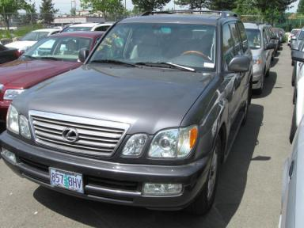 | 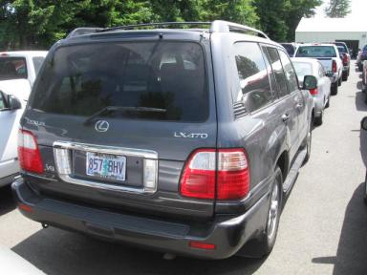
  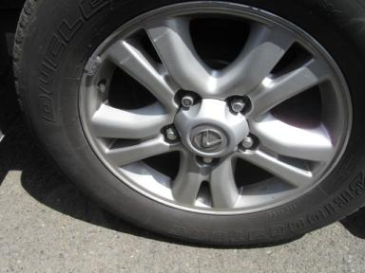 | 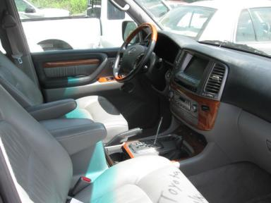
  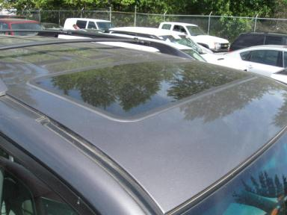 | 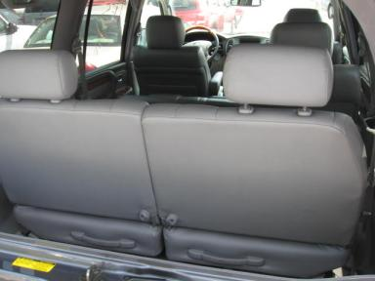

VEHICLE INFORMATION
  MECHANICAL
  8 Cylinder Gas
  Automatic
  4X4
  Pwr Brakes
  4.7 L
  INTERIOR
  Odometer - 6 Digits Digital Operable
  Stained
  GRY - Leather
  Int Odor: OK
  Wood Trim Dash
  OPTIONS
  Pwr Lock  Pwr Window  Tilt Steering  Cruise Ctl  CD Player  Dual Air Bags  Power Folding Mirrors  Tinted Windows  Rear Wiper  Luggage Rack  Steering Wheel Audio Control  DVD with Screen  Power Telescopic Steering |  | Pwr Steering  Pwr Seats - Both  A/C  Rear Defrost  Side Air Bags  Power Mirrors  ABS Brakes  Rear Air Conditioning  Third Seat  Floor Mats  Heated Seats  Rear View Camera  Navigation System
FLUID LEVELS
Fuel Level: Empty

  TIRES AND WHEELS
  Tire | Tread Depth | Brand | Size
  Left Front: | 4/32" | BRIDGESTONE | 275/60R18
  Left Rear: | 4/32" | BRIDGESTONE | 275/60R18
  Right Front: | 4/32" | BRIDGESTONE | 275/60R18
  Right Rear: | 4/32" | BRIDGESTONE | 275/60R18
  Spare: | 0/32" | (Mini)
  Tire Condition: Average
  Wheels: Alloy
  KEYS
  Combo Key - 1

ANNOUNCED CONDITION: Navigation CD Present, Shift Knob Present, Buyer Fee includes a $10 TFS/LFS Administrative Fee.
INTERNET REMARKS:
REMARKS/ADDITIONAL DAMAGE:
DISCLOSURES:
NOTES TO CONSIGNOR:
REMARKS:
COMMENTS FOR CONSIGNOR:

2004 LEXUS LX470 - DKGREY
VIN: JTJHT00WX43536700 Work Order #: 7034538
Manheim Seattle 19711 77th Ave South
Kent, WA 98032
(253) 872-6800

DAMAGES
 | DESCRIPTION | CONDITION | SEVERITY | REPAIR  HOURS | PAINT  HOURS | PART  HOURS | TOTAL  HOURS
 | Windshield | Cracked | GR 12" | .00 | .00 | .00 | .00
 | LF Wheel Cover | Missing | Replacement Req | .00 | .00 | .00 | .00
 | Rear Bumper | Scratched | 4" to 5" | .00 | .00 | .00 | .00
 | RF Door | Scratched | 5" to 6" | .00 | .00 | .00 | .00
 | RR Door | Scratched | 2" to 3" | .00 | .00 | .00 | .00
 | R Qtr Panel | Scratched | 2" to 3" | .00 | .00 | .00 | .00
 |  |  | TOTALS | .00 | .00 | .00 | .00



