VEHICLE DETAILS
2004 LEXUS RX330
VIN: | 2T2HA31U54C001932 | Body Style: | 4SUV | Top Type: | Sun Roof
EXT COLOR/Code: | SILVER- 1C0 | INT COLOR/Code: | BLK- LA22 | Mileage: | 95,222
Work Order #: | 7433878 | Lane Number: | 22 | Run Number: | 156
Seller: | R M HOLLENSHEAD AUTO SALES INC | Inspector: | KSTRASSMAN 07/21/2009 | Rcv Date: | 07/21/2009

VEHICLE IMAGES
 |  |  | GRADING
  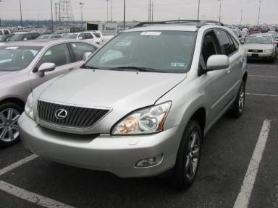 | 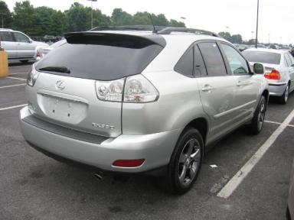
  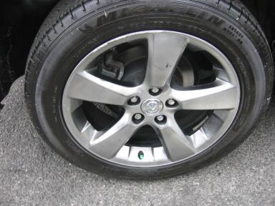 | 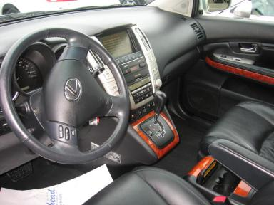
  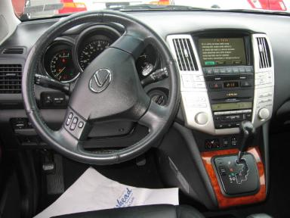 | 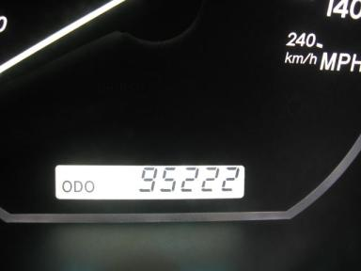
  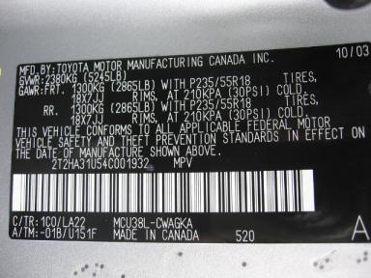
  
  Grade 2.9 Below Average
  More About Auto Grade
  Certified - No
  Drivable - Yes

VEHICLE INFORMATION
OPTIONS
Pwr Lock  A/C  Side Air Bags  Owner's Manual  CD Changer - OEM - 6.00  Warranty Books  5 Passenger Seating  Security System  2 Captain Seats 1 Bench  Cargo Cover  Woodgrain Interior Package  Directional Stability Control |  | Pwr Steering  Cruise Ctl  Dual Air Bags  ABS Brakes  Rear Wiper  Trip Computer  Floor Mats  Step Bumper  Dual Air Conditioning  Power Lift Gate  Power Telescopic Steering |  | Pwr Window  Rear Defrost  50 State Emissions  Fog Lamps  NO Rear Air Conditioning  Luggage Rack  Xenon Headlights  Steering Wheel Audio Control  HomeLink  Memory Seat  Power Tilt Steering |  | Pwr Seats - Both  Cassette Tape  Power Mirrors  Trip Counter  Power Trunk/Liftgate  NO Third Seat  US EPA Label  Traction Control  Heated Seats  Rear View Camera  Navigation System

MECHANICAL | INTERIOR
  6 Cylinder Gas
  Automatic
  AWD
  Pwr Brakes
  3.5 L
  Average
  BLK - Leather
  Int Odor: OK
  Regular Dash
TIRES AND WHEELS | KEYS
  Tire Condition: | Good | Wheels: | Alloy
  Tire | Tread Depth | Brand | Size
  Left Front: | 9/32" | MICHELIN | 235/55R18
  Left Rear: | 9/32" | MICHELIN | 235/55R18
  Right Front: | 9/32" | MICHELIN | 235/55R18
  Right Rear: | 9/32" | MICHELIN | 235/55R18
  Spare: | 11/32" | MICHELIN | 235/55R18
  Valet Key - 1
  Combo Key - 1

ADDITIONAL INFORMATION
1 KNOB 1 VAL KEY
Common Abbreviations

DAMAGES - SUGGESTED REPAIRS
Suggested repairs are based on Manheim professional inspector's recommendation.
Total labor hours include paint, body or repair estimates.
 | DESCRIPTION | CONDITION | SEVERITY | SUGGESTED  REPAIR | TOTAL  LABOR  HOURS
 | Front Bumper Co | Multiple Chips | 10 or More | Paint Chip Repair | .00
 | Hood | Multiple Chips | 10 or More | Paint Chip Repair | .00
 | Roof | Chipped | 1 | Paint Chip Repair | .00
 | LF Wheel | Curb Rash | 2" to 3" | Repair | .00
 | LF Door | Dings | PDR/2 | PDR | .00
 | RF Wheel | Curb Rash | 3" to 4" | Repair | .00
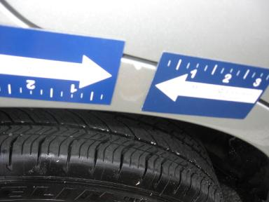 | R Qtr Panel | Dent/Paint Dmg | Less 1" | Repair | 4.30
 | RR Wheel | Curb Rash | 5" to 6" | Repair | .00
 | Warning - Maint | On | Unacceptable | Ck/Advise | 1.00
 | RF Door | Prev Repair | Acceptable | No Action Required | .00
 | RR Door | Replaced | Acceptable | No Action Required | .00
 | R Qtr Panel | Prev Repair | Acceptable | No Action Required | .00
 |  |  |  | TOTALS | 5.30

