Начало формы
VEHICLE DETAILS
VEHICLE IMAGES
 |  |  | GRADING
  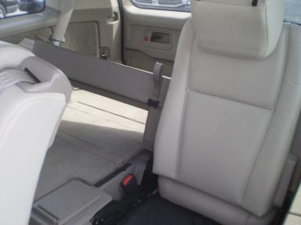 | 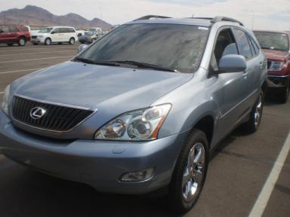
  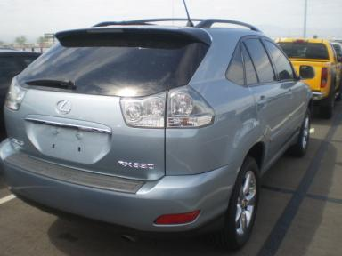 | 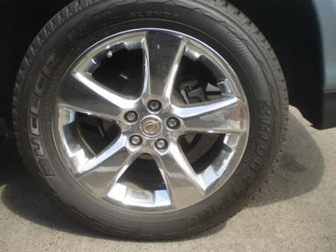
  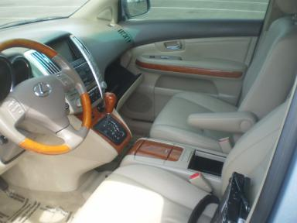 | 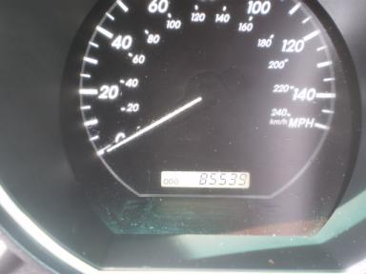
  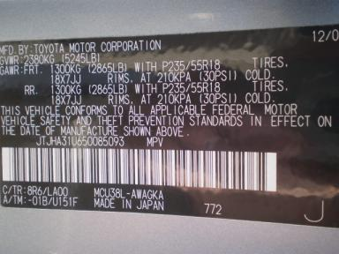
  
  Grade 5.0 Extra Clean
  More About Auto Grade
  Certified - No
  Drivable - Yes

VEHICLE INFORMATION
OPTIONS
Pwr Lock  Tilt Steering  Side Air Bags  Heated Mirrors  Tinted Windows  CD Changer - OEM - 6.00  Warranty Books  On-Board Computer  Step Bumper  HomeLink  Woodgrain Interior Package |  | Pwr Steering  A/C  Dual Air Bags  Owner's Manual  4 Door  Rear Wiper  Trip Computer  Spoiler  Steering Wheel Audio Control  Heated Seats  First Aid Kit |  | Pwr Window  Cruise Ctl  50 State Emissions  ABS Brakes  Fog Lamps  NO Rear Air Conditioning  Luggage Rack  US EPA Label  Traction Control  Cargo Cover |  | Pwr Seats - Both  Tape/CD  Power Mirrors  Premium Stereo - EM  Trip Counter  Power Trunk/Liftgate  NO Third Seat  Security System  Dual Air Conditioning  Memory Seat

MECHANICAL | INTERIOR
  6 Cylinder Gas
  Automatic
  AWD
  Pwr Brakes
  3.3 L
  Odometer - 6 Digits Digital - Operable
  Average
  TAN - Leather
  Int Odor: OK
  Wood Trim Dash
TIRES AND WHEELS | KEYS
  Tire Condition: | Good | Wheels: | Alloy
  Tire | Tread Depth | Brand | Size
  Left Front: | 11/32" | BRIDGESTONE | 235/55R18
  Left Rear: | 11/32" | BRIDGESTONE | 235/55R18
  Right Front: | 11/32" | BRIDGESTONE | 235/55R18
  Right Rear: | 11/32" | BRIDGESTONE | 235/55R18
  Spare: | 0/32" | (Mini)
  Combo Key - 1

2005 LEXUS RX330
VIN: | JTJHA31U650085093 | Body Style: | 4CUV | Top Type: | Sun Roof
EXT COLOR/Code: | BLUE | INT COLOR/Code: | TAN | Mileage: | 85,539
Work Order #: | 1372746 | Lane Number: | 7 | Run Number: | 140
Seller: | ROCKY GAP LOANS LLC | Inspector: | GEOFFROYD 07/21/2009 | Rcv Date: | 07/20/2009

ADDITIONAL INFORMATION
NAV
Common Abbreviations

DAMAGES - SUGGESTED REPAIRS
Suggested repairs are based on Manheim professional inspector's recommendation.
Total labor hours include paint, body or repair estimates.
 | DESCRIPTION | CONDITION | SEVERITY | SUGGESTED  REPAIR | TOTAL  LABOR  HOURS
 | Front | Chipped | Less 1" | Detail | .00
 | Windshield | Chipped | < 1/8" | No Action Required | .00
 | Front Bumper | Repainted | Acceptable | No Action Required | .00
 |  |  |  | TOTALS | .00


Конец формы
VIN: JTJHA31U650085093, Work Order #: 1372746

