Начало формы
VEHICLE DETAILS
VEHICLE IMAGES
 |  |  | GRADING
  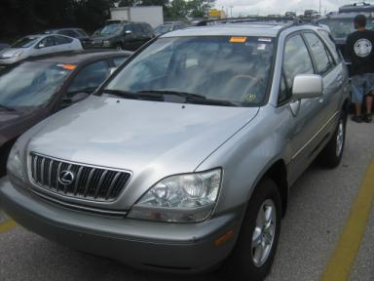 | 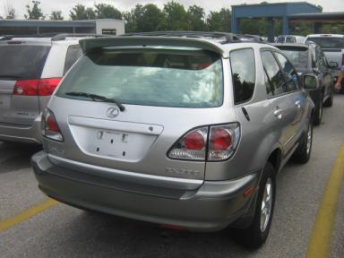
  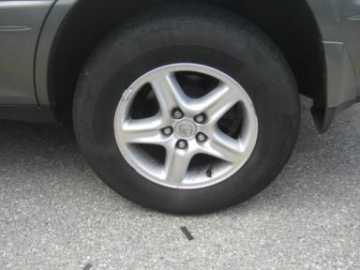 | 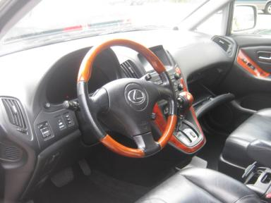
  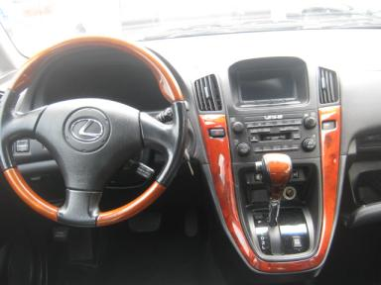 | 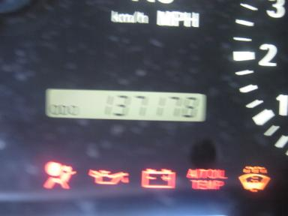
  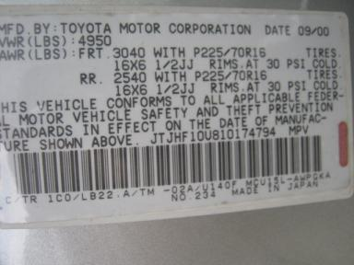
  
  Grade 4.3 Clean
  More About Auto Grade
  Certified - No
  Drivable - Yes

VEHICLE INFORMATION
OPTIONS
Pwr Lock  Tilt Steering  Cassette Tape  ABS Brakes  Rear Wiper  NO Third Seat  Wheel Locks |  | Pwr Steering  A/C  Dual Air Bags  Tinted Windows  NO Rear Air Conditioning  5 Passenger Seating |  | Pwr Window  Cruise Ctl  Power Mirrors  Fog Lamps  Warranty Books  US EPA Label |  | Pwr Seats - Drivers Only  Rear Defrost  Owner's Manual  Trip Counter  Luggage Rack  2 Captain Seats 1 Bench

MECHANICAL | INTERIOR
  6 Cylinder Gas
  Automatic
  AWD
  Pwr Brakes
  3.3 L
  Odometer - 6 Digits Digital - Operable
  Average
  BLK - Leather
  Int Odor: OK
  Wood Trim Dash
TIRES AND WHEELS | KEYS
  Tire Condition: | Good | Wheels: | Alloy
  Tire | Tread Depth | Brand | Size
  Left Front: | 6/32" | GOODYEAR | 225/70R16
  Left Rear: | 6/32" | GOODYEAR | 225/70R16
  Right Front: | 6/32" | GOODYEAR | 225/70R16
  Right Rear: | 7/32" | GOODYEAR | 225/70R16
  Spare: | 7/32" | GOODYEAR | 225/70R16
  Master Key - 2
  Spare Key - 1

2001 LEXUS RX300
VIN: | JTJHF10U810174794 | Body Style: | 4CUV | Top Type: | Sun Roof
EXT COLOR/Code: | SILVER | INT COLOR/Code: | BLK | Mileage: | 137,178
Work Order #: | 8091601 | Lane Number: | 2 | Run Number: | 24
Seller: | SHEEHY NISSAN OF ANNAPOLIS | Inspector: | RIJOHNSON 07/23/2009 | Rcv Date: | 07/23/2009

ADDITIONAL INFORMATION
OV1K
Common Abbreviations

DAMAGES - SUGGESTED REPAIRS
Suggested repairs are based on Manheim professional inspector's recommendation.
Total labor hours include paint, body or repair estimates.
 | DESCRIPTION | CONDITION | SEVERITY | SUGGESTED  REPAIR | TOTAL  LABOR  HOURS
 | Front Bumper | Scratches | 1" to 2" | Airbrush | .00
 | LF Door | Scratches | Less 1" | Airbrush | .00
 | LR Door | Dent/No Paint Dmg | PDR/1 | PDR | .00
 | Rear Bumper | Scratches | 1" to 2" | Airbrush | .00
 | RF Door | Scratches | 1" to 2" | Airbrush | .00
 | R Qtr Panel | Dent/No Paint Dmg | PDR/1 | PDR | .00
 | Carpet | Soiled | Needs Cleaning | Detail | .00
 | Front Mats | Missing | Replacement Req | Replace | .00
 |  |  |  | TOTALS | .00


Конец формы
VIN: JTJHF10U810174794, Work Order #: 8091601

