2007 LEXUS RX350 - OLIVE
VIN: 2T2HK31U97C005869 Work Order #: 6744831
Manheim Pennsylvania 1190 Lancaster Rd
Manheim, PA 17545-9789
(717) 665-3571

VIN:
  2T2HK31U97C005869
  Body Style: | 4CUV - Pwr Glass Sun Roof
  Ext Color/Code: | OLIVE - 6T1
  Int Color/Code: | BEI - LA00
  Mileage: | 74,999
  ECM Mileage:
  Seller: | LEXUS FINANCIAL SERVICES/EASTERN
  Title State: | PA
  Certified: | No
  Condition/Grade: | 3.0, Average
  Sale: | 48
  Lane: | 93
  Run: | 24
  Inspection: | JWIENHOLD 07/17/2009
  Drivable: | Yes
  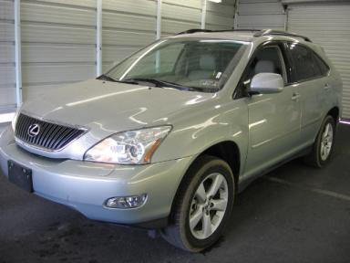 | 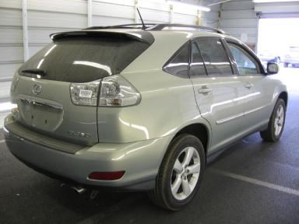
  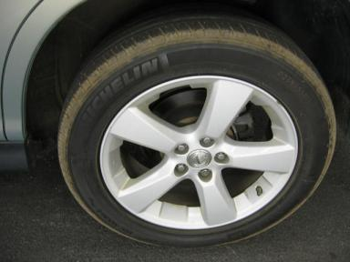 | 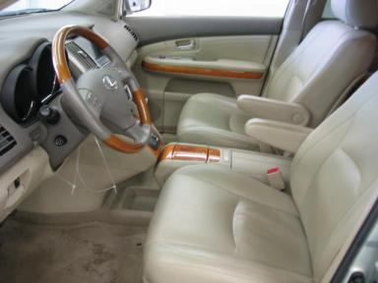
  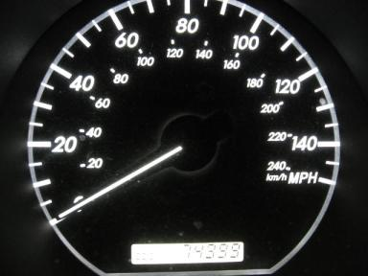 | 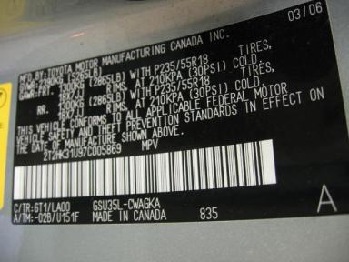
  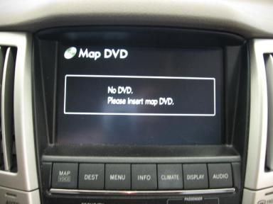

VEHICLE INFORMATION
  MECHANICAL
  6 Cylinder Gas
  Automatic
  AWD
  Pwr Brakes
  3.5 L
  INTERIOR
  Average
  BEI - Leather
  Int Odor: OK
  Regular Dash
  OPTIONS
  Pwr Lock  Pwr Window  A/C  Rear Defrost  Side Air Bags  Power Mirrors  Owner's Manual  Tinted Windows  Fog Lamps  CD Changer - OEM - 6.00  NO Rear Air Conditioning  Trip Computer  NO Third Seat  Floor Mats  Security System  Steering Wheel Audio Control  Dual Air Conditioning  Rear Tail/Lift Gate  Cargo Cover  Power Lift Gate  Rear View Camera  Power Telescopic Steering  Navigation System  Parking Distance Control  First Aid Kit |  | Pwr Steering  Pwr Seats - Both  Cruise Ctl  Cassette Tape  Dual Air Bags  Heated Mirrors  ABS Brakes  4 Door  Trip Counter  Rear Wiper  Power Trunk/Liftgate  Luggage Rack  5 Passenger Seating  Xenon Headlights  MP3 Compatible Stereo  Traction Control  HomeLink  Heated Seats  Wheel Locks  Memory Seat  Woodgrain Interior Package  Power Tilt Steering  Directional Stability Control  Hand Tool Kit
FLUID LEVELS
Fuel Level: 1/8

  TIRES AND WHEELS
  Tire | Tread Depth | Brand | Size
  Left Front: | 6/32" | MICHELIN | 235/55R18
  Left Rear: | 6/32" | MICHELIN | 235/55R18
  Right Front: | 7/32" | MICHELIN | 235/55R18
  Right Rear: | 6/32" | MICHELIN | 235/55R18
  Spare: | 4/32" | MICHELIN
  Tire Condition: Average
  Wheels: Alloy
  KEYS
  Master Key - 2
  Valet Key - 1

ANNOUNCED CONDITION: AWD,NAV;KEYS;KNOB;NAVDISC, Navigation CD Present, Shift Knob Present, Buyer Fee includes a $10 TFS/LFS Administrative Fee.
INTERNET REMARKS:
REMARKS/ADDITIONAL DAMAGE:
DISCLOSURES: PD 03/06 AV NO WARNING LIGHTS
NOTES TO CONSIGNOR:
REMARKS:
COMMENTS FOR CONSIGNOR: BAGGED KEYS,KNOB & NAV CD, PD 03/06 AV NO WARNING LIGHTS EXPORT

2007 LEXUS RX350 - OLIVE
VIN: 2T2HK31U97C005869 Work Order #: 6744831
Manheim Pennsylvania 1190 Lancaster Rd
Manheim, PA 17545-9789
(717) 665-3571

DAMAGES
 | DESCRIPTION | CONDITION | SEVERITY | REPAIR  HOURS | PAINT  HOURS | PART  HOURS | TOTAL  HOURS
 | LF Mirror Housi | Peeling | Repair Required | .50 | 1.00 | .00 | 1.50
 | Windshield | Multiple Chips | < 1/8" | .00 | .00 | .00 | .00
 | Front Bumper | Prev Repair | Acceptable | .00 | .00 | .00 | .00
 | Hood | Multiple Chips | Less 1" | .00 | .00 | .00 | .00
 | Rear Bumper | Prev Repair | Acceptable | .00 | .00 | .00 | .00
 | R Qtr Panel | Dent/No Paint Dmg | PDR/2 | .00 | .00 | .00 | .00
 | R Qtr Panel | Scratch Heavy | 1" to 2" | .00 | .00 | .00 | .00
 |  |  | TOTALS | .50 | 1.00 | .00 | 1.50



