Начало формы
VEHICLE DETAILS
VEHICLE IMAGES
 |  |  | GRADING
  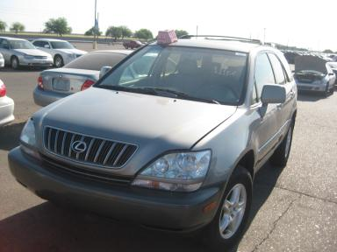 | 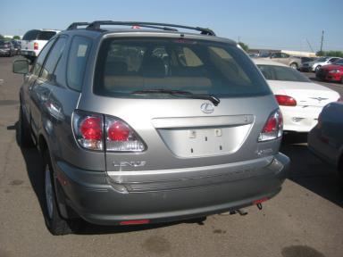
  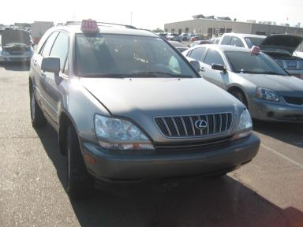 | 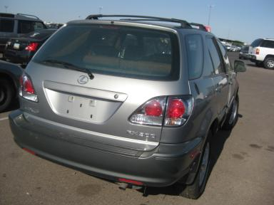
  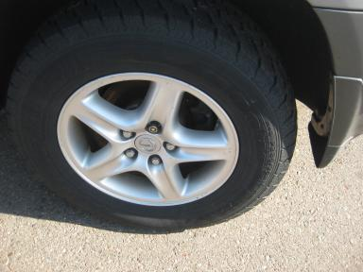 | 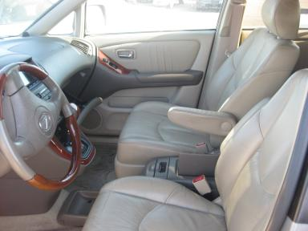
  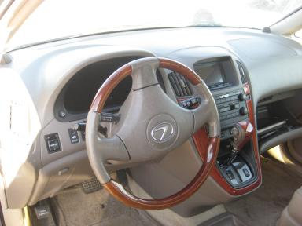 | 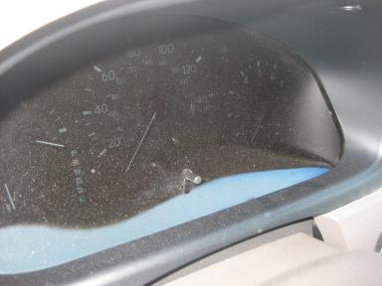
  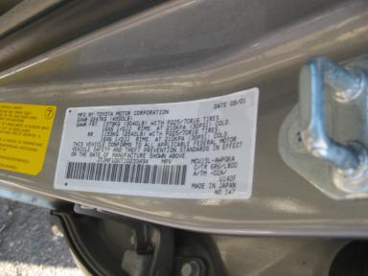
  
  Grade 2.2 Below Average
  More About Auto Grade
  Certified - No
  Drivable - Unknown

VEHICLE INFORMATION
OPTIONS
Pwr Lock  Tilt Steering  Tape/CD  Owner's Manual  Trip Counter  Luggage Rack  Traction Control  Woodgrain Interior Package |  | Pwr Steering  A/C  Dual Air Bags  ABS Brakes  CD Changer - OEM - 6.00  Keyless Entry  Dual Air Conditioning |  | Pwr Window  Cruise Ctl  Power Mirrors  Tinted Windows  Rear Wiper  US EPA Label  HomeLink |  | Pwr Seats - Both  Rear Defrost  Heated Mirrors  Fog Lamps  Trip Computer  Steering Wheel Audio Control  Heated Seats

MECHANICAL | INTERIOR
  6 Cylinder Gas
  Automatic
  AWD
  Pwr Brakes
  3.0 L
  Odometer - 6 Digits Analog - Operable
  Clean
  TAN - Leather
  Int Odor: OK
  Wood Trim Dash
TIRES AND WHEELS | KEYS
  Tire Condition: | Good | Wheels: | Alloy
  Tire | Tread Depth | Brand | Size
  Left Front: | 7/32" | PATHFINDER | 225/70R16
  Left Rear: | 7/32" | PATHFINDER | 225/70R16
  Right Front: | 7/32" | PATHFINDER | 225/70R16
  Right Rear: | 7/32" | PATHFINDER | 225/70R16
  Spare: | 0/32" | (Mini)
  Master Key

2001 LEXUS RX300
VIN: | JTJHF10U710233494 | Body Style: | 4CUV | Top Type: | Sun Roof
EXT COLOR/Code: | SILVER | INT COLOR/Code: | TAN | Mileage: | 106,503
Work Order #: | 565383 | Lane Number: | 7 | Run Number: | 34
Seller: | BANK OF AMERICA | Inspector: | FORTIZ2 06/29/2009 | Rcv Date: | 06/24/2009

ADDITIONAL INFORMATION
GREEN LIGHT
Common Abbreviations

DAMAGES - SUGGESTED REPAIRS
Suggested repairs are based on Manheim professional inspector's recommendation.
Total labor hours include paint, body or repair estimates.
 | DESCRIPTION | CONDITION | SEVERITY | SUGGESTED  REPAIR | TOTAL  LABOR  HOURS
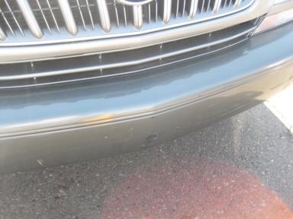 | Front Bumper | Dent/Paint Dmg | 4" to 5" | Repair | 5.50
 | Hood | Chipped | 6 | Paint Chip Repair | .00
 | LF Fender | Chipped | 4 | Brush Touch | .00
 | LF Door | Dent | PDR/1 | PDR | .00
 | L Qtr Panel | Dent | PDR/1 | PDR | .00
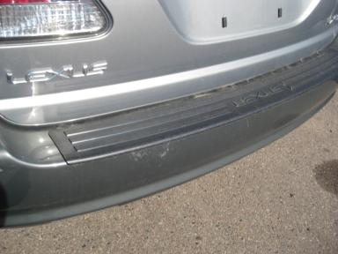 | Rear Bumper | Mult Scratches | 5" to 6" | Refinish | 4.60
 | RF Door | Dent/Paint Dmg | 2" to 3" | Repair | 4.30
 | RR Door | Mult Scratches | 2" to 3" | Refinish | 3.80
 | R Qtr Panel | Dent | 1" to 2" | Repair | 3.80
 | Keys | Missing KEYS ORDERED | Unknown | No Action Required | .00
 |  |  |  | TOTALS | 22.00
REPAIRED
 | DESCRIPTION | CONDITION | SEVERITY | SUGGESTED  REPAIR | TOTAL  LABOR  HOURS
 | Oil | Dirty OL CHNAGE | Replacement Req | Repair | .00
 |  |  |  | TOTALS | .00


Конец формы
VIN: JTJHF10U710233494, Work Order #: 565383

