Начало формы
VEHICLE DETAILS
VEHICLE IMAGES
 |  |  | GRADING
  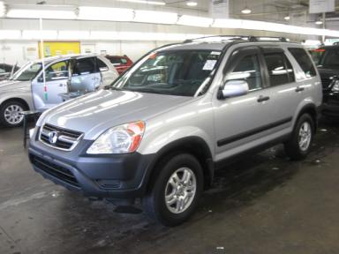 | 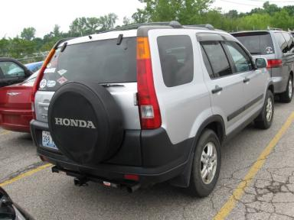
  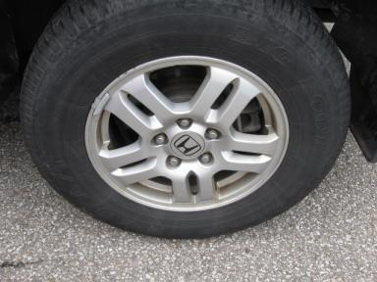 | 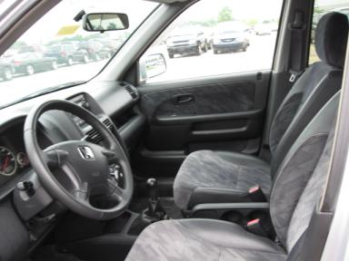
  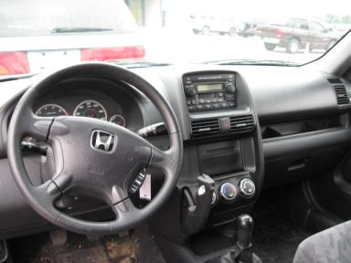 | 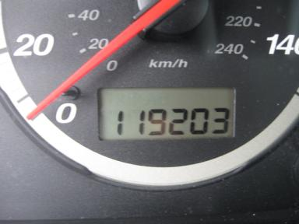
  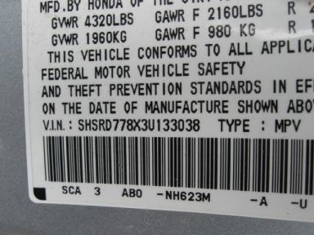
  
  Grade 4.2 Clean
  More About Auto Grade
  Certified - No
  Drivable - Yes

VEHICLE INFORMATION
OPTIONS
Pwr Lock  A/C  Side Air Bags  CD Changer - 6.00  NO Third Seat |  | Pwr Steering  Cruise Ctl  Dual Air Bags  Rear Wiper  5 Passenger Seating |  | Pwr Window  Rear Defrost  50 State Emissions  NO Rear Air Conditioning  Trailering Package |  | Tilt Steering  Tape/CD  Power Mirrors  Luggage Rack  Rain Sheilds

MECHANICAL | INTERIOR
  4 Cylinder Gas
  5 Speed
  4X4
  Pwr Brakes
  2.4 L
  Odometer - 6 Digits Digital - Operable
  Average
  GRY - Cloth
  Int Odor: OK
  Regular Dash
TIRES AND WHEELS | KEYS
  Tire Condition: | Average | Wheels: | Alloy
  Tire | Tread Depth | Brand | Size
  Left Front: | 6/32" | BIG O | 215/75R15
  Left Rear: | 6/32" | BIG O | 215/75R15
  Right Front: | 5/32" | BIG O | 215/75R15
  Right Rear: | 6/32" | BIG O | 215/75R15
  Spare: | 9/32" | BIG O | 215/75R15
  Master Key - 1

2003 HONDA CR-V EX
VIN: | SHSRD778X3U133038 | Body Style: | 4CUV | Top Type: | Sun Roof
EXT COLOR/Code: | SILVER | INT COLOR/Code: | GRY | Mileage: | 119,203
Work Order #: | 362894 | Lane Number: | 5 | Run Number: | 122
Seller: | GENERAL LEASING OF KENTUCKY | Inspector: | MWHITE2 08/05/2009 | Rcv Date: | 08/05/2009

ADDITIONAL INFORMATION
AS IS
Common Abbreviations

DAMAGES - SUGGESTED REPAIRS
Suggested repairs are based on Manheim professional inspector's recommendation.
Total labor hours include paint, body or repair estimates.
 | DESCRIPTION | CONDITION | SEVERITY | SUGGESTED  REPAIR | TOTAL  LABOR  HOURS
 | Hood | Chipped | 10 or More | Refinish | 3.80
 | LR Door | Scratch Light | 2" to 3" | Wet Sand | .00
 | Cargo Door | Scratch Light | 3" to 4" | Wet Sand | .00
 | RF Door | Dent/No Paint Dmg | PDR/3 | PDR | .00
 | RR Door | Dent/No Paint Dmg | PDR/1 | PDR | .00
 | RR Door | Scuffed | 2" to 3" | Wet Sand | .00
 | Owners manuals | Missing | Replacement Req | Replace | .00
 |  |  |  | TOTALS | 3.80


Конец формы
VIN: SHSRD778X3U133038, Work Order #: 362894

