2004 LEXUS RX330
4CUVTop Type: Pwr Steel Sun RoofVIN:
EXT COLOR/Code: JTJHA31U440028714Body Style: | GREY | INT COLOR/Code: | GRY | Mileage: | 128,779
Work Order #: | 1092253 | Lane Number: | 22 | Run Number: | 16
Seller: | TRIAD FINANCIAL CORP/TRA | Inspector: | ASUAREZ 06/22/2009 | Rcv Date: | 06/17/2009

VEHICLE IMAGES
 |  |  | GRADING
  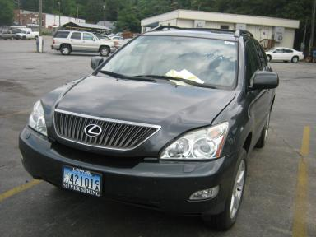 | 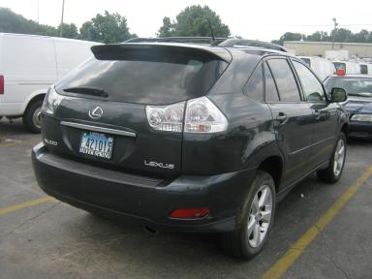
  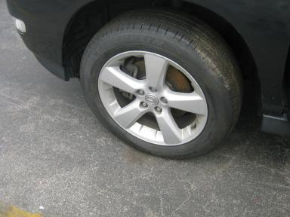 | 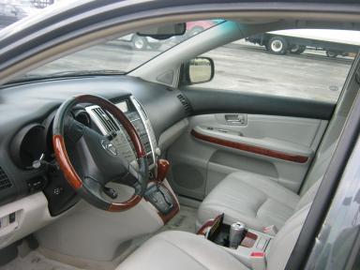
  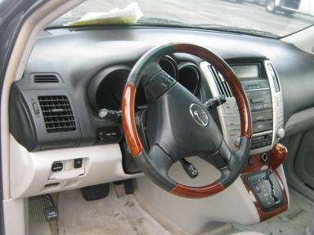 | 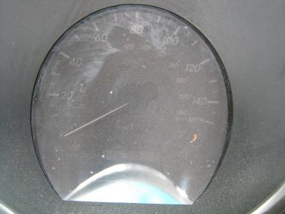
  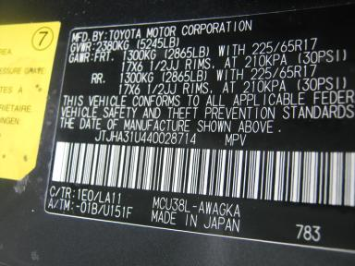
  
  Grade 3.8 Average
  More About Auto Grade
  Certified - No
  Drivable - Yes

VEHICLE INFORMATION
OPTIONS
Pwr Lock  Tilt Steering  CD Player  Owner's Manual  Fog Lamps  Floor Mats  Heated Seats |  | Pwr Steering  A/C  Side Air Bags  ABS Brakes  Trip Counter  Security System  Memory Seat |  | Pwr Window  Cruise Ctl  Dual Air Bags  Tinted Windows  Rear Wiper  Step Bumper  Power Telescopic Steering |  | Pwr Seats - Both  Rear Defrost  Power Mirrors  4 Door  Luggage Rack  Steering Wheel Audio Control  Power Tilt Steering

MECHANICAL | INTERIOR
  6 Cylinder Gas
  Automatic
  AWD
  Pwr Brakes
  3.3 L
  Odometer - 6 Digits Digital - Operable
  Dirty
  GRY - Leather
  Int Odor: OK
  Regular Dash
TIRES AND WHEELS | KEYS
  Tire Condition: | Average | Wheels: | Alloy
  Tire | Tread Depth | Brand | Size
  Left Front: | 9/32" | MICHELIN | 235/55R18
  Left Rear: | 7/32" | MICHELIN | 235/55R18
  Right Front: | 9/32" | MICHELIN | 235/55R18
  Right Rear: | 7/32" | MICHELIN | 235/55R18
  Spare: | 0/32" | (Mini)
  Master Key - 1

ADDITIONAL INFORMATION
MILES OVER
WASH
Common Abbreviations

DAMAGES - SUGGESTED REPAIRS
Suggested repairs are based on Manheim professional inspector's recommendation.
Total labor hours include paint, body or repair estimates.
 | DESCRIPTION | CONDITION | SEVERITY | SUGGESTED  REPAIR | TOTAL  LABOR  HOURS
 | Front Bumper | Mult Scratches | 3" to 4" | Refinish | .00
 | Hood | Scratches | Less 1" | Airbrush | .00
 | LF Fender | Scratch Light | 1" to 2" | Wet Sand | .00
 | LF Door | Scratch Light | 1" to 2" | Wet Sand | .00
 | LR Door | Mult Scratches | 2" to 3" | Refinish | .00
 | L Qtr Panel | Scratches | 1" to 2" | Airbrush | .00
 | RR Marker Lamp | Broken | Vsbl Close Insp | Replace | .00
 | Rear Bumper | Mult Scratches | GR 12" | Refinish | .00
 | R Qtr Panel | Scratch Light | 2" to 3" | Wet Sand | .00
 |  |  |  | TOTALS | .00



