Начало формы
EHICLE DETAILS
VEHICLE IMAGES
 |  |  | GRADING
  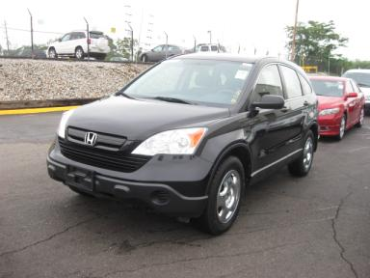 | 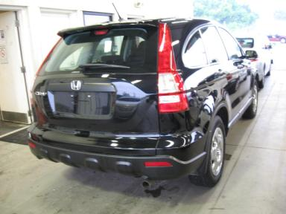
  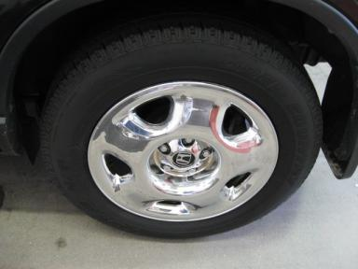 | 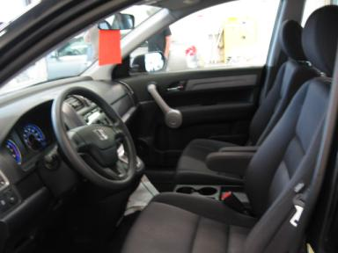
  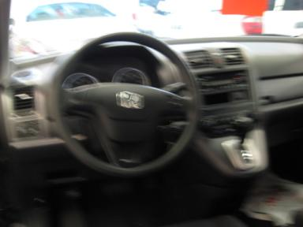 | 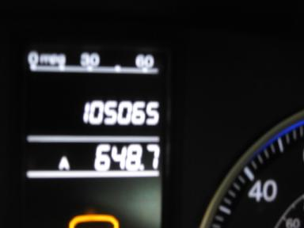
  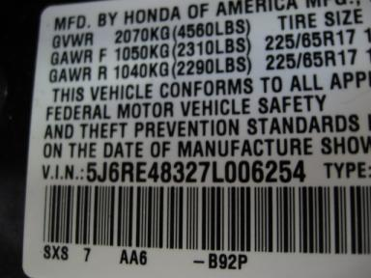
  
  Grade 2.9 Below Average
  More About Auto Grade
  Certified - No
  Drivable - Yes

VEHICLE INFORMATION
OPTIONS
Pwr Lock  A/C  Side Air Bags  Owner's Manual  5 Passenger Seating |  | Pwr Steering  Cruise Ctl  Dual Air Bags  Rear Wiper  MP3 Compatible Stereo |  | Pwr Window  Rear Defrost  50 State Emissions  NO Rear Air Conditioning  Auxiliary Input |  | Tilt Steering  CD Player  Power Mirrors  NO Third Seat  Wheel Covers

MECHANICAL | INTERIOR
  4 Cylinder Gas
  Automatic
  4X4
  Pwr Brakes
  2.4 L
  Odometer - 6 Digits Digital - Operable
  Clean
  BLK - Cloth
  Int Odor: OK
  Regular Dash
TIRES AND WHEELS | KEYS
  Tire Condition: | Average | Wheels: | Steel
  Tire | Tread Depth | Brand | Size
  Left Front: | 7/32" | TOYO | 225/65R17
  Left Rear: | 7/32" | TOYO | 225/65R17
  Right Front: | 7/32" | TOYO | 225/65R17
  Right Rear: | 7/32" | TOYO | 225/65R17
  Spare: | 4/32" | FIRESTONE(Mini) | 155/90R17
  Spare Key - 1
  Combo Key - 2

2007 HONDA CR-V LX
VIN: | 5J6RE48327L006254 | Body Style: | 4CUV | Top Type: | Hard Top
EXT COLOR/Code: | BLACK | INT COLOR/Code: | BLK | Mileage: | 105,065
Work Order #: | 362860 | Lane Number: | 5 | Run Number: | 92
Seller: | MIKE ALBERT LIMITED | Inspector: | MWHITE2 08/05/2009 | Rcv Date: | 08/04/2009

ADDITIONAL INFORMATION
Common Abbreviations

DAMAGES - SUGGESTED REPAIRS
Suggested repairs are based on Manheim professional inspector's recommendation.
Total labor hours include paint, body or repair estimates.
 | DESCRIPTION | CONDITION | SEVERITY | SUGGESTED  REPAIR | TOTAL  LABOR  HOURS
 | Front Bumper | Chipped | 10 or More | Refinish | 3.50
 | Hood | Chipped | 10 or More | Refinish | 3.80
 | LF Fender | Chipped | 10 or More | Refinish | 2.90
 | L Qtr Panel | Dent/No Paint Dmg | PDR/4 | PDR | .00
 | RF Fender | Chipped | 10 or More | Refinish | 2.90
 | R Qtr Panel | Dent/No Paint Dmg | PDR/5 | PDR | .00
 | Hood | Prev Repair | Acceptable | No Action Required | .00
 | LF Fender | Dent/No Paint Dmg | PDR/1 | PDR | .00
 | LF Fender | Scratch Light | Less 1" | Included | .00
 | LR Door | Dent/No Paint Dmg | PDR/2 | PDR | .00
 | Lift Gate | Scratch Light | GR 12" | Wet Sand | .00
 | RF Fender | Dent/No Paint Dmg | PDR/1 | PDR | .00
 | R Qtr Panel | Scratch Light | 3" to 4" | Wet Sand | .00
 |  |  |  | TOTALS | 13.10


Конец формы
VIN: 5J6RE48327L006254, Work Order #: 362860

