2007 LEXUS RX350
4SUVTop Type: Sun RoofVIN:
Ext Color: 2T2HK31U97C022526Body Style: | SILVER- 1CO | Int Color: | GRY- LA11 | Odometer: | 73,866
Work Order: | 7434623 | Lane Number: | 22 | Run Number: | 125
Seller: | R M HOLLENSHEAD AUTO SALES INC | Inspector: | JEVES 08/13/2009 | Received Date: | 08/11/2009

VEHICLE IMAGES
 |  |  | GRADING
  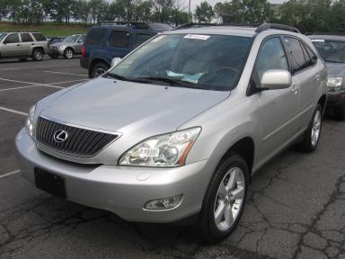 | 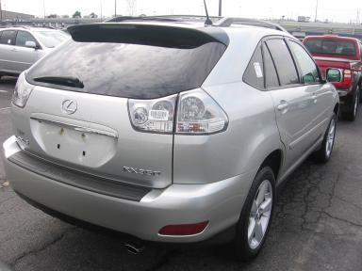
  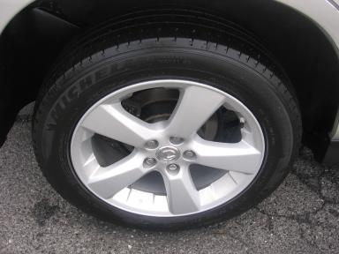 | 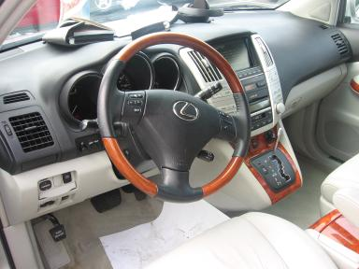
  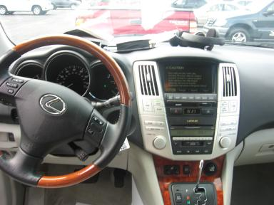 | 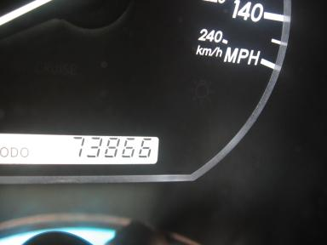
  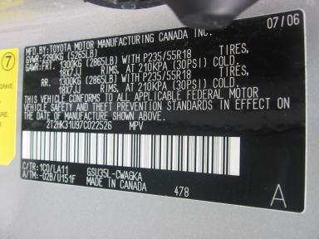
  
  Grade 3.9 Average
  More About Auto Grade
  Certified - No
  Drivable - Yes

VEHICLE INFORMATION
OPTIONS
Pwr Lock  A/C  Side Air Bags  Owner's Manual  Fog Lamps  Rear Wiper  Luggage Rack  Security System  Dual Air Conditioning  DVD with Screen  Navigation System |  | Pwr Steering  Cruise Ctl  Dual Air Bags  ABS Brakes  Maintenance Records  NO Rear Air Conditioning  NO Third Seat  MP3 Compatible Stereo  HomeLink  Rear View Camera |  | Pwr Window  Rear Defrost  50 State Emissions  Tinted Windows  Trip Counter  Warranty Books  Xenon Headlights  Steering Wheel Audio Control  Heated Seats  Power Telescopic Steering |  | Pwr Seats - Both  Tape/CD  Power Mirrors  4 Door  CD Changer - 6.00  Trip Computer  US EPA Label  Traction Control  Memory Seat  Power Tilt Steering

MECHANICAL | INTERIOR
  6 Cylinder Gas
  Automatic
  AWD
  Pwr Brakes
  3.5 L
  Odometer - 6 Digits Digital - Operable
  Average
  GRY - Leather
  Int Odor: OK
  Wood Trim Dash
TIRES AND WHEELS | KEYS
  Tire Condition: | Average | Wheels: | Alloy
  Tire | Tread Depth | Brand | Size
  Left Front: | 7/32" | MICHELIN | 235/55R18
  Left Rear: | 4/32" | MICHELIN | 235/55R18
  Right Front: | 6/32" | MICHELIN | 235/55R18
  Right Rear: | 4/32" | MICHELIN | 235/55R18
  Spare: | 0/32" | (Mini)
  Master Key - 1

ADDITIONAL INFORMATION
T/A;KNOB;2M
Common Abbreviations

DAMAGES - SUGGESTED REPAIRS
Suggested repairs are based on Manheim professional inspector's recommendation.
Total labor hours include paint, body or repair estimates.
 | DESCRIPTION | CONDITION | SEVERITY | SUGGESTED  REPAIR | TOTAL  LABOR  HOURS
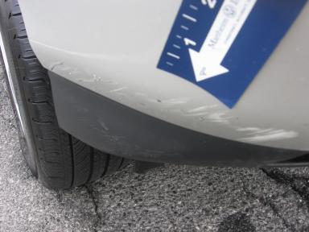 | Front Bumper | Scratches | 7" to 8" | Refinish | 3.50
 | Rear Door | Scratched | 1" to 2" | Airbrush | .00
 | Rear Bumper | Multiple Chips | Less 1" | Brush Touch | .00
 | RR Door Molding | Scratches | 2" to 3" | Airbrush | .00
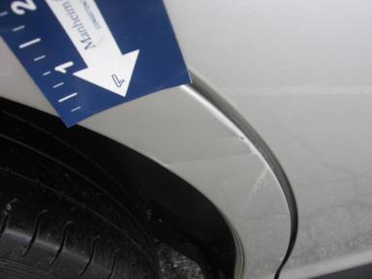 | R Qtr Panel | Dent/Paint Dmg | 1" to 2" | Repair | 4.30
 |  |  |  | TOTALS | 7.80

VIN: 2T2HK31U97C022526, Work Order: 7434623



