VEHICLE DETAILS
1999 LEXUS RX300 RX300
VIN: | JT6HF10U3X0062360 | Body Style: | 4CUV | Top Type: | Pwr Glass Sun Roof
Ext Color: | SILVER | Int Color: | GRY | Odometer: | 205,635
Work Order: | 386362 | Lane Number: | 5 | Run Number: | 130
Seller: | NATIONAL AUTO LEASING | Inspector: | JSOSNOSKI 08/07/2009 | Received Date: | 08/06/2009

VEHICLE IMAGES
 |  |  | GRADING
  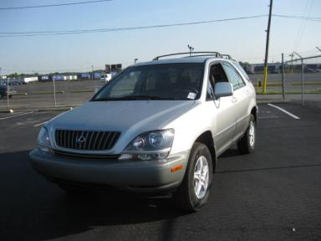 | 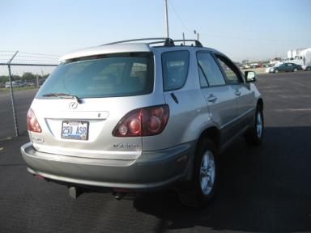
  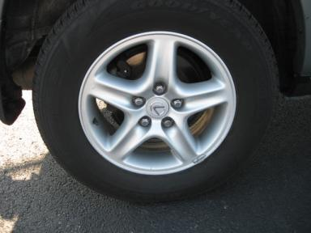 | 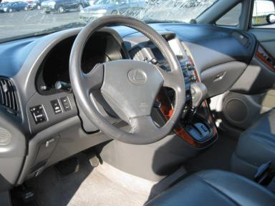
  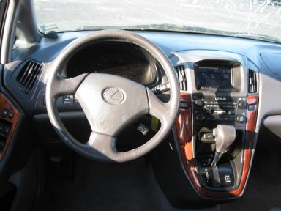 | 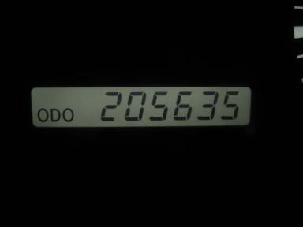
  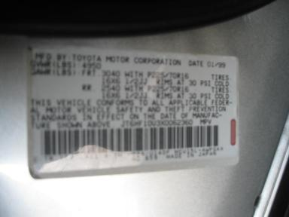
  
  Grade 2.5 Below Average
  More About Auto Grade
  Certified - No
  Drivable - Yes

VEHICLE INFORMATION
OPTIONS
Pwr Lock  Tilt Steering  Tape/CD  Owner's Manual  Rear Wiper  5 Passenger Seating  Heated Seats |  | Pwr Steering  A/C  Side Air Bags  ABS Brakes  NO Rear Air Conditioning  US EPA Label  Woodgrain Interior Package |  | Pwr Window  Cruise Ctl  Dual Air Bags  Tinted Windows  Luggage Rack  Power Antenna  Directional Stability Control |  | Pwr Seats - Both  Rear Defrost  Power Mirrors  Trip Counter  NO Third Seat  Trailering Package

MECHANICAL | INTERIOR
  6 Cylinder Gas
  Automatic
  AWD
  Pwr Brakes
  3.0 L
  Odometer - 6 Digits Digital - Operable
  Average
  GRY - Leather
  Int Odor: OK
TIRES AND WHEELS | KEYS
  Tire Condition: | Good | Wheels: | Alloy
  Tire | Tread Depth | Brand | Size
  Left Front: | 7/32" | GOODYEAR | 225/70R16
  Left Rear: | 9/32" | GOODYEAR | 225/70R16
  Right Front: | 7/32" | GOODYEAR | 225/70R16
  Right Rear: | 8/32" | GOODYEAR | 225/70R16
  Spare: | 0/32" | (Mini)
  Combo Key - 1

ADDITIONAL INFORMATION
GREEN LT - MILES OVER 2X - T/A
Common Abbreviations

DAMAGES - SUGGESTED REPAIRS
Suggested repairs are based on Manheim professional inspector's recommendation.
Total labor hours include paint, body or repair estimates.
 | DESCRIPTION | CONDITION | SEVERITY | SUGGESTED  REPAIR | TOTAL  LABOR  HOURS
 | Hood | Multiple Chips | 10 or More | Refinish | 4.80
 | LF Door | Dent/No Paint Dmg | PDR/2 | PDR | .00
 | LF Door | Edge Chipped | 10 or More | Paint Chip Repair | .00
 | LF Door | Scratch Light | Less 1" | Wet Sand | .00
 | LR Door | Dent/No Paint Dmg | PDR/2 | PDR | .00
 | LR Door Molding | Chipped | 4 | Paint Chip Repair | .00
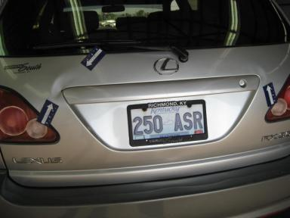 | Rear Door | Multiple Dents | 6" to 7" | Repair | 7.50
 | Rear Bumper Cov | Multiple Chips | 10 or More | Refinish | 4.60
 | RF Door Molding | Mult Scratches | GR 12" | Refinish | 3.00
 | RR Door | Dent/No Paint Dmg | PDR/1 | PDR | .00
 | RR Door Molding | Mult Scratches | 1" to 2" | Repair | 3.00
 | LF Seat Cushion | Cracked | Repair Required | Repair | .00
 | Exhaust | Leak | Repair Required | Ck/Advise | 1.00
 | LF Fender | Replaced | Acceptable | No Action Required | .00
 |  |  |  | TOTALS | 23.90

VIN: JT6HF10U3X0062360, Work Order: 386362



