VEHICLE DETAILS
2005 LEXUS RX330
VIN: | 2T2HA31U15C055052 | Body Style: | 4CUV | Top Type: | Moon Roof
Ext Color: | GREEN- 6Y1 | Int Color: | GRY- LA11 | Odometer: | 84,568
Work Order: | 2334713 | Lane Number: | 6 | Run Number: | 45
Seller: | PRIME FINANCIAL CREDIT UNION | Inspector: | CANDREWS 07/24/2009 | Received Date: | 07/23/2009

VEHICLE IMAGES
 |  |  | GRADING
  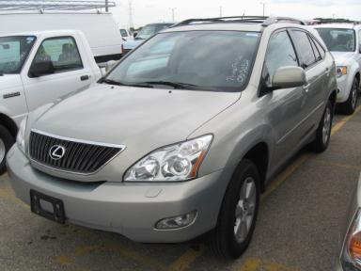 | 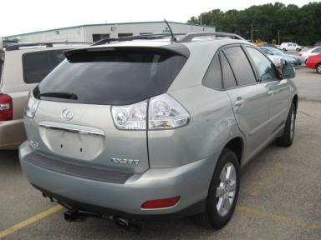
  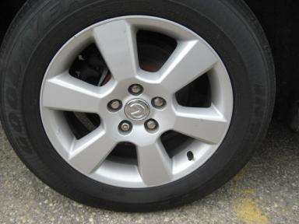 | 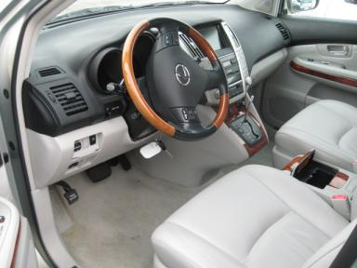
  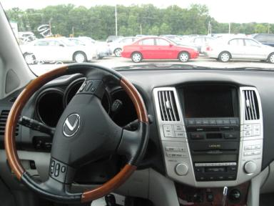 | 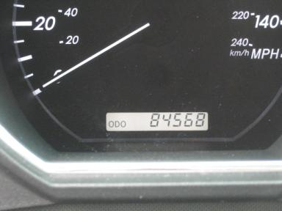
  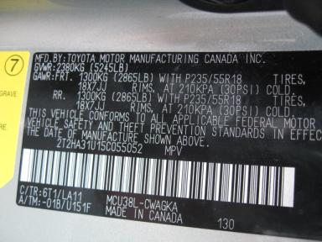
  
  Grade 2.9 Below Average
  More About Auto Grade
  Certified - No
  Drivable - Yes

VEHICLE INFORMATION
OPTIONS
Pwr Lock  Tilt Steering  Tape/CD  Power Mirrors  Tinted Windows  CD Changer - OME - 6.00  Spoiler  Dual Air Conditioning  Power Telescopic Steering |  | Pwr Steering  A/C  Side Air Bags  Heated Mirrors  4 Door  NO Rear Air Conditioning  US EPA Label  HomeLink  Power Tilt Steering |  | Pwr Window  Cruise Ctl  Dual Air Bags  Owner's Manual  Fog Lamps  NO Third Seat  Security System  Rear View Camera  Navigation System |  | Pwr Seats - Both  Rear Defrost  50 State Emissions  ABS Brakes  Trip Counter  Floor Mats  Steering Wheel Audio Control  Woodgrain Interior Package  Cell Phone - OEM

MECHANICAL | INTERIOR
  6 Cylinder Gas
  Automatic
  AWD
  Pwr Brakes
  3.3 L
  Odometer - 5 Digits Digital - Operable
  Clean
  GRY - Leather
  Int Odor: OK
  Wood Trim Dash
TIRES AND WHEELS | KEYS
  Tire Condition: | Average | Wheels: | Alloy
  Tire | Tread Depth | Brand | Size
  Left Front: | 6/32" | GOODYEAR | 225/65R17
  Left Rear: | 5/32" | GOODYEAR | 225/65R17
  Right Front: | 6/32" | GOODYEAR | 225/65R17
  Right Rear: | 3/32" | GOODYEAR | 225/65R17
  Spare: | 6/32" | GOODYEAR | 225/65R17
  Combo Key - 1

ADDITIONAL INFORMATION
Common Abbreviations

DAMAGES - SUGGESTED REPAIRS
Suggested repairs are based on Manheim professional inspector's recommendation.
Total labor hours include paint, body or repair estimates.
 | DESCRIPTION | CONDITION | SEVERITY | SUGGESTED  REPAIR | TOTAL  LABOR  HOURS
 | F Bumper Cover | Gouged | 1" to 2" | Partial Repair | .00
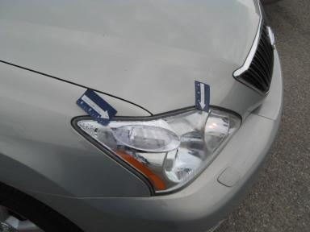 | R Headlight | Water Damage | Unacceptable | Replace | 2.30
 | Hood | Multiple Chips | 10 or More | Paint Chip Repair | .00
 | LF Mirror Housi | Scratch Light | Less 1" | Wet Sand | .00
 | LF Door Edge | Chipped | 4 | Paint Chip Repair | .00
 | LR Door | Scratch Light | 1" to 2" | Wet Sand | .00
 | Lift Gate | Scratched | 4" to 5" | Refinish | 3.10
 | RF Door | Dent/Paint Dmg | 2 | Repair | 4.30
 | RF Mirror Housi | Scratched | 3" to 4" | Refinish | 1.50
 | RF Door Molding | Chipped | 4 | Paint Chip Repair | .00
 | RR Door | Scratch Light | 1" to 2" | Wet Sand | .00
 | R Qtr Panel | Scratched | 1" to 2" | Airbrush | .00
 | RR Tire | Worn | Replacement Req | Replace | .00
 |  |  |  | TOTALS | 11.20

VIN: 2T2HA31U15C055052, Work Order: 2334713

