Manheim San Antonio
2042 Ackerman Rd
San Antonio, TX 78219
(210) 661-4200

VEHICLE DETAILS
2003 LEXUS GX470
VIN: | JTJBT20X130012071 | Body Style: | 4SUV | Top Type: | Sun Roof
Ext Color: | SLVR | Odometer: | 106,866
Work Order: | 1922314 | Lane Number: | 4 | Run Number: | 25
Seller: | AUTO MAX | Inspector: | JPRIESTLY 08/18/2009 | Received Date: | 08/17/2009

VEHICLE IMAGES
 |  |  | GRADING
  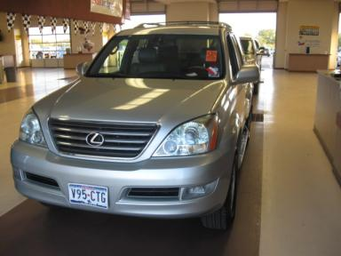 | 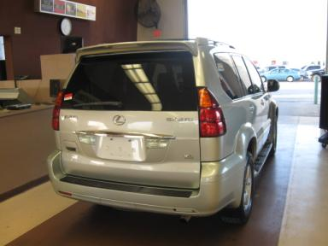
  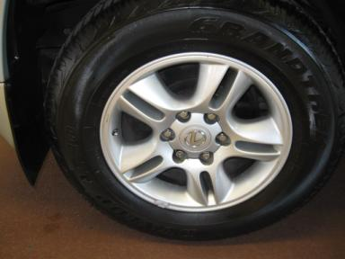 | 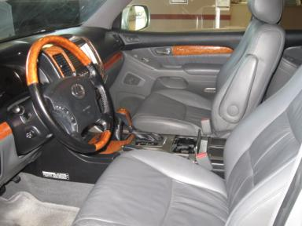
  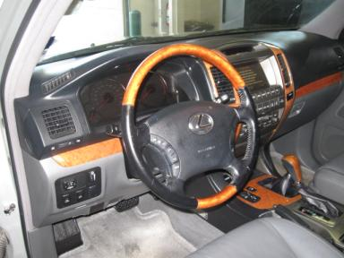 | 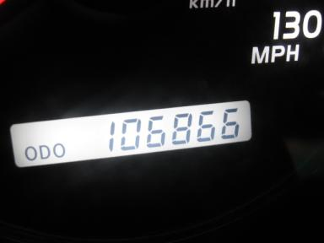
  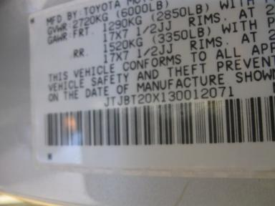
  
  Grade 4.2 Clean
  More About Auto Grade
  Certified - No
  Drivable - Yes

VEHICLE INFORMATION
OPTIONS
Pwr Steering  A/C  50 State Emissions  Tinted Windows  Trip Counter  Luggage Rack  7 Passenger Seating  Running Board  HomeLink  Memory Seat |  | Pwr Window  Cruise Ctl  Power Mirrors  4 Door  Rear Air Conditioning  Keyless Entry  US EPA Label  Steering Wheel Audio Control  Rear Tail/Lift Gate  Woodgrain Interior Package |  | Pwr Seats - Both  CD Player  Owner's Manual  Fog Lamps  Rear Wiper  Floor Mats  Security System  2 Captain Seats 1 Bench  Quad Seating  Navigation System |  | Tilt Steering  Dual Air Bags  ABS Brakes  Maintenance Records  Third Seat  Spoiler  Step Bumper  Dual Air Conditioning  Heated Seats

MECHANICAL | INTERIOR
  8 Cylinder Gas
  Automatic
  4X4
  Pwr Brakes
  4.7 L
  Average
  Leather
  Int Odor: OK
  Wood Trim Dash
TIRES AND WHEELS | KEYS
  Tire Condition: | Good | Wheels: | Alloy
  Tire | Tread Depth | Brand | Size
  Left Front: | 8/32" | DUNLOP | 265/65R17
  Left Rear: | 8/32" | DUNLOP | 265/65R17
  Right Front: | 8/32" | DUNLOP | 265/65R17
  Right Rear: | 8/32" | DUNLOP | 265/65R17
  Spare: | 0/32" | (Mini)
  Master Key - 1

ADDITIONAL INFORMATION
KIW #150
ECR/081809/JP
Common Abbreviations

DAMAGES - SUGGESTED REPAIRS
Suggested repairs are based on Manheim professional inspector's recommendation.
Total labor hours include paint, body or repair estimates.
 | DESCRIPTION | CONDITION | SEVERITY | SUGGESTED  REPAIR | TOTAL  LABOR  HOURS
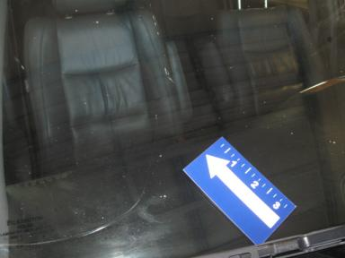 | Windshield | Cracked | 7" to 8" | Replace | .00
 | Front Bumper | Scratch Light | 3" to 4" | Wet Sand | .00
 | Hood | Chipped | 10 or More | Refinish | 3.80
 | LF Door | Scratch Light | Less 1" | Wet Sand | .00
 | Rear Bumper | Scratch Light | 2" to 3" | Wet Sand | .00
 | RF Fender Moldi | Scratch Light | Less 1" | Airbrush | .00
 | RF Door | Scratch Light | Less 1" | Wet Sand | .00
 |  |  |  | TOTALS | 3.80

VIN: JTJBT20X130012071, Work Order: 1922314



