2000 HONDA CR-V EX
4CUVTop Type: Hard TopVIN:
Ext Color: JHLRD1866YC027355Body Style: | SILVER | Int Color: | BLK | Odometer: | 143,418
Work Order: | 1052430 | Lane Number: | 11 | Run Number: | 151
Seller: | PAR NORTH AMERICA | Inspector: | JBAKER4 07/16/2009 | Received Date: | 07/14/2009

VEHICLE IMAGES
 |  |  | GRADING
  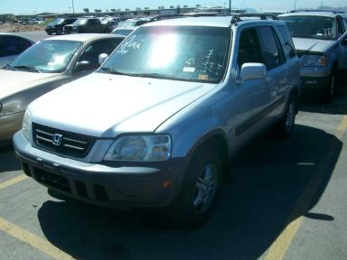 | 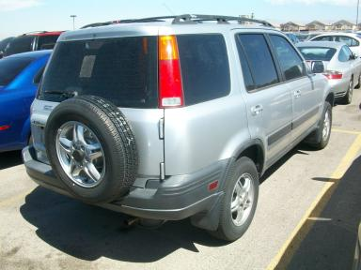
  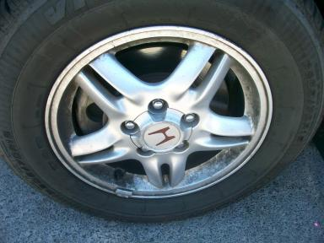 | 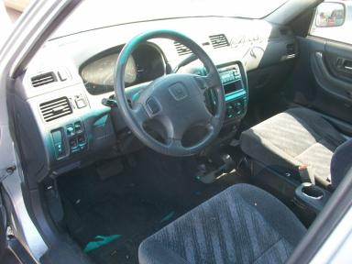
  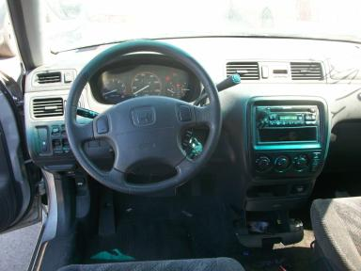 | 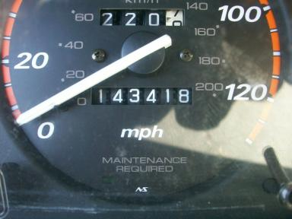
  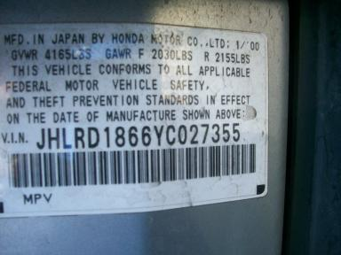
  
  Grade 3.2 Average
  More About Auto Grade
  Certified - No
  Drivable - Yes

VEHICLE INFORMATION
OPTIONS
Pwr Lock  A/C  Dual Air Bags  ABS Brakes  Rear Wiper  US EPA Label |  | Pwr Steering  Cruise Ctl  50 State Emissions  Tinted Windows  Luggage Rack  Security System |  | Pwr Window  Rear Defrost  Power Mirrors  4 Door  NO Third Seat  Step Bumper |  | Tilt Steering  CD Player  Owner's Manual  Trip Counter  Floor Mats

MECHANICAL | INTERIOR
  4 Cylinder Gas
  Automatic
  AWD
  Pwr Brakes
  2.0 L
  Odometer - 6 Digits Analog - Operable
  Dirty
  BLK - Cloth
  Int Odor: OK
  Regular Dash
TIRES AND WHEELS | KEYS
  Tire Condition: | Poor | Wheels: | Alloy
  Tire | Tread Depth | Brand | Size
  Left Front: | 4/32" | BFGOODRICH | 205/70R15
  Left Rear: | 4/32" | BFGOODRICH | 205/70R15
  Right Front: | 4/32" | BFGOODRICH | 205/70R15
  Right Rear: | 4/32" | BFGOODRICH | 205/70R15
  Spare: | 0/32" | BFGOODRICH | 205/70R15
  Master Key - 1
  Remote Key/Fob - 1

ADDITIONAL INFORMATION
REPO/RL, OVER
Common Abbreviations

DAMAGES - SUGGESTED REPAIRS
Suggested repairs are based on Manheim professional inspector's recommendation.
Total labor hours include paint, body or repair estimates.
 | DESCRIPTION | CONDITION | SEVERITY | SUGGESTED  REPAIR | TOTAL  LABOR  HOURS
 | Hood | Multiple Dents | PDR/4 | PDR | .00
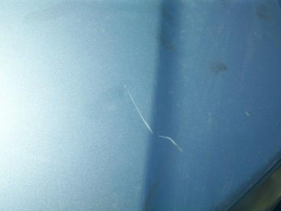 | Hood | Mult Scratches | 3" to 4" | Refinish | 3.80
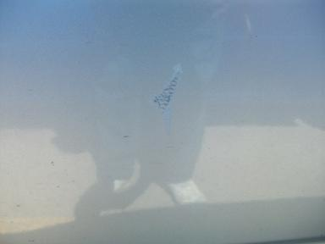 | LF Door | Scuffed | 1" to 2" | Wet Sand | .00
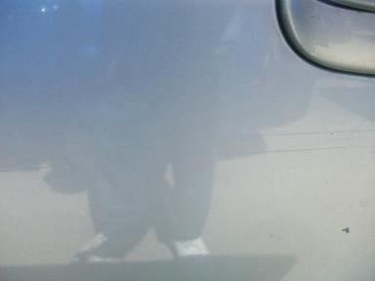 | LR Door | Mult Scratches | 3" to 4" | Refinish | 3.20
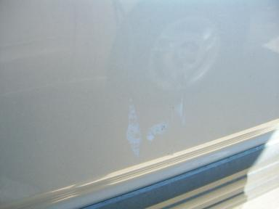 | RF Door | Scuffed | 3" to 4" | Wet Sand | .00
 | RR Door | Multiple Dents | PDR/3 | PDR | .00
 | R Qtr Panel | Dent/Paint Dmg | 1" to 2" | Repair | 5.70
 | Oil | Dirty | Unacceptable | Replace | .00
 |  |  |  | TOTALS | 12.70

