VEHICLE DETAILS
2004 LEXUS GX470
VIN: | JTJBT20X440061489 | Body Style: | 4SUV | Top Type: | Pwr Glass Sun Roof
Ext Color: | BLACK | Int Color: | GRY | Odometer: | 102,352
Work Order: | 7435273 | Lane Number: | 22 | Run Number: | 190
Seller: | R M HOLLENSHEAD AUTO SALES INC | Inspector: | WKEPERLING 09/03/2009 | Received Date: | 09/01/2009

VEHICLE IMAGES
 |  |  | GRADING
  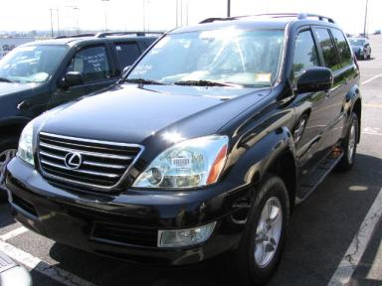 | 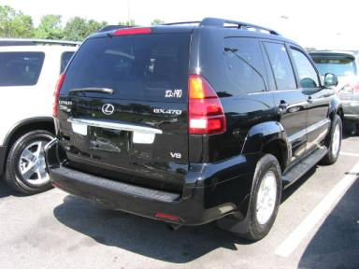
  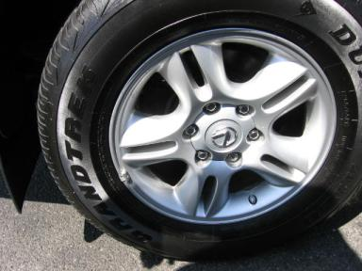 | 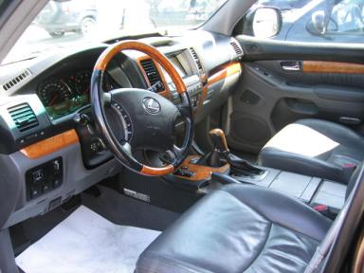
  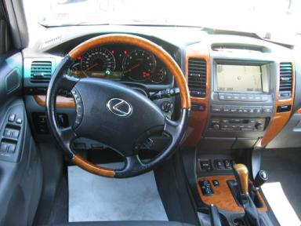 | 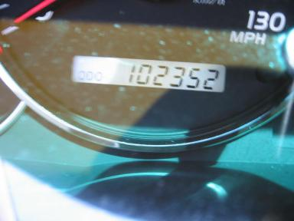
  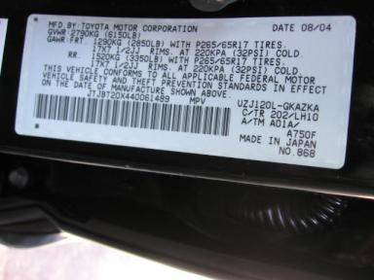
  
  Grade 4.7 Clean
  More About Auto Grade
  Certified - No
  Drivable - Yes

VEHICLE INFORMATION
OPTIONS
Pwr Lock  Tilt Steering  Cassette Tape  Power Mirrors  Tinted Windows  CD Changer - OEM - 6.00  Luggage Rack  Running Board  HomeLink  Power Telescopic Steering  Parking Distance Control |  | Pwr Steering  A/C  Side Air Bags  Heated Mirrors  Fog Lamps  Rear Wiper  7 Passenger Seating  Steering Wheel Audio Control  Heated Seats  Power Tilt Steering  Ride Control |  | Pwr Window  Cruise Ctl  Dual Air Bags  Owner's Manual  Trip Counter  Trip Computer  Xenon Headlights  Traction Control  Memory Seat  Navigation System |  | Pwr Seats - Both  Rear Defrost  50 State Emissions  ABS Brakes  Rear Air Conditioning  Third Seat  Security System  Dual Air Conditioning  Woodgrain Interior Package  Directional Stability Control

MECHANICAL | INTERIOR
  8 Cylinder Gas
  Automatic
  4X4
  Pwr Brakes
  4.7 L
  Average
  GRY - Leather
  Int Odor: OK
  Wood Trim Dash
TIRES AND WHEELS | KEYS
  Tire Condition: | Average | Wheels: | Alloy
  Tire | Tread Depth | Brand | Size
  Left Front: | 5/32" | DUNLOP | 265/65R17
  Left Rear: | 4/32" | DUNLOP | 265/65R17
  Right Front: | 5/32" | DUNLOP | 265/65R17
  Right Rear: | 4/32" | DUNLOP | 265/65R17
  Spare: | 4/32" | DUNLOP | 265/65R17
  Combo Key - 1

ADDITIONAL INFORMATION
T/A OVER100K CLEAN CAR FAX
Common Abbreviations

DAMAGES - SUGGESTED REPAIRS
Suggested repairs are based on Manheim professional inspector's recommendation.
Total labor hours include paint, body or repair estimates.
 | DESCRIPTION | CONDITION | SEVERITY | SUGGESTED  REPAIR | TOTAL  LABOR  HOURS
 | Front Bumper | Scratched | Less 1" | Airbrush | .00
 | L Qtr Panel | Dent/No Paint Dmg | PDR/3 | PDR | .00
 |  |  |  | TOTALS | .00

VIN: JTJBT20X440061489, Work Order: 7435273



