Manheim California
1320 N Tustin Ave
Anaheim, CA 92807-1619
(714) 996-2400

VEHICLE DETAILS - 2004 LEXUS GX470
VIN: | JTJBT20XX40057656 | Body Style: | 4SUV | Top Type: | Sun Roof
Ext Color: | WHITE | Int Color: | BEI | Odometer: | 103,476 miles
Work Order: | 5220447 | Seller: | WACHOVIA DEALER SERVICES | Received Date: | 08/25/2009
Sale Number: | 37 | Lane Number: | 12 | Run Number: | 57
Inspector: | DTAO 08/27/2009

VEHICLE IMAGES
 |  |  | GRADING
  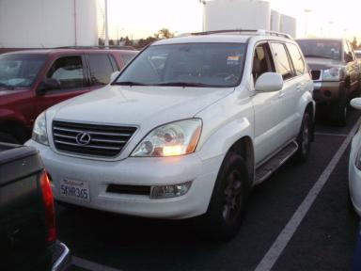 | 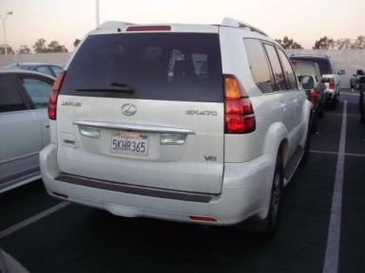
  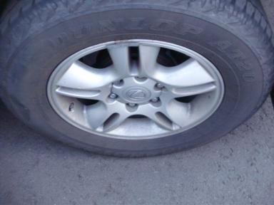 | 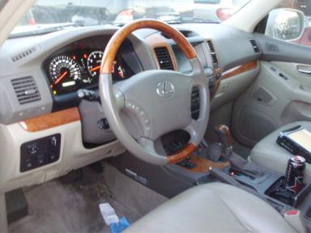
  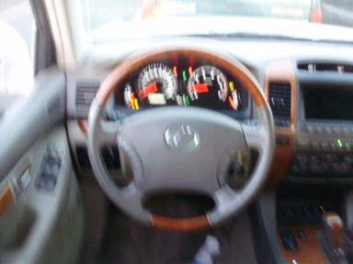 | 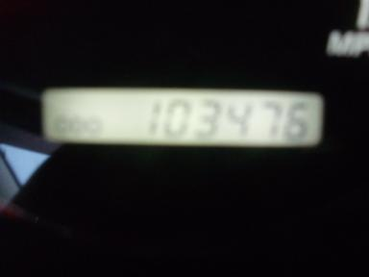
  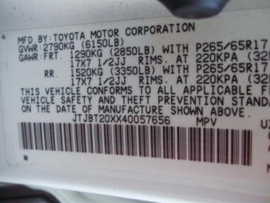
  
  Grade 4.8 Clean
  More About Auto Grade
  MMR: - ¤ 18 319
  MSRP - Not Available
  Certified - No
  Drivable - Yes

VEHICLE INFORMATION
OPTIONS
Pwr Lock  A/C  Side Air Bags  Heated Mirrors  4 Door  CD Changer - FACT - 6.00  Luggage Rack  8 Passenger Seating  Dual Air Conditioning  Rear View Camera  Ride Control |  | Pwr Steering  Cruise Ctl  Dual Air Bags  Owner's Manual  Fog Lamps  Rear Wiper  Floor Mats  Running Board  Heated Seats  Woodgrain Interior Package  Rear Radio Controls |  | Pwr Window  Rear Defrost  50 State Emissions  ABS Brakes  Trip Counter  Trip Computer  US EPA Label  Steering Wheel Audio Control  Rear Power Seats  Power Tilt Steering |  | Pwr Seats - Both  Cassette Tape  Power Mirrors  Tinted Windows  Rear Air Conditioning  Third Seat  Security System  Traction Control  Television  Navigation System

MECHANICAL | INTERIOR
  8 Cylinder Gas
  Automatic
  4X4
  Pwr Brakes
  4.7 L
  Odometer - 6 Digits Digital - Operable
  Dirty
  BEI - Leather
  Int Odor: OK
  Wood Trim Dash
TIRES AND WHEELS
  Tire Condition: | Good | Wheels:
  Tire | Tread Depth | Brand | Size
  Left Front: | 8/32" | DUNLOP | 265/65R17
  Left Rear: | 8/32" | DUNLOP | 265/65R17
  Right Front: | 8/32" | DUNLOP | 265/65R17
  Right Rear: | 8/32" | DUNLOP | 265/65R17
  Spare: | 0/32" | DUNLOP | 265/65R17
  KEYS
  Combo Key - 1
  OTHER
  Title State:
  Title Date: N/A

ADDITIONAL INFORMATION
GUAR, BYR RESP $237 DMV PEN REPO
*OVER 1OOK HEIGHT CONTROL BUTTON INOP
6S 7HR 2LP
Common Abbreviations

DAMAGES - SUGGESTED REPAIRS
Suggested repairs are based on Manheim professional inspector's recommendation.
Total labor hours include paint, body or repair estimates.
 | DESCRIPTION | CONDITION | SEVERITY | SUGGESTED  REPAIR | TOTAL  LABOR  HOURS
 | RF Fender | Dent/No Paint Dmg | PDR/1 | PDR | .00
 | Interior | Dirty | Needs Cleaning | Detail | .00
 | Warning - Maint | On | Unacceptable | Ck/Advise | 1.00
 | Owners manuals | Missing | Replacement Req | Replace | .00
 |  |  |  | TOTALS | 1.00

VIN: JTJBT20XX40057656, Work Order: 5220447

