Manheim Harrisonburg
3560 Early Rd
Harrisonburg, VA 22801
(540) 434-5991

VEHICLE DETAILS - 2001 LEXUS RX300
VIN: | JTJHF10U710169327 | Body Style: | 4CUV | Top Type: | Moon Roof
Ext Color: | SILVER | Int Color: | BLK | Odometer: | 92,833 miles
Work Order: | 5204997 | Seller: | WACHOVIA DEALER SERVICES | Received Date: | 08/27/2009
Sale Number: | 37 | Lane Number: | 7 | Run Number: | 21
Inspector: | TMYERS2 08/28/2009

VEHICLE IMAGES
 |  |  | GRADING
  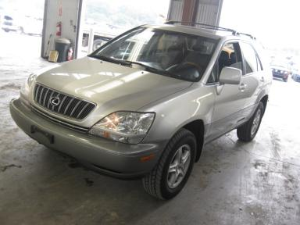 | 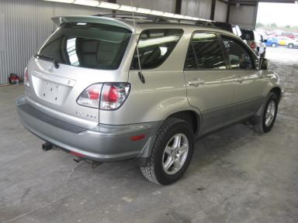
  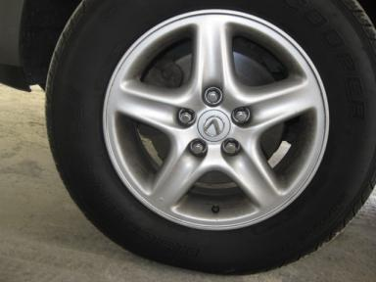 | 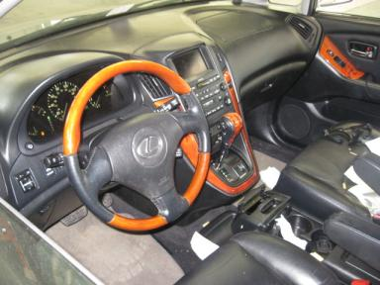
  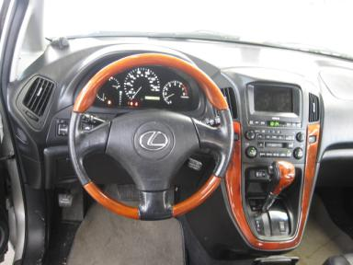 | 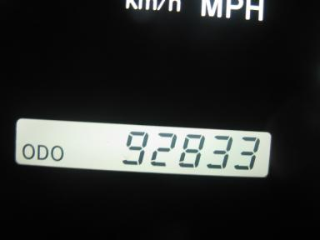
  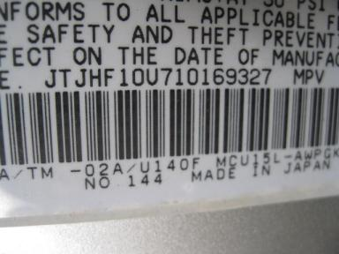
  
  Grade 2.9 Below Average
  More About Auto Grade
  MMR: - ¤ 10 393
  MSRP - Not Available
  Certified - No
  Drivable - Yes

VEHICLE INFORMATION
OPTIONS
Pwr Lock  Tilt Steering  CD Player  Power Mirrors  Fog Lamps  NO Rear Air Conditioning  5 Passenger Seating  Trailer Hitch  Woodgrain Interior Package |  | Pwr Steering  A/C  Side Air Bags  ABS Brakes  Trip Counter  Trip Computer  Floor Mats  Traction Control  Navigation System |  | Pwr Window  Cruise Ctl  Dual Air Bags  Tinted Windows  CD Changer  Luggage Rack  Spoiler  HomeLink |  | Pwr Seats - Both  Rear Defrost  50 State Emissions  4 Door  Rear Wiper  NO Third Seat  Security System  Heated Seats

MECHANICAL | INTERIOR
  6 Cylinder Gas
  Automatic
  AWD
  Pwr Brakes
  3.0 L
  Odometer - 6 Digits Digital - Operable
  Stained
  BLK - Leather
  Int Odor: OK
  Wood Trim Dash
TIRES AND WHEELS
  Tire Condition: | Good | Wheels: | Alloy
  Tire | Tread Depth | Brand | Size
  Left Front: | 8/32" | COOPER | 225/70R16
  Left Rear: | 8/32" | COOPER | 225/70R16
  Right Front: | 8/32" | COOPER | 225/70R16
  Right Rear: | 8/32" | COOPER | 225/70R16
  Spare: | 0/32" | (Mini)
  KEYS
  Combo Key - 1
  OTHER
  Title State: VA
  Title Date: 09/03/2009

ADDITIONAL INFORMATION
Common Abbreviations

DAMAGES - SUGGESTED REPAIRS
Suggested repairs are based on Manheim professional inspector's recommendation.
Total labor hours include paint, body or repair estimates.
 | DESCRIPTION | CONDITION | SEVERITY | SUGGESTED  REPAIR | TOTAL  LABOR  HOURS
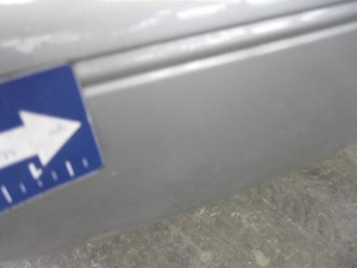 | Front Bumper | Peeling | 3" to 4" | Refinish | 6.50
 | Hood | Multiple Chips | 4 | Paint Chip Repair | .00
 | LF Fender | Chipped | 3 | Paint Chip Repair | .00
 | LF Door | Chipped | 2 | Paint Chip Repair | .00
 | LF Door | Dent/No Paint Dmg | PDR/3 | PDR | .00
 | LF Door Molding | Chipped | 2 | Paint Chip Repair | .00
 | LR Door | Dent/No Paint Dmg | PDR/3 | PDR | .00
 | L Qtr Panel | Chipped | 2 | Paint Chip Repair | .00
 | L Qtr Panel | Dent/No Paint Dmg | PDR/3 | PDR | .00
 | L Qtr Panel | Scratch Light | 1" to 2" | Wet Sand | .00
 | Rear Door | Dent/No Paint Dmg | PDR/2 | PDR | .00
 | Rear Door | Scratch Light | 2" to 3" | Wet Sand | .00
 | Rear Bumper | Scratch Light | 1" to 2" | Wet Sand | .00
 | RF Fender | Chipped | 2 | Paint Chip Repair | .00
 | RF Fender | Scratch Light | 2" to 3" | Wet Sand | .00
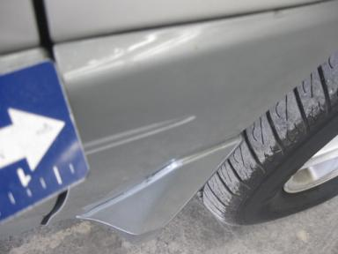 | RF Fender Moldi | Peeling | Repair Required | Refinish | 2.30
 | RF Door | Dent/No Paint Dmg | PDR/3 | PDR | .00
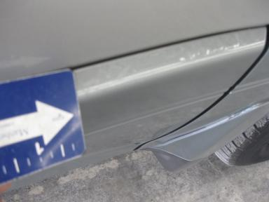 | RF Door Molding | Peeling | 2" to 3" | Refinish | 3.30
 | RR Door | Dent/No Paint Dmg | PDR/3 | PDR | .00
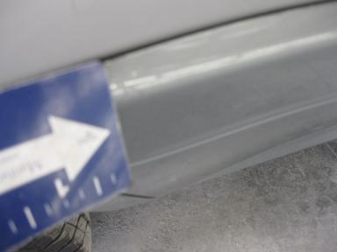 | RR Door Molding | Peeling | 1" to 2" | Refinish | 2.60
 | R Qtr Panel | Dent/No Paint Dmg | PDR/3 | PDR | .00
 | R Qtr Panel | Scratch Light | 1" to 2" | Wet Sand | .00
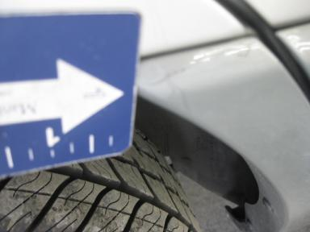 | R Qtr Panel Mol | Peeling | 1" to 2" | Refinish | 2.20
 | Warranty Books | Missing | Replacement Req | Replace | .00
 | Owners manuals | Missing | Replacement Req | Replace | .00
 | Maintenance Boo | Missing | Replacement Req | Replace | .00
 | Front Bumper | Prev Repair | Acceptable | No Action Required | .00
 | Hood | Prev Repair | Acceptable | No Action Required | .00
 | Rear Bumper | Prev Repair | Acceptable | No Action Required | .00
 |  |  |  | TOTALS | 16.90

VIN: JTJHF10U710169327, Work Order: 5204997


© 2009 Manheim All Rights Reserved

