Manheim San Francisco Bay
29900 Auction Ct
Hayward, CA 94544-6914
(510) 786-4500

VEHICLE DETAILS - 2006 BMW X5 4.4L
VIN: | 5UXFB53506LV27034 | Body Style: | 4CUV | Top Type: | Panoramic
Ext Color: | BLACK SA- 475 | Int Color: | BLA | Odometer: | 119,310 miles
Work Order: | 3226563 | Seller: | FINANCIAL SERVICES REMARKETING (LEASE) | Received Date: | 08/11/2009
Sale Number: | 38 | Lane Number: | 24 | Run Number: | 191
Inspector: | OCORONA 08/17/2009 | InService Date: | 06/30/2006

VEHICLE IMAGES
 |  |  | GRADING
  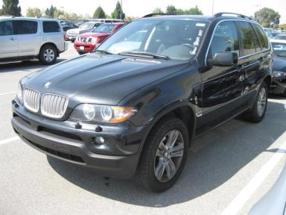 | 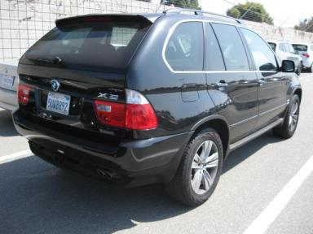
  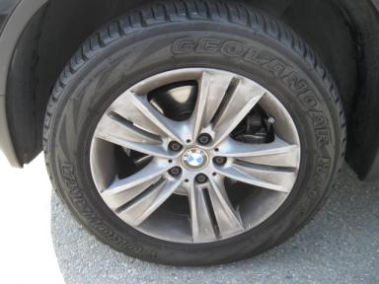 | 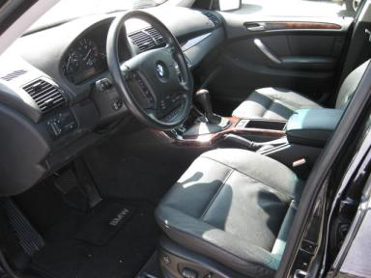
  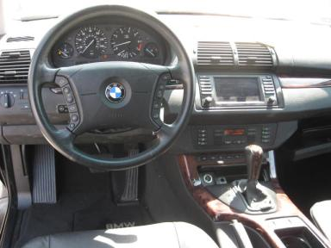 | 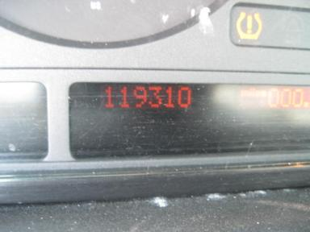
  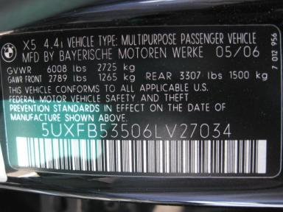
  
  Grade 3.1 Average
  More About Auto Grade
  MMR: - ¤ 20 831
  MSRP - Not Available
  Certified - No
  Drivable - Yes

VEHICLE INFORMATION
OPTIONS
Pwr Lock  A/C  Side Air Bags  Power Folding Mirrors  Trip Counter  Luggage Rack  DSC-Dynamic Stability Control  Dual Air Conditioning  Heated Seats  Rain Sensor  Heated Steering Wheel  Parking Distance Control  Heated Seats - Front |  | Pwr Steering  Cruise Ctl  Dual Air Bags  Owner's Manual  CD Changer  Floor Mats  Steering Wheel Audio Control  HDC - Hill Descent Control  Cargo Cover  Power Telescopic Steering  Navigation System  Adaptive Xenon Lights |  | Pwr Window  Rear Defrost  50 State Emissions  ABS Brakes  Rear Wiper  BiXenon Headlights  HSW - Heated Steering Wheel  HomeLink  Memory Seat  Panoramic Glass Roof  Rain Sensor Windshield  Sunshade - Manual |  | Pwr Seats - Both  Tape/CD  Power Mirrors  Fog Lamps  Cold Weather Package  US EPA Label  Panoramic Glass Roof  Premium Package  Comfort Seats  Power Tilt Steering  Directional Stability Control  Power Seats - Dual

MECHANICAL | INTERIOR
  8 Cylinder Gas
  Automatic
  AWD
  Pwr Brakes
  4.4 L
  Average
  BLA - Leather
  Int Odor: OK
  Wood Trim Dash
TIRES AND WHEELS
  Tire Condition: |  | Wheels: | Alloy
  Tire | Tread Depth | Brand | Size
  Left Front: | 6/32" | YOKOHAMA | 255/55R18
  Left Rear: | 4/32" | YOKOHAMA | 255/55R18
  Right Front: | 5/32" | YOKOHAMA | 255/55R18
  Right Rear: | 5/32" | YOKOHAMA | 255/55R18
  Spare: | 10/32" | MICHELIN(Mini) | 235/65R17
  KEYS
  Master Key - 1
  OTHER
  Title State: CA
  Title Date: 08/12/2009

ADDITIONAL INFORMATION
CS;CWP;HSW;NAV;PDC;PREM PKG, AS IS OVER 100K
*CCF 08/12/09*SPT PKG*DMV$976*N
Common Abbreviations

DAMAGES - SUGGESTED REPAIRS
Suggested repairs are based on Manheim professional inspector's recommendation.
Total labor hours include paint, body or repair estimates.
 | DESCRIPTION | CONDITION | SEVERITY | SUGGESTED  REPAIR | TOTAL  LABOR  HOURS
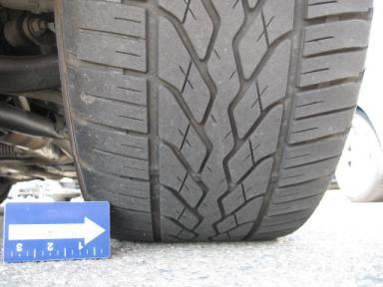 | LF Tire | Cupped | None | Replace | .00
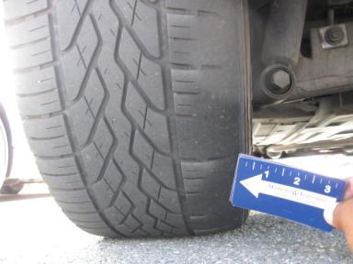 | LR Tire | Cupped | None | Replace | .00
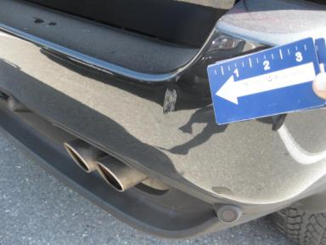 | Rear Bumper Cov | Dent/Paint Dmg 1 ON EACH SIDE | 2" to 3" | Repair | 6.30
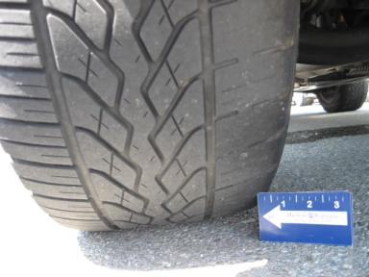 | RF Tire | Cupped | None | Replace | .00
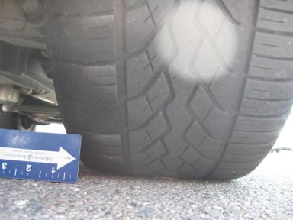 | RR Tire | Cupped | None | Replace | .00
 | Warning - Tire | On TIRES NEED PRESSURE | None | Mech Ck/Not Approved | 1.00
 | Front Bumper Co | Prev Repair | Acceptable | No Action Required | .00
 | LF Fender | Dent/No Paint Dmg | PDR/1 | PDR | .00
 | LF Door | Dent/No Paint Dmg | PDR/2 | PDR | .00
 | Lift Gate | Dent | Less 1" | Repair | 3.50
 | Rear Bumper Cov | Prev Repair | Acceptable | No Action Required | .00
 | RF Wheel | Curb Rash | 5" to 6" | Trim/Sublet | .00
 |  |  |  | TOTALS | 10.80

VIN: 5UXFB53506LV27034, Work Order: 3226563


© 2009 Manheim All Rights Reserve

