Manheim Pennsylvania
1190 Lancaster Rd
Manheim, PA 17545-9789
(717) 665-3571

VEHICLE DETAILS - 2002 TOYOTA LAND CRUISER
VIN: | JTEHT05J022022398 | Body Style: | 4SUV | Top Type: | Pwr Glass Sun Roof
Ext Color: | GREY | Int Color: | GRY | Odometer: | 121,844 miles
Work Order: | 8646524 | Seller: | DAB INTERNATIONAL INC | Received Date: | 09/05/2009
Sale Number: | 57 | Lane Number: | 14 | Run Number: | 764
Inspector: | WKEPERLING 09/08/2009

VEHICLE IMAGES
 |  |  | GRADING
  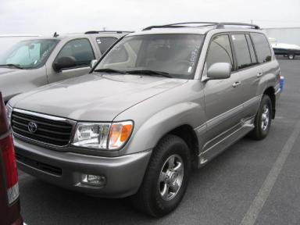 | 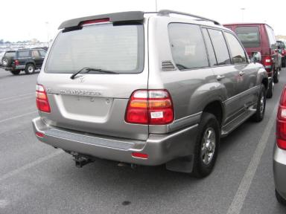
  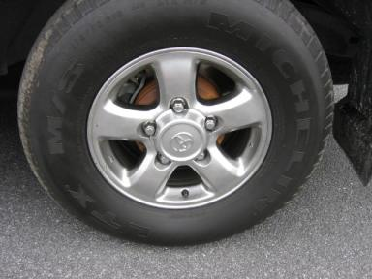 | 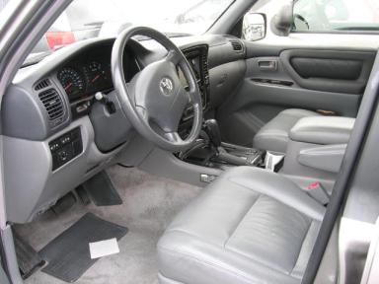
  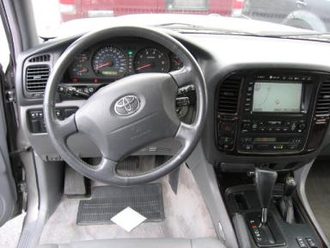 | 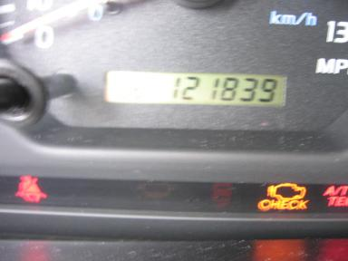
  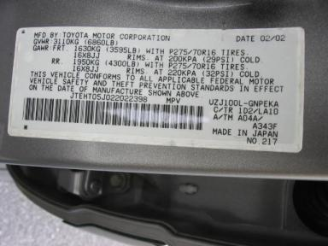
  
  Grade 4.1 Clean
  More About Auto Grade
  MMR: - ¤ 15 524
  MSRP - Not Available
  Certified - No
  Drivable - Yes

VEHICLE INFORMATION
OPTIONS
Pwr Lock  Tilt Steering  Cassette Tape  Heated Mirrors  Fog Lamps  Rear Wiper  7 Passenger Seating  Steering Wheel Audio Control  HomeLink |  | Pwr Steering  A/C  Dual Air Bags  Owner's Manual  Trip Counter  Trip Computer  Security System  Power Antenna  Heated Seats |  | Pwr Window  Cruise Ctl  50 State Emissions  ABS Brakes  Rear Air Conditioning  Third Seat  Power Vent Windows  Trailer Hitch  Woodgrain Interior Package |  | Pwr Seats - Both  Rear Defrost  Power Mirrors  Tinted Windows  CD Changer - OEM - 6.00  Luggage Rack  Running Board  Traction Control  Navigation System

MECHANICAL | INTERIOR
  8 Cylinder Gas
  Automatic
  4X4
  Pwr Brakes
  4.7 L
  Average
  GRY - Leather
  Int Odor: OK
  Regular Dash
TIRES AND WHEELS
  Tire Condition: | Good | Wheels: | Alloy
  Tire | Tread Depth | Brand | Size
  Left Front: | 9/32" | MICHELIN | 275/70R16
  Left Rear: | 6/32" | MICHELIN | 275/70R16
  Right Front: | 9/32" | MICHELIN | 275/70R16
  Right Rear: | 6/32" | MICHELIN | 275/70R16
  Spare: | 6/32" | MICHELIN | 275/70R16
  KEYS
  Spare Key - 1
  Combo Key - 1
  OTHER
  Title State: NC
  Title Date: 09/18/2009

ADDITIONAL INFORMATION
Common Abbreviations

DAMAGES - SUGGESTED REPAIRS
Suggested repairs are based on Manheim professional inspector's recommendation.
Total labor hours include paint, body or repair estimates.
 | DESCRIPTION | CONDITION | SEVERITY | SUGGESTED  REPAIR | TOTAL  LABOR  HOURS
 | Front Bumper | Mult Scratches | GR 12" | Refinish | 3.10
 | RR Door | Scratched | 1" to 2" | Airbrush | .00
 | R Qtr Panel | Scratched | 2" to 3" | Refinish | 3.10
 | LF Fender | Prev Repair | Acceptable | No Action Required | .00
 |  |  |  | TOTALS | 6.20

VIN: JTEHT05J022022398, Work Order: 8646524

