Manheim Pennsylvania
1190 Lancaster Rd
Manheim, PA 17545-9789
(717) 665-3571

VEHICLE DETAILS - 2001 LEXUS LX470
VIN: | JTJHT00W013502132 | Body Style: | 4MPV | Top Type: | Sun Roof
Ext Color: | SILVER | Int Color: | GRY | Odometer: | 130,961 miles
Work Order: | 7435690 | Seller: | R M HOLLENSHEAD AUTO SALES INC | Received Date: | 09/10/2009
Sale Number: | 57 | Lane Number: | 22 | Run Number: | 173
Inspector: | JMARTIN 09/16/2009

VEHICLE IMAGES
 |  |  | GRADING
  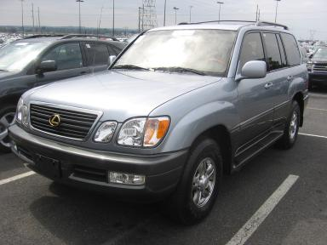 | 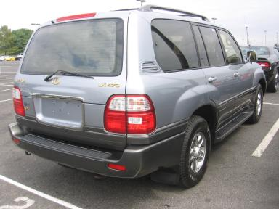
  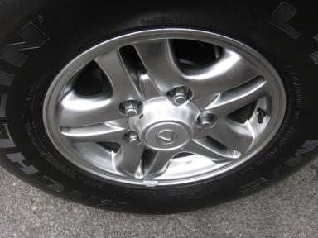 | 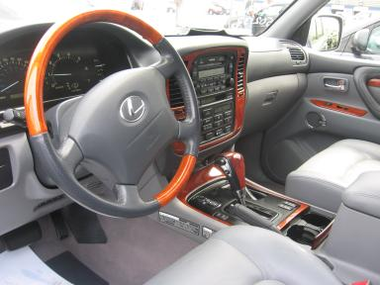
  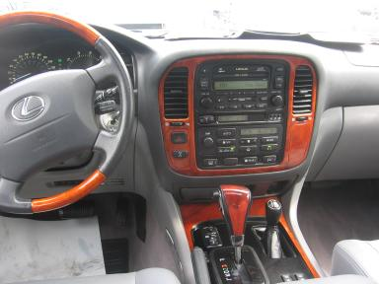 | 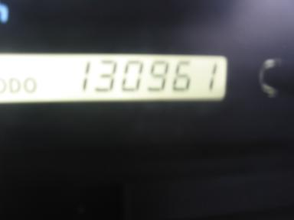
  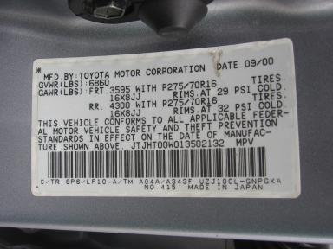
  
  Grade 3.4 Average
  More About Auto Grade
  MMR: - ¤ 13 829
  MSRP - Not Available
  Certified - No
  Drivable - Yes

VEHICLE INFORMATION
OPTIONS
Pwr Lock  A/C  Dual Air Bags  Owner's Manual  4 Door  Rear Wiper  8 Passenger Seating  Heated Seats  Gold Package |  | Pwr Steering  Cruise Ctl  50 State Emissions  ABS Brakes  Fog Lamps  Third Seat  Running Board  Wheel Locks  Woodgrain Interior Package |  | Pwr Window  Rear Defrost  Power Mirrors  Premium Stereo - MAR/LEVIN  Trip Counter  Luggage Rack  Traction Control  Memory Seat  Power Telescopic Steering |  | Pwr Seats - Both  Tape/CD  Heated Mirrors  Tinted Windows  CD Changer - MAR/LEVIN - 6.00  US EPA Label  HomeLink  DVD with Screen  Power Tilt Steering

MECHANICAL | INTERIOR
  8 Cylinder Gas
  Automatic
  4X4
  Pwr Brakes
  4.7 L
  Average
  GRY - Leather
  Int Odor: OK
  Wood Trim Dash
TIRES AND WHEELS
  Tire Condition: | Good | Wheels: | Alloy
  Tire | Tread Depth | Brand | Size
  Left Front: | 12/32" | MICHELIN | 275/70R16
  Left Rear: | 13/32" | MICHELIN | 275/70R16
  Right Front: | 12/32" | MICHELIN | 275/70R16
  Right Rear: | 12/32" | MICHELIN | 275/70R16
  Spare: | 14/32" |  | 275/70R16
  KEYS
  Master Key - 1
  Remote Key/Fob - 1
  OTHER
  Title State:
  Title Date: N/A

ADDITIONAL INFORMATION
T/A OVER100K GOOD CAR FAX
***HOLDING GP FOR PAYMENT
Common Abbreviations

DAMAGES - SUGGESTED REPAIRS
Suggested repairs are based on Manheim professional inspector's recommendation.
Total labor hours include paint, body or repair estimates.
 | DESCRIPTION | CONDITION | SEVERITY | SUGGESTED  REPAIR | TOTAL  LABOR  HOURS
 | LF Wheel | Scratched | 2" to 3" | Repair | .00
 | LF Door | Ding | PDR/1 | PDR | .00
 | LR Door | Ding | PDR/1 | PDR | .00
 | L Qtr Panel | Scratched | 1" to 2" | Airbrush | .00
 | LR Wheel | Scratched | > 1/8" | Repair | .00
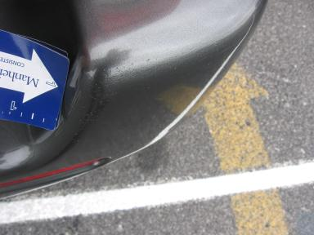 | Rear Bumper | Prev Repair | Substd Repair | Repair | 5.10
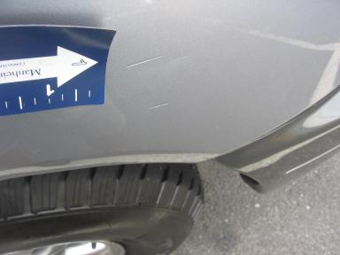 | RF Fender | Dent/Paint Dmg | Less 1" | Repair | 4.60
 | RR Door | Scratch Light | 2" to 3" | Wet Sand | .00
 | Front Bumper | Prev Repair | Acceptable | No Action Required | .00
 | Hood | Prev Repair | Acceptable | No Action Required | .00
 | LF Fender | Replaced | Acceptable | No Action Required | .00
 | Rear Bumper | Dent | 1" to 2" | Included | .00
 | RF Fender | Prev Repair | Acceptable | No Action Required | .00
 | RF Fender | Scratches | 1" to 2" | Included | .00
 |  |  |  | TOTALS | 9.70

VIN: JTJHT00W013502132, Work Order: 7435690



