2002 MITSUBISHI MONTERO LTD - SILVER
VIN: JA4MW51R82J033216 Work Order: 486442
Manheim Missouri 2944 W Sunshine St
Springfield, MO 65807-1099
(417) 882-1666

VIN:
  JA4MW51R82J033216
  Body Style: | 4SUV - Sun Roof
  Ext Color/Code: | SILVER
  Int Color/Code: | BLK
  Odometer: | 130,016
  ECM Mileage:
  Seller: | WELLS FARGO AUTO FINANCE/TEMPE
  Title State: | WI
  Certified: | No
  Condition/Grade: | 2.0, Below Average
  Sale: | 34
  Lane: | 7
  Run: | 81
  Inspection: | MCORDRAY 08/24/2009
  Cyberlot: | No
  Drivable: | Yes
  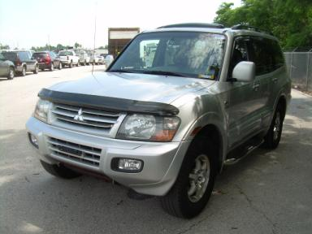
  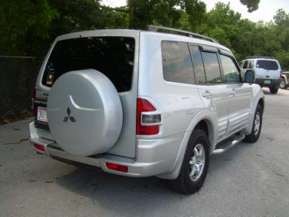
  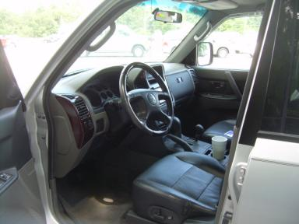 | 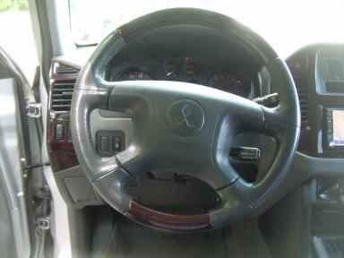
  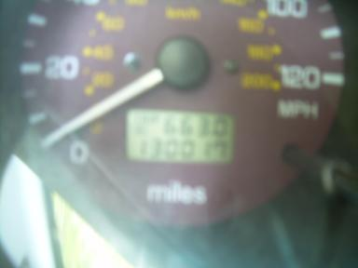 | 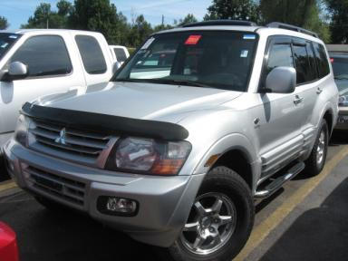
  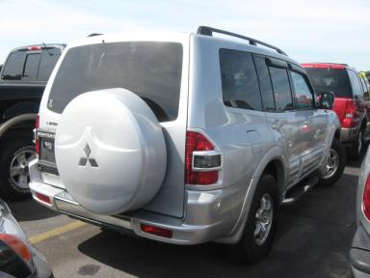 | 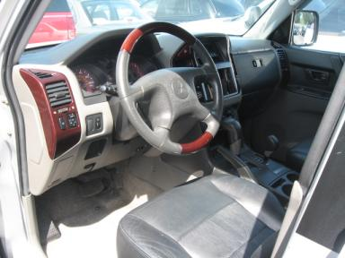
  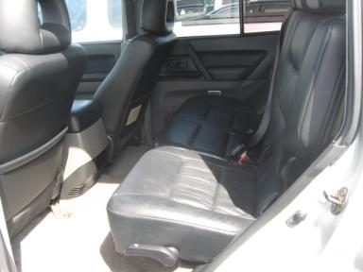 | 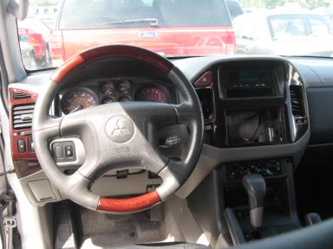

VEHICLE INFORMATION
  MECHANICAL
  6 Cylinder Gas
  Automatic
  4X4
  Pwr Brakes
  3.5 L
  INTERIOR
  Odometer - 6 Digits Digital Operable
  Average
  BLK - Leather
  Int Odor: OK
  Regular Dash
  OPTIONS
  Pwr Lock  Pwr Window  Tilt Steering  Cruise Ctl  CD Player  Dual Air Bags  Tinted Windows  Fog Lamps  Rear Wiper  Luggage Rack  Floor Mats  Power Antenna  Panoramic Glass Roof  Rain Sheilds |  | Pwr Steering  Pwr Seats - Drivers Only  A/C  Rear Defrost  Side Air Bags  Power Mirrors  4 Door  Trip Counter  Power Trunk/Liftgate  Keyless Entry  Running Board  Bug Deflector  Heated Seats
FLUID LEVELS
Fuel Level: Empty

  TIRES AND WHEELS
  Tire | Tread Depth | Brand | Size
  Left Front: | 8/32" | GOODYEAR | 265/70R16
  Left Rear: | 8/32" | GOODYEAR | 265/70R16
  Right Front: | 8/32" | GOODYEAR | 265/70R16
  Right Rear: | 8/32" | GOODYEAR | 265/70R16
  Spare: | 10/32" | GOODYEAR
  Tire Condition: Good
  Wheels: Alloy
  KEYS
  Master Key - 1
  Remote Key/Fob - 1

ANNOUNCED CONDITION: 4X4/3RD ST/AS IS--MLS OVER
INTERNET REMARKS:
REMARKS/ADDITIONAL DAMAGE:
DISCLOSURES:
NOTES TO CONSIGNOR:
REMARKS:
COMMENTS FOR CONSIGNOR:

2002 MITSUBISHI MONTERO LTD - SILVER
VIN: JA4MW51R82J033216 Work Order: 486442
Manheim Missouri 2944 W Sunshine St
Springfield, MO 65807-1099
(417) 882-1666

DAMAGES
 | DESCRIPTION | CONDITION | SEVERITY | REPAIR  HOURS | PAINT  HOURS | PART  HOURS | TOTAL  HOURS
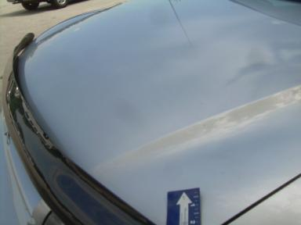 | Hood | Multiple Chips | 10 or More | .00 | 3.60 | .00 | 3.60
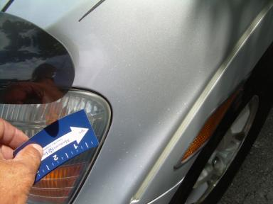 | LF Fender | Multiple Chips | 10 or More | .00 | 2.80 | .00 | 2.80
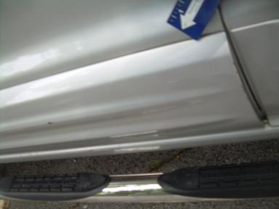 | LF Door Molding | Multiple Dmg | Repair Required | .00 | 1.40 | .00 | 1.40
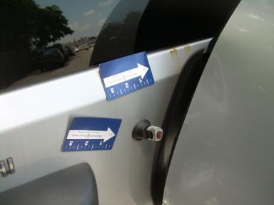 | Lift Gate | Mult Scratches | Repair Required | .00 | 4.00 | .00 | 4.00
 | Rear Wiper | Missing | Replacement Req | .00 | .00 | .20 | .20
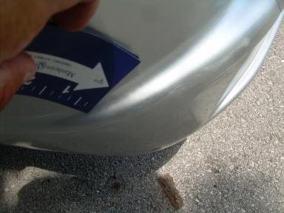 | Left Rear Bumpe | Mult Scratches | 1" to 2" | .00 | 1.00 | .00 | 1.00
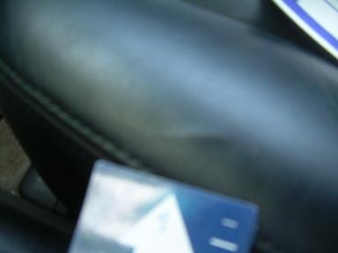 | RF Seat Cushion | Cut | Repair Required | .00 | .00 | .00 | .00
 | Warranty Books | Missing | Replacement Req | .00 | .00 | .00 | .00
 | Owners manuals | Missing | Replacement Req | .00 | .00 | .00 | .00
 | Engine | Idle Rough | Repair Required | .00 | .00 | .00 | .00
 | LF Door | Dent/No Paint Dmg | PDR/1 | .00 | .00 | .00 | .00
 | RF Fender | Repainted | Acceptable | .00 | .00 | .00 | .00
 |  |  | TOTALS | .00 | 12.80 | .20 | 13.00

