2004 LEXUS GX470 - SILVER
VIN: JTJBT20X440056406 Work Order: 6053458
Manheim Orlando 11801 W Colonial Dr
Ocoee, FL 34761-3328
(407) 656-6200

VIN:
  JTJBT20X440056406
  Body Style: | 4SUV - Sun Roof
  Ext Color/Code: | SILVER
  Int Color/Code: | GRA
  Odometer: | 88,440
  ECM Mileage:
  Seller: | LEXUS FINANCIAL SERVICES/NASHVILLE
  Title State: | GA
  Certified: | No
  Condition/Grade: | 3.0, Average
  Sale: | 39
  Lane: | 18
  Run: | 43
  Inspection: | RBEVILACQU 07/02/2009
  Drivable: | Yes
  Factory Category: | R
  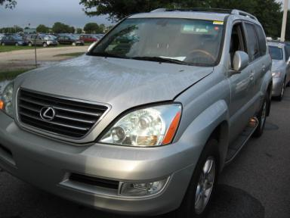 | 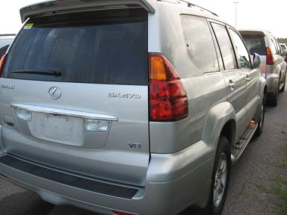
  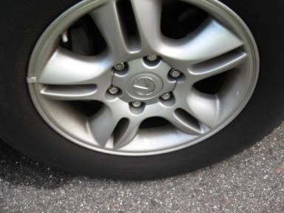 | 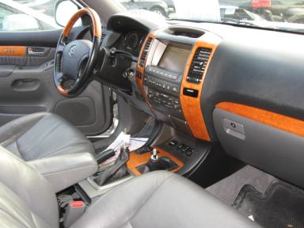
  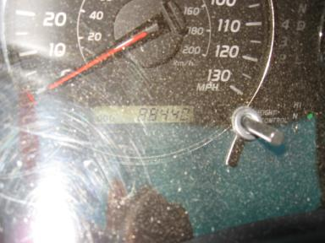 | 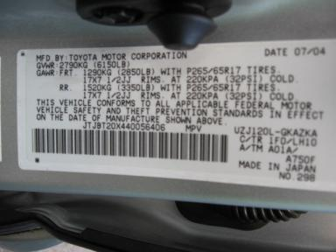
  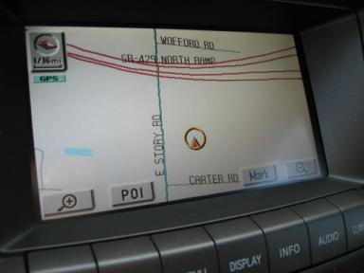

VEHICLE INFORMATION
  MECHANICAL
  8 Cylinder Gas
  Automatic
  4X4
  Pwr Brakes
  4.7 L
  INTERIOR
  Odometer - 6 Digits Digital Operable
  Average
  GRA - Leather
  Int Odor: OK
  Wood Trim Dash
  OPTIONS
  Pwr Lock  Pwr Window  Tilt Steering  Cruise Ctl  Cassette Tape  Dual Air Bags  Owner's Manual  Premium Stereo - MARK LEVINSON  Trip Counter  CD Changer  Third Seat  Floor Mats  Steering Wheel Audio Control  Dual Air Conditioning  Heated Seats  Memory Seat  Woodgrain Interior Package  Power Tilt Steering |  | Pwr Steering  Pwr Seats - Both  A/C  Rear Defrost  Side Air Bags  Power Mirrors  ABS Brakes  Fog Lamps  Rear Air Conditioning  Rear Wiper  Luggage Rack  8 Passenger Seating  Auto-Suspension  HomeLink  Wheel Locks  Rear View Camera  Power Telescopic Steering  Navigation System
FLUID LEVELS
Fuel Level: Empty

  TIRES AND WHEELS
  Tire | Tread Depth | Brand | Size
  Left Front: | 6/32" | MICHELIN | 265/65R17
  Left Rear: | 6/32" | MICHELIN | 265/65R17
  Right Front: | 5/32" | MICHELIN | 265/65R17
  Right Rear: | 5/32" | MICHELIN | 265/65R17
  Spare: | 7/32" | MICHELIN
  Tire Condition: Average
  Wheels: Alloy
  KEYS
  Master Key - 1

ANNOUNCED CONDITION: LA,DC,MO,GPS, Buyer Fee includes a $10 TFS/LFS Administrative Fee.
INTERNET REMARKS:
REMARKS/ADDITIONAL DAMAGE:
DISCLOSURES:
NOTES TO CONSIGNOR: *1 MST 1 VAL KNOB 3RD SEAT
REMARKS: *1 MST 1 VAL KNOB 3RD SEAT
COMMENTS FOR CONSIGNOR:

2004 LEXUS GX470 - SILVER
VIN: JTJBT20X440056406 Work Order: 6053458
Manheim Orlando 11801 W Colonial Dr
Ocoee, FL 34761-3328
(407) 656-6200

DAMAGES
 | DESCRIPTION | CONDITION | SEVERITY | REPAIR  HOURS | PAINT  HOURS | PART  HOURS | TOTAL  HOURS
 | Warning - Tire | On | Repair Required | .00 | .00 | .00 | .00
 | Warning - Maint | On | Repair Required | .00 | .00 | .00 | .00
 | Front Bumper | Prev Repair | Acceptable | .00 | .00 | .00 | .00
 | Hood | Chipped | Surface Damage | .00 | .00 | .00 | .00
 | LF Door Molding | Scratched | Less 1" | .00 | .00 | .00 | .00
 | L Qtr Panel | Dent/Paint Dmg | Less 1" | .00 | .00 | .00 | .00
 | LR Bumper Cover | Mult Scratches | Less 1" | .00 | .00 | .00 | .00
 | RF Door | Poor Repair | Substd Repair | .00 | .00 | .00 | .00
 | RR Door | Poor Repair | Substd Repair | .00 | .00 | .00 | .00
 |  |  | TOTALS | .00 | .00 | .00 | .00



