004 LEXUS GX470 - BLACK
VIN: JTJBT20XX40049346 Work Order: 197733
Manheim Atlanta 4900 Buffington Rd
Atlanta, GA 30349
(404) 762-9211

VIN:
  JTJBT20XX40049346
  Body Style: | 4SUV - Moon Roof
  Ext Color/Code: | BLACK
  Int Color/Code: | TAN
  Odometer: | 254,881
  ECM Mileage:
  Seller: | H T AUTO INC
  Certified: | No
  Condition/Grade: | 2.7 , Below Average
  Sale: | 39
  Lane: | 9
  Run: | 30
  Inspection: | AWYCUFF 09/17/2009
  Cyberlot: | No
  Drivable: | Yes
   | 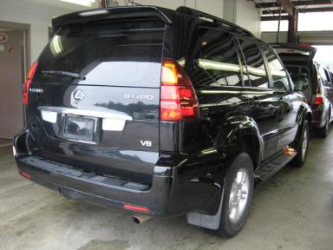
  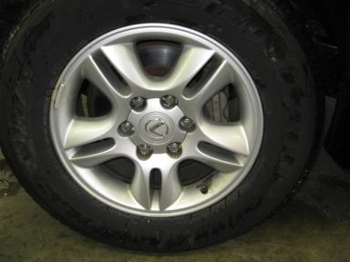 | 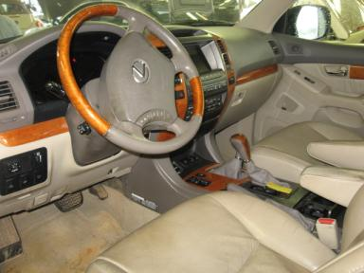
  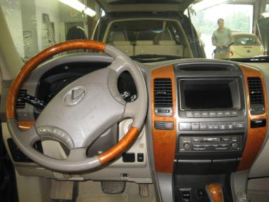 | 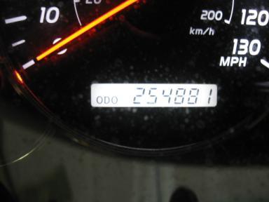
  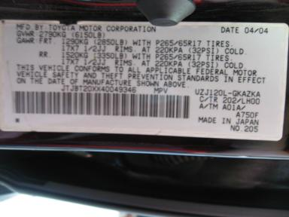

VEHICLE INFORMATION
  MECHANICAL
  8 Cylinder Gas
  Automatic
  4X4
  Pwr Brakes
  4.7 L
  INTERIOR
  Odometer - 6 Digits Digital Operable
  Dirty
  TAN - Leather
  Int Odor: OK
  Wood Trim Dash
  OPTIONS
  Pwr Lock  Pwr Window  Tilt Steering  Cruise Ctl  Cassette Tape  50 State Emissions  ABS Brakes  Fog Lamps  Rear Air Conditioning  Rear Wiper  Luggage Rack  Spoiler  Running Board  Traction Control  HomeLink  Rear View Camera  Power Telescopic Steering  Navigation System |  | Pwr Steering  Pwr Seats - Both  A/C  Rear Defrost  Dual Air Bags  Power Mirrors  4 Door  Trip Counter  CD Changer - OEM - 6.00  Third Seat  Floor Mats  7 Passenger Seating  Steering Wheel Audio Control  Dual Air Conditioning  Memory Seat  Woodgrain Interior Package  Power Tilt Steering  First Aid Kit
FLUID LEVELS
Fuel Level: Unknown

  TIRES AND WHEELS
  Tire | Tread Depth | Brand | Size
  Left Front: | 11/32" | BRIDGESTONE | 265/65R17
  Left Rear: | 5/32" | BRIDGESTONE | 265/65R17
  Right Front: | 4/32" | BRIDGESTONE | 265/65R17
  Right Rear: | 5/32" | BRIDGESTONE | 265/65R17
  Spare: | 7/32" | CONTINENTAL
  Tire Condition: Average
  Wheels: Alloy
  KEYS
  Master Key - 1

ANNOUNCED CONDITION: GRN LITE T/A M/O BUT RITE
INTERNET REMARKS:
REMARKS/ADDITIONAL DAMAGE:
DISCLOSURES:
NOTES TO CONSIGNOR:
REMARKS:
COMMENTS FOR CONSIGNOR:

2004 LEXUS GX470 - BLACK
VIN: JTJBT20XX40049346 Work Order: 197733
Manheim Atlanta 4900 Buffington Rd
Atlanta, GA 30349
(404) 762-9211

DAMAGES
 | DESCRIPTION | CONDITION | SEVERITY | REPAIR  HOURS | PAINT  HOURS | PART  HOURS | TOTAL  HOURS
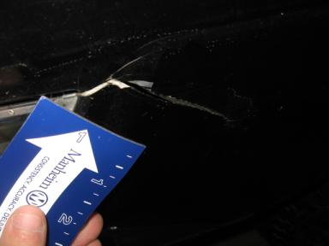 | Front Bumper | Torn | 1" to 2" | .00 | 3.60 | 1.80 | 5.40
 | Hood | Chipped | 6 | .00 | .00 | .00 | .00
 | Hood Strut | Inop | Replacement Req | 1.00 | .00 | .00 | 1.00
 | LF Fender | Prev Repair | Substd Repair | 1.00 | 3.10 | .00 | 4.10
 | LR Door | Scratch Light | Less 1" | .00 | .00 | .00 | .00
 | L Qtr Panel | Scratch Light | Less 1" | .00 | .00 | .00 | .00
 | L Fuel Door | Dent | Less 1" | 1.00 | .70 | .00 | 1.70
 | Rear Door | Scratch Light | 2" to 3" | .00 | .00 | .00 | .00
 | Rear Bumper | Scratch Light | 1" to 2" | .00 | .00 | .00 | .00
 | R Fender Flare | Scratch Light | GR 12" | .00 | .00 | .00 | .00
 | RF Door | Scratch Light | Less 1" | .00 | .00 | .00 | .00
 | RF Door Molding | Chipped | 1 | .00 | .00 | .00 | .00
 | RR Door | Scratch Light | Less 1" | .00 | .00 | .00 | .00
 | RR Door Molding | Chipped | 3 | .00 | .00 | .00 | .00
 | LF Seat Cushion | Worn | 1" to 2" | .00 | .00 | 1.00 | 1.00
 | LF Seat Back | Hole | 1" to 2" | .00 | .00 | 1.00 | 1.00
 | Warranty Books | Missing | Replacement Req | .00 | .00 | .00 | .00
 | Owners manuals | Missing | Replacement Req | .00 | .00 | .00 | .00
 | Front Bumper | Cracked | 3" to 4" | .00 | .00 | .00 | .00
 | Front Bumper | Multiple Dents | 5" to 6" | .00 | .00 | .00 | .00
 | Front Bumper | Dent/Paint Dmg | 1" to 2" | .00 | .00 | .00 | .00
 | Hood | Prev Repair | Acceptable | .00 | .00 | .00 | .00
 | LF Door | Prev Repair | Acceptable | .00 | .00 | .00 | .00
 | LR Door | Prev Repair | Acceptable | .00 | .00 | .00 | .00
 | L Qtr Panel | Prev Repair | Acceptable | .00 | .00 | .00 | .00
 | Rear Bumper | Prev Repair | Acceptable | .00 | .00 | .00 | .00
 |  |  | TOTALS | 3.00 | 7.40 | 3.80 | 14.20

