VEHICLE DETAILS - 2003 LEXUS GX470
VIN: | JTJBT20X530014020 | Body Style: | 4SUV | Top Type: | Sun Roof
Ext Color: | SILVER | Int Color: | GRY | Odometer: | 98,109
Work Order: | 1328676 | Seller: | REMARKETING BY GE/ALASKA USA FCU | Received Date: | 09/08/2009
Sale Number: | 39 | Lane Number: | 6 | Run Number: | 7
Inspector: | JPLIMLEY 09/10/2009

VEHICLE IMAGES
 |  |  | GRADING
  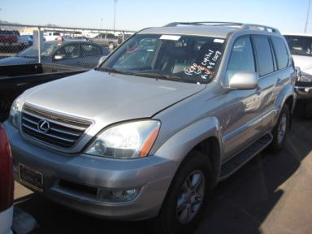 | 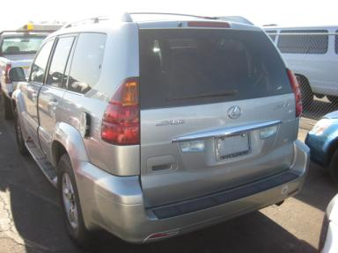
  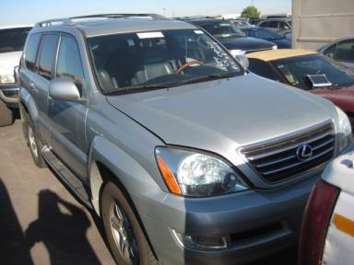 | 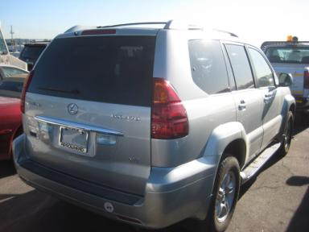
  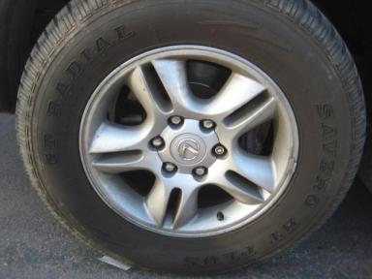 | 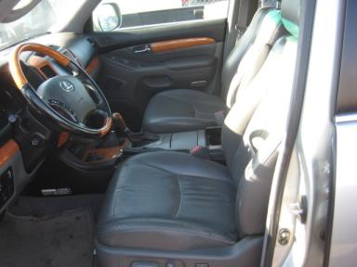
  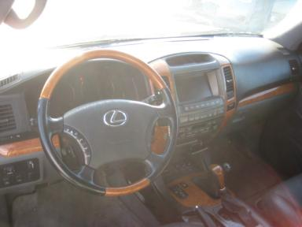 | 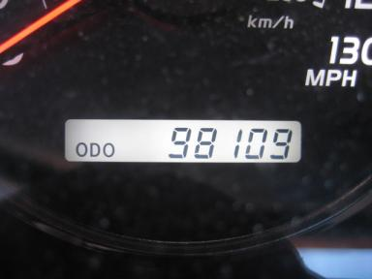
  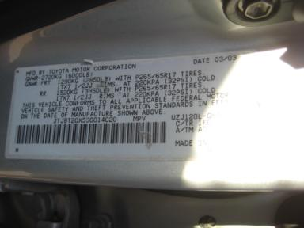 | 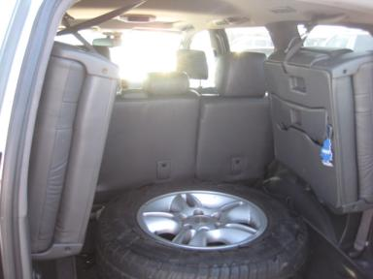
  
  Grade 2.8 Below Average
  More About Auto Grade
  MMR: - Not Available
  MSRP - Not Available
  Certified - No
  Drivable - Yes

VEHICLE INFORMATION
OPTIONS
Pwr Lock  Tilt Steering  CD Player  Power Mirrors  Premium Stereo  Maintenance Records  Rear Wiper  Luggage Rack  Step Bumper  Trailering Package  HomeLink  Navigation System |  | Pwr Steering  A/C  Side Air Bags  Heated Mirrors  Tinted Windows  Trip Counter  Warranty Books  Keyless Entry  Running Board  Traction Control  Heated Seats |  | Pwr Window  Cruise Ctl  Dual Air Bags  Owner's Manual  4 Door  Rear Air Conditioning  Trip Computer  Floor Mats  Steering Wheel Audio Control  Trailer Plug  Memory Seat |  | Pwr Seats - Both  Rear Defrost  50 State Emissions  ABS Brakes  Fog Lamps  CD Changer  Third Seat  US EPA Label  Trailer Hitch  Dual Air Conditioning  Woodgrain Interior Package

MECHANICAL | INTERIOR
  8 Cylinder Gas
  Automatic
  4X4
  Pwr Brakes
  4.7 L
  Odometer - 6 Digits Digital - Operable
  Average
  GRY - Leather
  Int Odor: OK
  Wood Trim Dash
TIRES AND WHEELS
  Tire Condition: | Average | Wheels: | Alloy
  Tire | Tread Depth | Brand | Size
  Left Front: | 10/32" | GENERIC | 265/65R17
  Left Rear: | 6/32" | MICHELIN | 265/65R17
  Right Front: | 10/32" | GENERIC | 265/65R17
  Right Rear: | 5/32" | MICHELIN | 265/65R17
  Spare: | 10/32" | PATHFINDER | 265/65R17
  KEYS
  Combo Key - 1
  OTHER
  Title State: WA
  Title Date: 09/25/2009

ADDITIONAL INFORMATION
Common Abbreviations

DAMAGES - SUGGESTED REPAIRS
Suggested repairs are based on Manheim professional inspector's recommendation.
Total labor hours include paint, body or repair estimates.
 | DESCRIPTION | CONDITION | SEVERITY | SUGGESTED  REPAIR | TOTAL  LABOR  HOURS
 | Windshield | Multiple Chips | 7 | Replace | .00
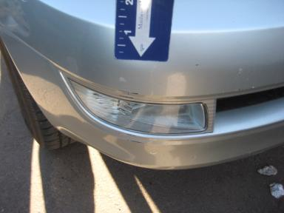 | Front Bumper Co | Mult Scratches | 2" to 3" | Refinish | 5.60
 | Headlights | Faded | 7" to 8" | Wet Sand | .00
 | Hood | Dent/No Paint Dmg | 2" to 3" | PDR | .00
 | Hood | Scratch Light | 3" to 4" | Included | .00
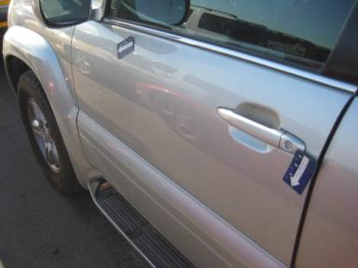 | LF Door | Multiple Dents | 2" to 3" | Repair | 7.40
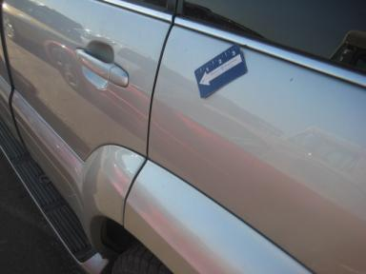 | L Qtr Panel | Dent | 1" to 2" | Repair | 6.60
 | LR Tire | Separated | None | Replace | .00
 | Rear Bumper Cov | Mult Scratches | 2" to 3" | Included | .00
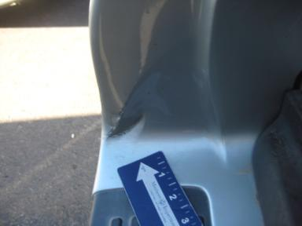 | Rear Bumper Cov | Dent/Paint Dmg | 3" to 4" | Repair | 6.60
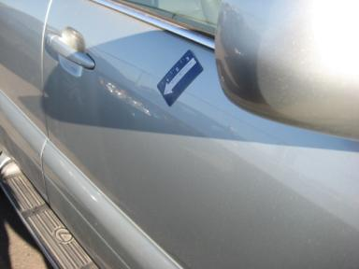 | RF Door | Dent | 1" to 2" | Repair | 6.40
 | RR Door | Dent/No Paint Dmg | 1" to 2" | PDR | .00
 | R Qtr Panel | Dent/No Paint Dmg | 1" to 2" | PDR | .00
 |  |  |  | TOTALS | 32.60

VIN: JTJBT20X530014020, Work Order: 1328676

