VEHICLE DETAILS - 2004 LEXUS RX330
VIN: | JTJHA31U640001658 | Body Style: | 4SUV | Top Type: | Sun Roof
Ext Color: | SILVER- 1C0 | Int Color: | BLK- LA22 | Odometer: | 131,903
Work Order: | 7436230 | Seller: | R M HOLLENSHEAD AUTO SALES INC | Received Date: | 09/28/2009
Sale Number: | 60 | Lane Number: | 22 | Run Number: | 140
Inspector: | JMARTIN 09/29/2009

VEHICLE IMAGES
 |  |  | GRADING
  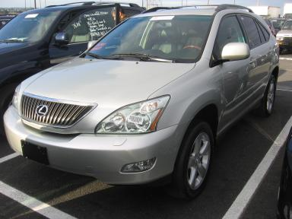 | 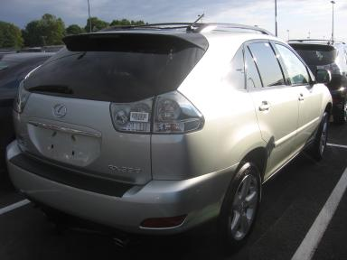
  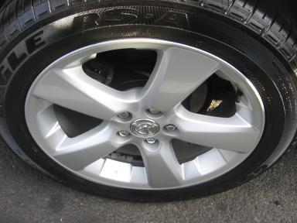 | 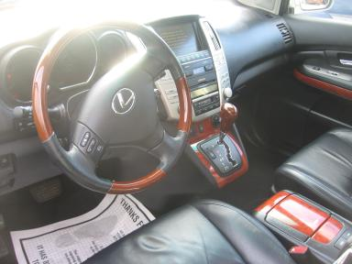
  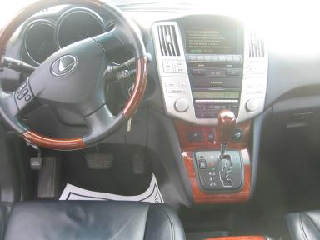 | 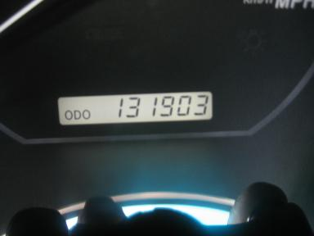
  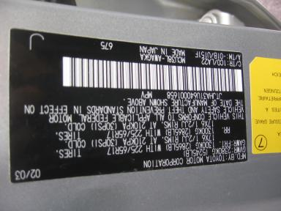
  
  Grade 2.9 Below Average
  More About Auto Grade
  MMR: - ¤ 13 814
  MSRP - Not Available
  Certified - No
  Drivable - Yes

VEHICLE INFORMATION
OPTIONS
Pwr Lock  A/C  Side Air Bags  Heated Mirrors  4 Door  Rear Wiper  Floor Mats  Steering Wheel Audio Control  Heated Seats  Rear View Camera  Navigation System |  | Pwr Steering  Cruise Ctl  Dual Air Bags  Owner's Manual  Fog Lamps  NO Rear Air Conditioning  Xenon Headlights  Traction Control  Cargo Cover  Woodgrain Interior Package  Rain Sensor Windshield |  | Pwr Window  Rear Defrost  50 State Emissions  ABS Brakes  Trip Counter  Luggage Rack  US EPA Label  Dual Air Conditioning  Wheel Locks  Power Telescopic Steering  First Aid Kit |  | Pwr Seats - Both  Tape/CD  Power Mirrors  Tinted Windows  CD Changer - OEM - 6.00  5 Passenger Seating  Security System  HomeLink  Memory Seat  Power Tilt Steering

MECHANICAL | INTERIOR
  6 Cylinder Gas
  Automatic
  AWD
  Pwr Brakes
  3.3 L
  Average
  BLK - Leather
  Int Odor: OK
  Regular Dash
TIRES AND WHEELS
  Tire Condition: | Average | Wheels: | Alloy
  Tire | Tread Depth | Brand | Size
  Left Front: | 7/32" | GOODYEAR | 235/55R18
  Left Rear: | 9/32" | GOODYEAR | 235/55R18
  Right Front: | 8/32" | GOODYEAR | 235/55R18
  Right Rear: | 9/32" | GOODYEAR | 235/55R18
  Spare: | 11/32" |  | 235/55R18
  KEYS
  Master Key - 2
  OTHER
  Title State: PA
  Title Date: 10/01/2009

ADDITIONAL INFORMATION
OVER100K, HOLDING GP FOR PAYMENT
**HOLDING GP FOR PAYMENT
Common Abbreviations

DAMAGES - SUGGESTED REPAIRS
Suggested repairs are based on Manheim professional inspector's recommendation.
Total labor hours include paint, body or repair estimates.
 | DESCRIPTION | CONDITION | SEVERITY | SUGGESTED  REPAIR | TOTAL  LABOR  HOURS
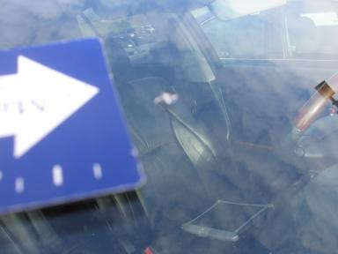 | Windshield | Star in Glass 2 STARS | > 1/8" | Replace | .00
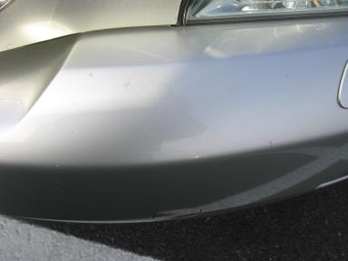 | Front Bumper | Chipped | 10 or More | Refinish | 4.50
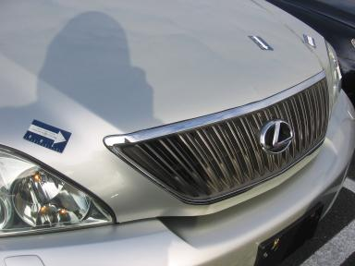 | Hood | Chipped | 10 or More | Refinish | 4.80
 | LF Door | Ding | PDR/1 | PDR | .00
 | LF Door | Scratched | Less 1" | Airbrush | .00
 | L Qtr Panel | Ding | PDR/1 | PDR | .00
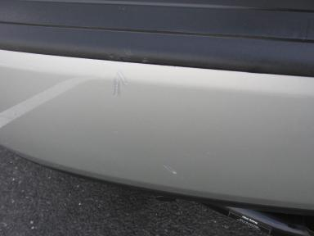 | Rear Bumper | Dent/Paint Dmg | 1" to 2" | Repair | 5.10
 | RF Door | Ding | PDR/1 | PDR | .00
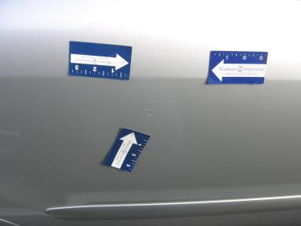 | RR Door | Poor Prior PDR | 2" to 3" | Repair | 4.80
 | Rear Bumper | Scratches | 1" to 2" | Included | .00
 | RF Door Molding | Prev Touchup | Less 1" | No Action Required | .00
 | RR Door | Scratches | Less 1" | Included | .00
 | RR Door Molding | Prev Touchup | > 1/8" | No Action Required | .00
 | R Qtr Panel | Prev Touchup | > 1/8" | No Action Required | .00
 |  |  |  | TOTALS | 19.20

VIN: JTJHA31U640001658, Work Order: 7436230



