VEHICLE DETAILS - 2003 HONDA CR-V
VIN: | JHLRD78833C013653 | Body Style: | 4CUV | Top Type: | Moon Roof
Ext Color: | SILVER | Int Color: | BLK | Odometer: | 161,212
Work Order: | 8050576 | Seller: | KIA OF OMAHA | Received Date: | 10/07/2009
Sale Number: | 40 | Lane Number: | 8 | Run Number: | 26
Inspector: | LCUNNINGH2 10/07/2009

VEHICLE IMAGES
 |  |  | GRADING
  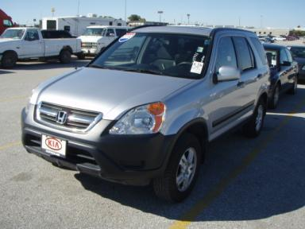 | 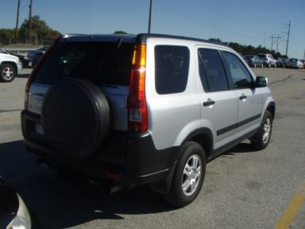
  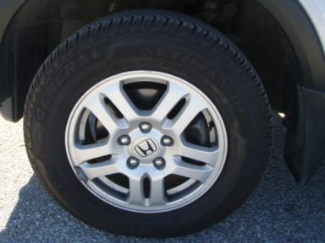 | 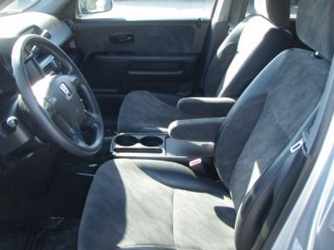
  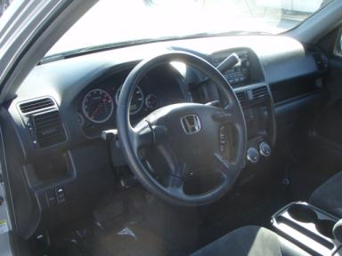 | 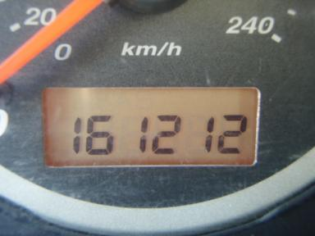
  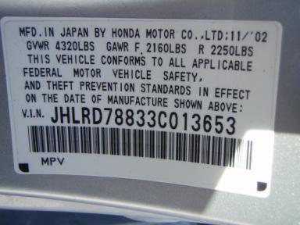
  
  Grade 3.2 Average
  More About Auto Grade
  MMR: - ¤ 5 978
  MSRP - Not Available
  Certified - No
  Drivable - Yes

VEHICLE INFORMATION
OPTIONS
Pwr Lock  A/C  Side Air Bags  NO Third Seat |  | Pwr Steering  Cruise Ctl  Dual Air Bags  US EPA Label |  | Pwr Window  Rear Defrost  Power Mirrors |  | Tilt Steering  Tape/CD  NO Rear Air Conditioning

MECHANICAL | INTERIOR
  4 Cylinder Gas
  Automatic
  AWD
  Pwr Brakes
  2.4 L
  Odometer - 6 Digits Analog - Operable
  Average
  BLK - Cloth
  Int Odor: OK
TIRES AND WHEELS
  Tire Condition: |  | Wheels:
  Tire | Tread Depth | Brand | Size
  Left Front: | 7/32" | GENERAL | 205/70R15
  Left Rear: | 9/32" | GENERAL | 205/70R15
  Right Front: | 7/32" | GENERAL | 205/70R15
  Right Rear: | 9/32" | GENERAL | 205/70R15
  Spare: | 6/32" | GENERIC | 205/70R15
  KEYS
  Master Key - 2
  OTHER
  Title State:
  Title Date: N/A

ADDITIONAL INFORMATION
AS IS
Common Abbreviations

DAMAGES - SUGGESTED REPAIRS
Suggested repairs are based on Manheim professional inspector's recommendation.
Total labor hours include paint, body or repair estimates.
 | DESCRIPTION | CONDITION | SEVERITY | SUGGESTED  REPAIR | TOTAL  LABOR  HOURS
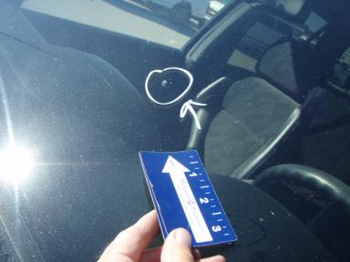 | Windshield | Star in Glass | Less 1" | Replace | .00
 | Front Bumper | Scratch Light | 1" to 2" | Wet Sand | .00
 | Hood | Multiple Chips | 10 or More | Refinish | 3.60
 | LF Fender | Multiple Chips | 5 | Paint Chip Repair | .00
 | LF Door | Dent/No Paint Dmg | PDR/1 | PDR | .00
 | LR Door | Mult Scratches | 1" to 2" | Airbrush | .00
 | L Qtr Panel | Scratch Light | Less 1" | Wet Sand | .00
 | RF Fender | Multiple Chips | 4 | Paint Chip Repair | .00
 | RF Door | Multiple Dents | PDR/3 | PDR | .00
 | RR Door | Multiple Dents | PDR/5 | PDR | .00
 | R Qtr Panel | Scratch Light | Less 1" | Wet Sand | .00
 | Warning - Engin | On | Unacceptable | Ck/Advise | 1.00
 | Owners manuals | Missing | Replacement Req | Replace | .00
 |  |  |  | TOTALS | 4.60

VIN: JHLRD78833C013653, Work Order: 8050576

