VEHICLE DETAILS - 1999 TOYOTA LAND CRUISER
VIN: | JT3HT05J6X0050377 | Body Style: | 4SUV | Top Type: | Pwr Glass Sun Roof
Ext Color: | BLACK | Int Color: | TAN | Odometer: | 146,659
Work Order: | 8641141 | Seller: | FIRST FINANCIAL CREDIT UNION | Received Date: | 09/23/2009
Sale Number: | 40 | Lane Number: | 12 | Run Number: | 31
Inspector: | IMULJANA 09/24/2009

VEHICLE IMAGES
 |  |  | GRADING
  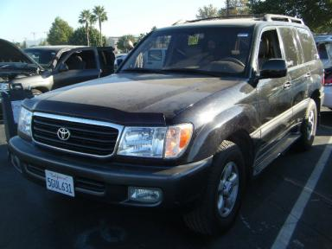 | 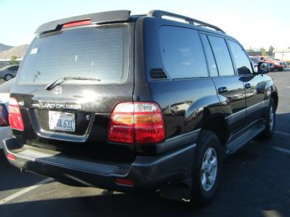
  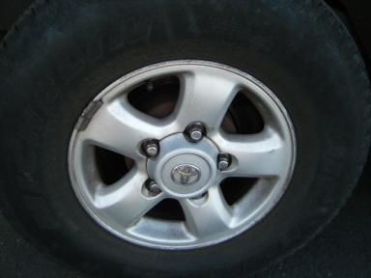 | 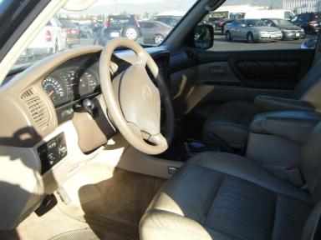
  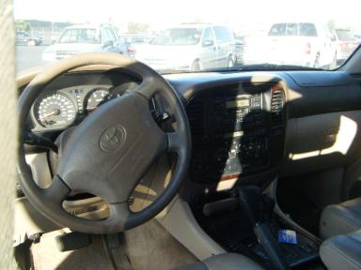 | 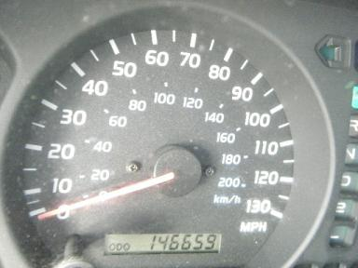
  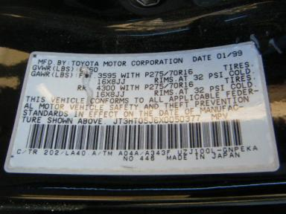
  
  Grade 2.6 Below Average
  More About Auto Grade
  MMR: - ¤ 10 289
  MSRP - Not Available
  Certified - No
  Drivable - Yes

VEHICLE INFORMATION
OPTIONS
Pwr Steering  A/C  Side Air Bags  ABS Brakes  Rear Wiper  Keyless Entry  US EPA Label  Traction Control |  | Pwr Window  Cruise Ctl  Dual Air Bags  Tinted Windows  Trip Computer  Floor Mats  Security System  Bug Deflector |  | Pwr Seats - Both  Rear Defrost  50 State Emissions  Fog Lamps  Third Seat  Spoiler  Step Bumper |  | Tilt Steering  Tape/CD  Power Mirrors  Rear Air Conditioning  Luggage Rack  7 Passenger Seating  Running Board

MECHANICAL | INTERIOR
  8 Cylinder Gas
  Automatic w O/D
  4X4
  Pwr Brakes
  4.7 L
  Stained
  TAN - Leather
  Int Odor: OK
  Regular Dash
TIRES AND WHEELS
  Tire Condition: | Average | Wheels: | Alloy
  Tire | Tread Depth | Brand | Size
  Left Front: | 6/32" | HERCULES | 265/70R16
  Left Rear: | 5/32" | UNIROYAL | 265/70R16
  Right Front: | 6/32" | HERCULES | 265/70R16
  Right Rear: | 6/32" | MICHELIN | 265/70R16
  Spare: | 7/32" | DUNLOP | 265/70R16
  KEYS
  Master Key - 1
  Remote Key/Fob - 1
  OTHER
  Title State: CA
  Title Date: 10/08/2009

ADDITIONAL INFORMATION
MILES OVER 100,000
*FRAME GUARANTEE SALE ONLY
Common Abbreviations

DAMAGES - SUGGESTED REPAIRS
Suggested repairs are based on Manheim professional inspector's recommendation.
Total labor hours include paint, body or repair estimates.
 | DESCRIPTION | CONDITION | SEVERITY | SUGGESTED  REPAIR | TOTAL  LABOR  HOURS
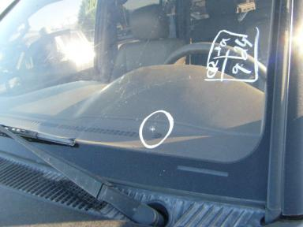 | Windshield | Star in Glass | Less 1" | Replace | .00
 | Front Bumper Co | Scratched | GR 12" | Refinish | 3.10
 | Bug Deflector | Broken | Replacement Req | Replace | .50
 | LF Fender | Scratched | 6" to 7" | Refinish | 3.10
 | LF Door Molding | Scratched | GR 12" | Refinish | 1.00
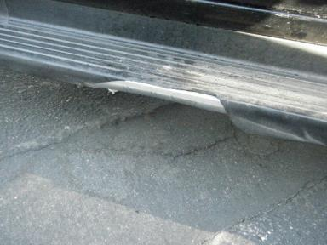 | L Running Board | Broken | Replacement Req | Replace | 1.00
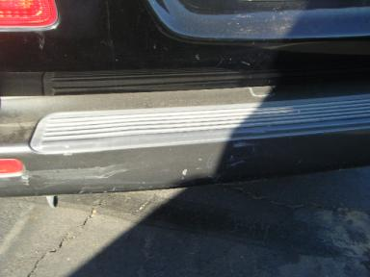 | Rear Bumper Cov | Dent/Paint Dmg | 5" to 6" | Repair | 5.10
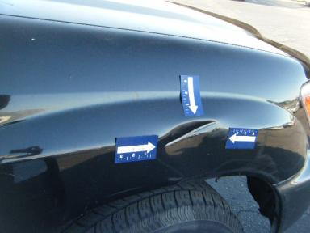 | RF Fender | Dent | 3" to 4" | Repair | 6.10
 | RF Door | Dent | Less 1" | Repair | 3.90
 | R Qtr Panel | Dent | Less 1" | Repair | 4.10
 | LR Speaker Cove | Broken | Replacement Req | Replace | .20
 | Owners manuals | Missing | Replacement Req | Replace | .00
 |  |  |  | TOTALS | 28.10

VIN: JT3HT05J6X0050377, Work Order: 8641141

