2003 LEXUS GX470 - CREAM
VIN: JTJBT20X430016874 Work Order: 3330336
Manheim San Francisco Bay 29900 Auction Ct
Hayward, CA 94544-6914
(510) 786-4500

VIN:
  JTJBT20X430016874
  Body Style: | 4SUV - Moon Roof
  Ext Color/Code: | CREAM - 4R2
  Int Color/Code: | TAN - LH00
  Odometer: | 98,000
  ECM Mileage:
  Seller: | LEXUS FINANCIAL SERVICES/TORRANCE
  Title State: | CA
  Certified: | No
  Condition/Grade: | 4.0, Clean
  Sale: | 42
  Lane: | 17
  Run: | 40
  Inspection: | JC 09/14/2009
  Drivable: | Yes
  Factory Category: | R
  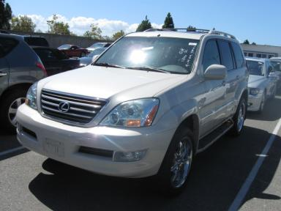 | 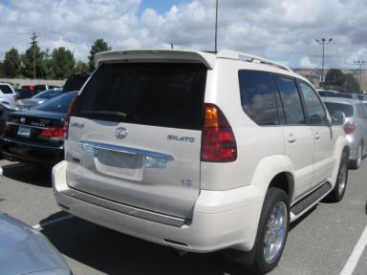
  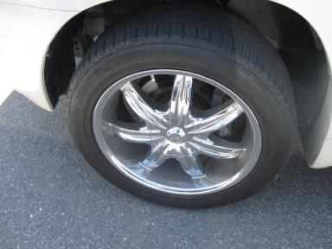 | 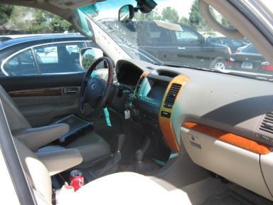

VEHICLE INFORMATION
  MECHANICAL
  8 Cylinder Gas
  Automatic
  4X4
  Pwr Brakes
  4.7 L
  INTERIOR
  TAN - Leather
  Wood Trim Dash
  OPTIONS
  Pwr Lock  Pwr Window  Tilt Steering  Cruise Ctl  Tape/CD  Dual Air Bags  Power Mirrors  ABS Brakes  Fog Lamps  Rear Wiper  Luggage Rack  US EPA Label  Memory Seat  Navigation System |  | Pwr Steering  Pwr Seats - Both  A/C  Rear Defrost  Side Air Bags  50 State Emissions  Owner's Manual  Tinted Windows  Trip Counter  Third Seat  Floor Mats  Heated Seats  DVD with Screen  Parking Distance Control
FLUID LEVELS
Fuel Level: Unknown

  TIRES AND WHEELS
  Tire | Tread Depth | Brand | Size
  Left Front: | 6/32" | FUZION | 265/50R20
  Left Rear: | 6/32" | FUZION | 265/50R20
  Right Front: | 6/32" | FUZION | 265/50R20
  Right Rear: | 6/32" | FUZION | 265/50R20
  Spare: | 0/32" | (Mini)
  Wheels: Chrome
  KEYS
  Valet Key - 1

ANNOUNCED CONDITION: REPO/DMV$BP, Shift Knob Present, Navigation CD Present, GSK IN F/L, NAV DISC IN F/L, Buyer Fee includes a $10 TFS/LFS Administrative Fee.
INTERNET REMARKS:
REMARKS/ADDITIONAL DAMAGE:
DISCLOSURES:
NOTES TO CONSIGNOR: **AS IS MILES OVER/**NO MASTER KEY
REMARKS: **AS IS MILES OVER/**NO MASTER KEY
COMMENTS FOR CONSIGNOR:

2003 LEXUS GX470 - CREAM
VIN: JTJBT20X430016874 Work Order: 3330336
Manheim San Francisco Bay 29900 Auction Ct
Hayward, CA 94544-6914
(510) 786-4500

DAMAGES
 | DESCRIPTION | CONDITION | SEVERITY | REPAIR  HOURS | PAINT  HOURS | PART  HOURS | TOTAL  HOURS
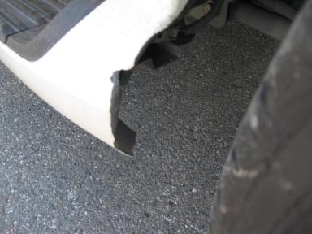 | L Running Board | Burns | 3" to 4" | .00 | .00 | .00 | .00
 |  |  | TOTALS | .00 | .00 | .00 | .00



