EHICLE DETAILS - 2004 LEXUS RX330
VIN: | JTJHA31U340045052 | Body Style: | 4CUV | Top Type: | Moon Roof
Ext Color: | SILVER | Int Color: | BLK | Odometer: | 160,866
Work Order: | 8050807 | Seller: | LEXUS OF OMAHA | Received Date: | 10/13/2009
Sale Number: | 41 | Lane Number: | 5 | Run Number: | 36
Inspector: | LCUNNINGH2 10/13/2009

VEHICLE IMAGES
 |  |  | GRADING
  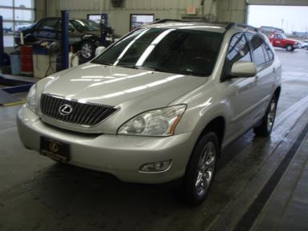 | 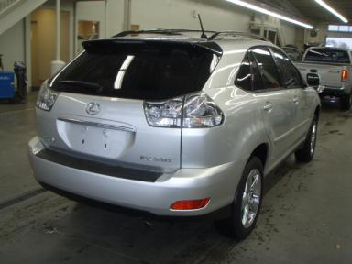
  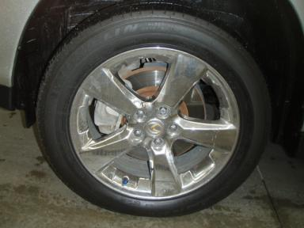 | 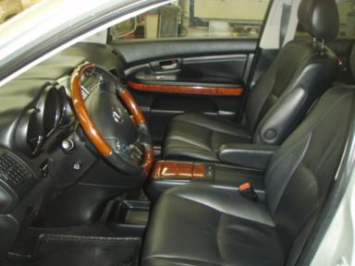
  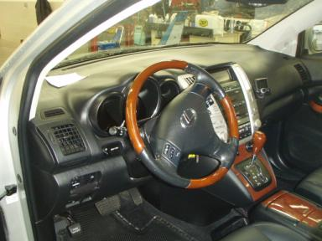 | 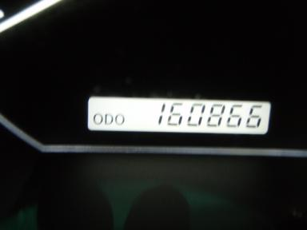
  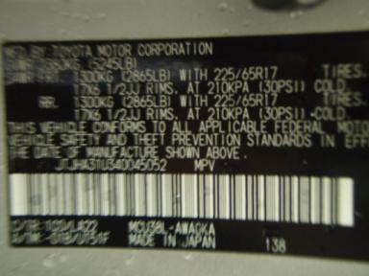
  
  Grade 4.1 Clean
  More About Auto Grade
  MMR: - ¤ 12 960
  MSRP - Not Available
  Certified - No
  Drivable - Yes

VEHICLE INFORMATION
OPTIONS
Pwr Lock  Tilt Steering  Tape/CD  Trip Counter  Steering Wheel Audio Control |  | Pwr Steering  A/C  Side Air Bags  NO Rear Air Conditioning  Heated Seats |  | Pwr Window  Cruise Ctl  Dual Air Bags  NO Third Seat  Memory Seat |  | Pwr Seats - Both  Rear Defrost  Power Mirrors  US EPA Label

MECHANICAL | INTERIOR
  6 Cylinder Gas
  Automatic
  AWD
  Pwr Brakes
  3.3 L
  Odometer - 6 Digits Analog - Operable
  Clean
  BLK - Leather
  Int Odor: OK
TIRES AND WHEELS
  Tire Condition: |  | Wheels:
  Tire | Tread Depth | Brand | Size
  Left Front: | 5/32" | MICHELIN | 235/55R18
  Left Rear: | 5/32" | MICHELIN | 235/55R18
  Right Front: | 5/32" | MICHELIN | 235/55R18
  Right Rear: | 5/32" | MICHELIN | 235/55R18
  Spare: | 0/32" | (Mini)
  KEYS
  Combo Key - 2
  OTHER
  Title State:
  Title Date: N/A

ADDITIONAL INFORMATION
R/D
Common Abbreviations

DAMAGES - SUGGESTED REPAIRS
Suggested repairs are based on Manheim professional inspector's recommendation.
Total labor hours include paint, body or repair estimates.
 | DESCRIPTION | CONDITION | SEVERITY | SUGGESTED  REPAIR | TOTAL  LABOR  HOURS
 | Front Bumper | Chipped | 2 | Paint Chip Repair | .00
 | Hood | Chipped | 2 | Paint Chip Repair | .00
 | LF Fender | Chipped | 1 | Paint Chip Repair | .00
 | LR Door | Scratch Light | GR 12" | Wet Sand | .00
 | Lift Gate | Dent/No Paint Dmg | PDR/1 | PDR | .00
 | Lift Gate | Scratch Light | 1" to 2" | Wet Sand | .00
 | Rear Bumper | Chipped | 1 | Paint Chip Repair | .00
 | RF Fender | Scratched | < 1/8" | Airbrush | .00
 | RR Door | Scratch Light | 1" to 2" | Wet Sand | .00
 | Owners manuals | Missing | Replacement Req | Replace | .00
 | Windshield | Chipped | < 1/8" | No Action Required | .00
 |  |  |  | TOTALS | .00

VIN: JTJHA31U340045052, Work Order: 8050807

