Manheim New England
123 Williams St
North Dighton, MA 02764-0001
(508) 823-6600

VEHICLE DETAILS - 2000 LEXUS RX300
VIN: | JT6HF10U9Y0124619 | Body Style: | 4CUV | Top Type: | Sun Roof
Ext Color: | SILVER | Int Color: | GRY | Odometer: | 141,384
Work Order: | 7106124 | Seller: | BOCH NEW TO YOU SUPERSTORE | Received Date: | 10/23/2009
Sale Number: | 44 | Lane Number: | 7 | Run Number: | 43
Inspector: | KMEAS 10/26/2009

VEHICLE IMAGES
 |  |  | GRADING
  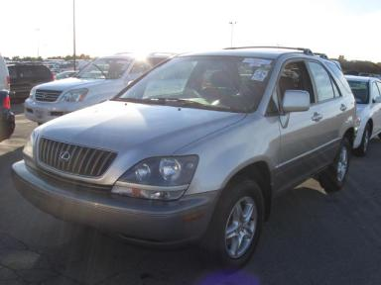 | 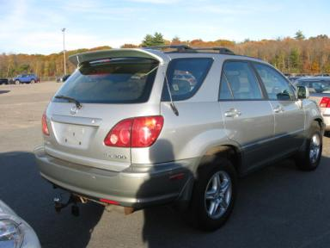
  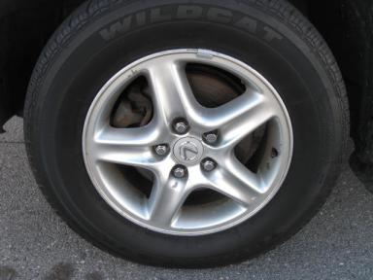 | 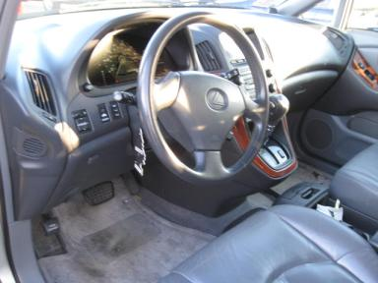
  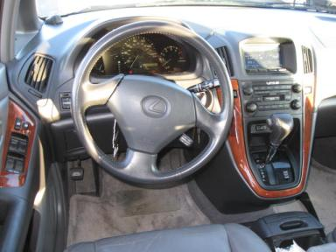 | 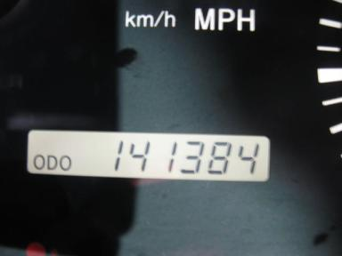
  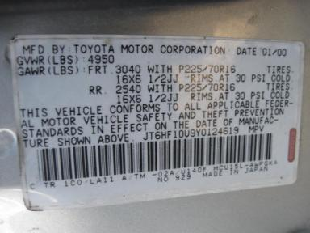
  
  Grade 2.8 Below Average
  More About Auto Grade
  MMR: - ¤ 6 408
  MSRP - Not Available
  Certified - No
  Drivable - Yes

VEHICLE INFORMATION
OPTIONS
Pwr Lock  Tilt Steering  Tape/CD  Owner's Manual  Trip Counter  5 Passenger Seating  2 Captain Seats 1 Bench  Rear Tail/Lift Gate |  | Pwr Steering  A/C  Dual Air Bags  ABS Brakes  CD Changer - OEM - 6.00  Spoiler  Panoramic Glass Roof  Woodgrain Interior Package |  | Pwr Window  Cruise Ctl  50 State Emissions  4 Door  Rear Wiper  US EPA Label  Hardtop Shell |  | Pwr Seats - Both  Rear Defrost  Power Mirrors  Fog Lamps  Luggage Rack  Trailer Hitch  HomeLink

MECHANICAL | INTERIOR
  6 Cylinder Gas
  Automatic
  AWD
  Pwr Brakes
  3.0 L
  GRY - Leather
  Int Odor: OK
  Wood Trim Dash
TIRES AND WHEELS
  Tire Condition: |  | Wheels: | Alloy
  Tire | Tread Depth | Brand | Size
  Left Front: | 5/32" | WILD CAT | 225/70R16
  Left Rear: | 5/32" | WILD CAT | 225/70R16
  Right Front: | 5/32" | WILD CAT | 225/70R16
  Right Rear: | 5/32" | WILD CAT | 225/70R16
  Spare: | 0/32" | (Mini)
  KEYS
  Combo Key - 1
  OTHER
  Title State: MA
  Title Date: 10/27/2009

ADDITIONAL INFORMATION
100+ *AS IS *AWD
Common Abbreviations

DAMAGES - SUGGESTED REPAIRS
Suggested repairs are based on Manheim professional inspector's recommendation.
Total labor hours include paint, body or repair estimates.
 | DESCRIPTION | CONDITION | SEVERITY | SUGGESTED  REPAIR | TOTAL  LABOR  HOURS
 | Front Bumper Co | Scratch Light | 1" to 2" | Wet Sand | .00
 | Hood | Dent/No Paint Dmg | PDR/4 | PDR | .00
 | Hood | Multiple Chips | 10 or More | Refinish | 3.80
 | LF Fender | Dent/No Paint Dmg | PDR/1 | PDR | .00
 | LF Door | Edge Chipped | 3 | Brush Touch | .00
 | LF Door | Scratch Light | 1/2" to 1" | Wet Sand | .00
 | LR Door | Scratch Light | GR 12" | Wet Sand | .00
 | L Qtr Panel | Multiple Dents | 1" to 2" | Repair | 4.80
 | Rear Bumper Cov | Cracked Paint | 3" to 4" | Refinish | 3.60
 | Rear Bumper Cov | Scratch Light | 1" to 2" | Included | .00
 | RF Fender | Scratch Light | 1" to 2" | Wet Sand | .00
 | RF Door | Dent/No Paint Dmg | PDR/3 | PDR | .00
 | RF Door | Scratch Light | 1" to 2" | Wet Sand | .00
 | RR Door | Dent/No Paint Dmg | PDR/3 | PDR | .00
 | RR Door | Scratch Heavy | < 1/8" | Airbrush | .00
 | RR Door | Scratch Light | 2" to 3" | Wet Sand | .00
 | R Qtr Panel | Dent | 1" to 2" | Repair | 4.30
 | Warning - Elect | On BATTERY LIGHT ON | Repair Required | Ck/Advise | 1.00
 |  |  |  | TOTALS | 17.50

