Manheim Kansas City
3901 N Skiles Ave
Kansas City, MO 64161
(816) 452-4084

VEHICLE DETAILS - 2001 LEXUS RX300
VIN: | JTJHF10U410193360 | Body Style: | 4CUV | Top Type: | Sun Roof
Ext Color: | SILVER | Odometer: | 169,967
Work Order: | 5446656 | Seller: | SUPERIOR LEXUS | Received Date: | 11/03/2009
Sale Number: | 44 | Lane Number: | 2 | Run Number: | 31
Inspector: | TFLUTY 11/03/2009

VEHICLE IMAGES
 |  |  | GRADING
  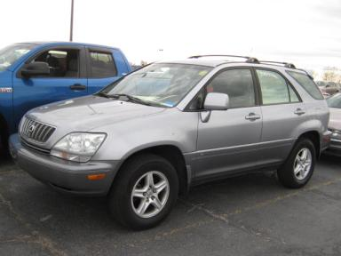 | 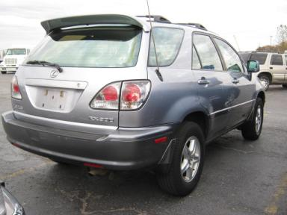
  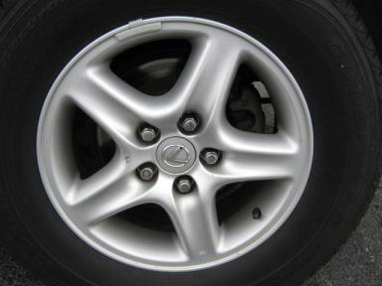 | 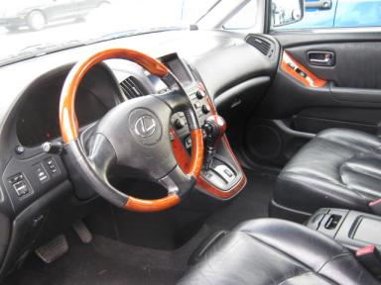
  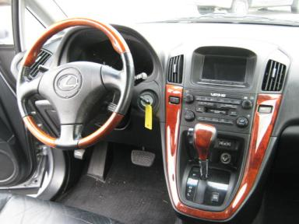 | 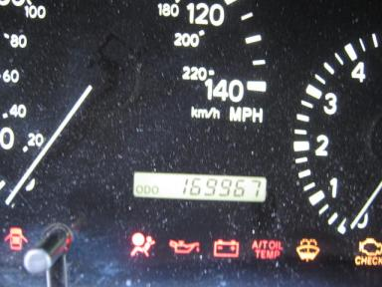
  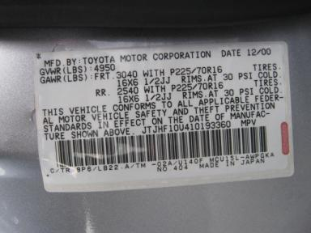
  
  Grade 3.4 Average
  More About Auto Grade
  MMR: - ¤ 7 174
  MSRP - Not Available
  Certified - No
  Drivable - Yes

VEHICLE INFORMATION
OPTIONS
Pwr Lock  Tilt Steering  Dual Air Bags  NO Rear Air Conditioning  Traction Control  First Aid Kit |  | Pwr Steering  A/C  Power Mirrors  Luggage Rack  Heated Seats |  | Pwr Window  Cruise Ctl  ABS Brakes  NO Third Seat  Memory Seat |  | Pwr Seats - Both  CD Player  Rear Wiper  Spoiler  Woodgrain Interior Package

MECHANICAL | INTERIOR
  6 Cylinder Gas
  Automatic
  AWD
  Pwr Brakes
  3.0 L
  Leather
  Int Odor: OK
  Wood Trim Dash
TIRES AND WHEELS
  Tire Condition: |  | Wheels: | Alloy
  Tire | Tread Depth | Brand | Size
  Left Front: | 5/32" | GOODYEAR | 225/70R16
  Left Rear: | 6/32" | GOODYEAR | 225/70R16
  Right Front: | 5/32" | GOODYEAR | 225/70R16
  Right Rear: | 6/32" | GOODYEAR | 225/70R16
  Spare: | 6/32" | GOODYEAR | 225/70R16
  KEYS
  Combo Key - 1
  OTHER
  Title State:
  Title Date: N/A

ADDITIONAL INFORMATION
MILES OVER, LT, AS IS
Common Abbreviations

DAMAGES - SUGGESTED REPAIRS
Suggested repairs are based on Manheim professional inspector's recommendation.
Total labor hours include paint, body or repair estimates.
 | DESCRIPTION | CONDITION | SEVERITY | SUGGESTED  REPAIR | TOTAL  LABOR  HOURS
 | Windshield | Chipped | Acceptable | No Action Required | .00
 | Front Bumper | Cracked Paint | 6" to 7" | Refinish | 3.50
 | Hood | Chipped | 10 or More | Refinish | 3.80
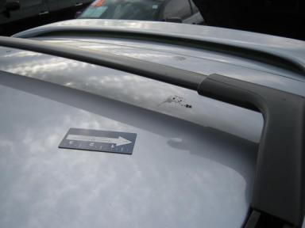 | Roof | Multiple Dents | 1" to 2" | Repair | 7.20
 | L Qtr Panel | Dent/No Paint Dmg | 1/2" to 1" | PDR | .00
 | RR Door | Dent/No Paint Dmg | > 1/8" | PDR | .00
 | Owners manuals | Missing | Replacement Req | Replace | .00
 | Hood | Prev Repair | Acceptable | No Action Required | .00
 | LF Fender | Prev Repair | Acceptable | No Action Required | .00
 | LF Door | Prev Repair | Acceptable | No Action Required | .00
 |  |  |  | TOTALS | 14.50

VIN: JTJHF10U410193360, Work Order: 5446656



