2004 LEXUS RX330 - SILVER
VIN: 2T2HA31U54C018844 Work Order: 8099051
Manheim Milwaukee 561 27th St
Caledonia, WI 53108
(262) 835-4436

VIN:
  2T2HA31U54C018844
  Body Style: | 4CUV - Sun Roof
  Ext Color/Code: | SILVER - 6T1
  Int Color/Code: | TAN - 01B
  Odometer: | 80,928
  ECM Mileage:
  Seller: | LEXUS FINANCIAL SERVICES/CEDAR RAPIDS
  Title State: | MI
  Certified: | No
  Condition/Grade: | 3.0, Average
  Sale: | 44
  Lane: | 13
  Run: | 136
  Inspection: | KWILLETT 09/14/2009
  Drivable: | Yes
  Factory Category: | R
  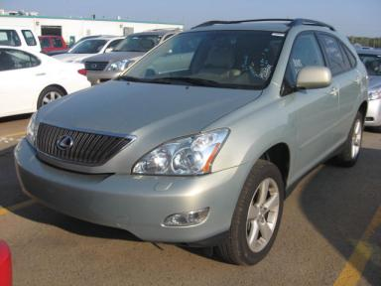 | 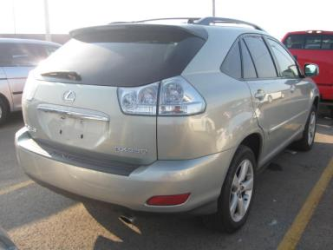
  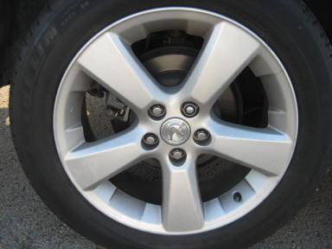 | 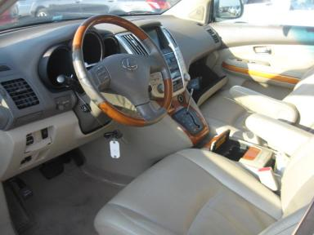
  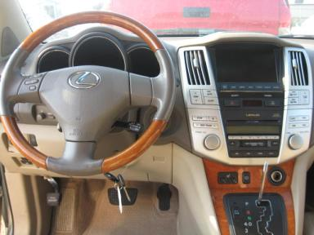 | 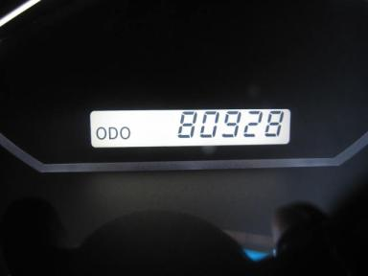
  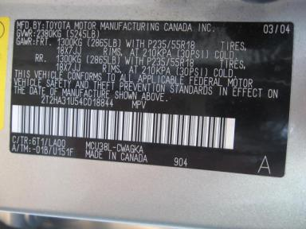

VEHICLE INFORMATION
  MECHANICAL
  6 Cylinder Gas
  Automatic
  AWD
  Pwr Brakes
  3.3 L
  INTERIOR
  Dirty
  TAN - Leather
  Int Odor: OK
  Wood Trim Dash
  OPTIONS
  Pwr Lock  Pwr Window  Tilt Steering  Cruise Ctl  Tape/CD  Dual Air Bags  Power Mirrors  ABS Brakes  Tinted Windows  Rear Wiper  Luggage Rack  Spoiler  Security System  Steering Wheel Audio Control  HomeLink  Heated Seats  Memory Seat  Power Telescopic Steering |  | Pwr Steering  Pwr Seats - Drivers Only  A/C  Rear Defrost  Side Air Bags  50 State Emissions  Owner's Manual  Premium Stereo - MARKLEVINSON  Trip Counter  Trip Computer  Floor Mats  US EPA Label  Step Bumper  Traction Control  Rear Tail/Lift Gate  Power Lift Gate  Woodgrain Interior Package
FLUID LEVELS
Fuel Level: Unknown

  TIRES AND WHEELS
  Tire | Tread Depth | Brand | Size
  Left Front: | 7/32" | MICHELIN | 235/55R18
  Left Rear: | 4/32" | MICHELIN | 235/55R18
  Right Front: | 4/32" | MICHELIN | 235/55R18
  Right Rear: | 5/32" | MICHELIN | 235/55R18
  Spare: | 7/32" | COVERD(Mini)
  Tire Condition: Good
  Wheels: Alloy
  KEYS
  Spare Key - 1

ANNOUNCED CONDITION: AWD, SKNOB,NAV DISC,BOOK-IN TRUNK, Shift Knob Present, Navigation CD Present, Buyer Fee includes a $10 TFS/LFS Administrative Fee.
INTERNET REMARKS:
REMARKS/ADDITIONAL DAMAGE:
DISCLOSURES:
NOTES TO CONSIGNOR: *PD
REMARKS: *PD
COMMENTS FOR CONSIGNOR:

2004 LEXUS RX330 - SILVER
VIN: 2T2HA31U54C018844 Work Order: 8099051
Manheim Milwaukee 561 27th St
Caledonia, WI 53108
(262) 835-4436

DAMAGES
 | DESCRIPTION | CONDITION | SEVERITY | REPAIR  HOURS | PAINT  HOURS | PART  HOURS | TOTAL  HOURS
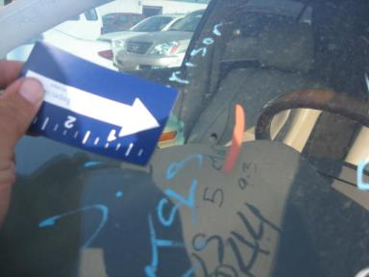 | Windshield | Cracked | Less 1" | .00 | .00 | .00 | .00
 | Front Bumper Co | Chipped | 1 | .00 | .00 | .00 | .00
 | Front Bumper Co | Peeling | 3" to 4" | 1.50 | 3.50 | .00 | 5.00
 | Hood | Chipped | 10 or More | .00 | .00 | .00 | .00
 | LF Wheel | Curb Rash | 7" to 8" | 1.00 | .00 | .00 | 1.00
 | LF Door Molding | Chipped | 2 | .00 | .00 | .00 | .00
 | LF Door Appliqu | Scratched | 1" to 2" | .00 | .00 | .20 | .20
 | LR Door Molding | Prev Touchup | 1" to 2" | 1.00 | 1.00 | .00 | 2.00
 | RF Door | Dent | PDR/1 | .00 | .00 | .00 | .00
 | RR Door | Dent | PDR/1 | .00 | .00 | .00 | .00
 | RR Door | Prev Repair | Acceptable | .00 | .00 | .00 | .00
 | RR Door Molding | Prev Touchup | 1" to 2" | 1.00 | 1.00 | .00 | 2.00
 | LR Door Appliqu | Scratched | 1" to 2" | .00 | .00 | .20 | .20
 | R Qtr Panel | Dent | PDR/1 | .00 | .00 | .00 | .00
 | R Qtr Panel | Prev Repair | Acceptable | .00 | .00 | .00 | .00
 | Master/Door Key | Broken | 1" to 2" | .00 | .00 | .00 | .00
 |  |  | TOTALS | 4.50 | 5.50 | .40 | 10.40



