Manheim Minneapolis
8001 Jefferson Hwy
Maple Grove, MN 55369
(763) 425-7653

VEHICLE DETAILS - 2004 LEXUS RX330
VIN: | JTJHA31U340003240 | Body Style: | 4CUV | Top Type: | Moon Roof
Ext Color: | SILVER | Int Color: | GRY | Odometer: | 124,285
Work Order: | 1584823 | Seller: | TRUSTONE FINANCIAL | Received Date: | 10/16/2009
Sale Number: | 46 | Lane Number: | 20 | Run Number: | 85
Inspector: | PHILLESHEI 10/19/2009

VEHICLE IMAGES
 |  |  | GRADING
  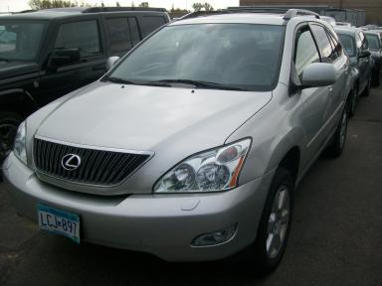 | 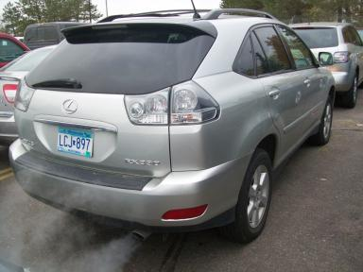
  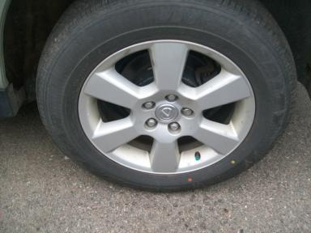 | 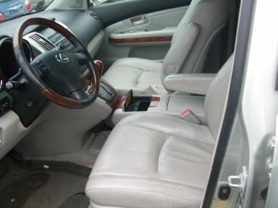
  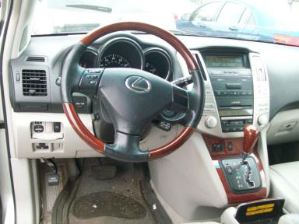 | 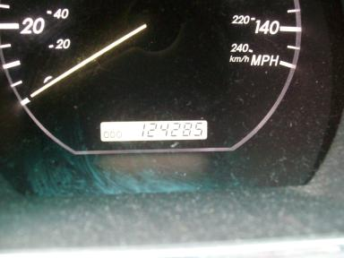
  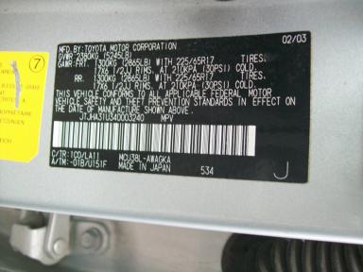
  
  Grade 4.2 Clean
  More About Auto Grade
  MMR: - ¤ 13 707
  MSRP - Not Available
  Certified - No
  Drivable - Yes

VEHICLE INFORMATION
OPTIONS
Pwr Lock  Tilt Steering  Tape/CD  ABS Brakes  CD Changer - FACTORY  On-Board Computer  Security System  Dual Air Conditioning |  | Pwr Steering  A/C  Dual Air Bags  4 Door  Rear Wiper  5 Passenger Seating  Step Bumper  HomeLink |  | Pwr Window  Cruise Ctl  Power Mirrors  Fog Lamps  NO Rear Air Conditioning  Floor Mats  Steering Wheel Audio Control  Heated Seats |  | Pwr Seats - Both  Rear Defrost  Owner's Manual  Trip Counter  NO Third Seat  US EPA Label  2 Captain Seats 1 Bench

MECHANICAL | INTERIOR
  6 Cylinder Gas
  Automatic
  AWD
  Pwr Brakes
  3.3 L
  Odometer - 6 Digits Digital - Operable
  Dirty
  GRY - Leather
  Int Odor: Foul
  Wood Trim Dash
TIRES AND WHEELS
  Tire Condition: | Average | Wheels: | Alloy
  Tire | Tread Depth | Brand | Size
  Left Front: | 3/32" | GOODYEAR | 225/65R17
  Left Rear: | 8/32" | GOODYEAR | 225/65R17
  Right Front: | 3/32" | GOODYEAR | 225/65R17
  Right Rear: | 8/32" | GOODYEAR | 225/65R17
  Spare: | 0/32" | (Mini)
  KEYS
  Combo Key - 1
  OTHER
  Title State: MN
  Title Date: 11/09/2009

ADDITIONAL INFORMATION
AWD AS IS MILES OVER
Common Abbreviations

DAMAGES - SUGGESTED REPAIRS
Suggested repairs are based on Manheim professional inspector's recommendation.
Total labor hours include paint, body or repair estimates.
 | DESCRIPTION | CONDITION | SEVERITY | SUGGESTED  REPAIR | TOTAL  LABOR  HOURS
 | LF Tire | Worn | Replacement Req | Replace | .00
 | LF Door | Scratch Light | 3" to 4" | Wet Sand | .00
 | LR Door | Scratch Light | GR 12" | Wet Sand | .00
 | Rear Bumper | Scratch Light | 5" to 6" | Wet Sand | .00
 | RF Tire | Worn | Replacement Req | Replace | .00
 | RF Door | Scratch Light | 1/2" to 1" | Wet Sand | .00
 | RR Door | Dent/No Paint Dmg | PDR/3 | PDR | .00
 | R Qtr Panel | Scratch Light | 2" to 3" | Wet Sand | .00
 | Warning - Maint | On | Unknown | Ck/Advise | .00
 | Gas | Low Fluid | Replacement Req | Replace | .00
 |  |  |  | TOTALS | .00

VIN: JTJHA31U340003240, Work Order: 1584823


© 2009 Manheim All Rights

