2001 LEXUS RX300 - SLVER
VIN: JTJHF10U510230948 Work Order: 6749634
Manheim Pennsylvania 1190 Lancaster Rd
Manheim, PA 17545-9789
(717) 665-3571

VIN:
  JTJHF10U510230948
  Body Style: | 4CUV - Sun Roof
  Ext Color/Code: | SLVER - 1C0
  Int Color/Code: | BLK - LB22
  Odometer: | 139,704
  ECM Mileage:
  Seller: | LEXUS FINANCIAL SERVICES/EASTERN
  Title State: | MD
  Certified: | No
  Condition/Grade: | 3.0, Average
  Sale: | 70
  Lane: | 43
  Run: | 2
  Inspection: | CLYNCH 10/19/2009
  Drivable: | Yes
  Factory Category: | R
  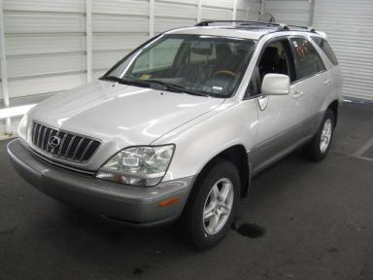 | 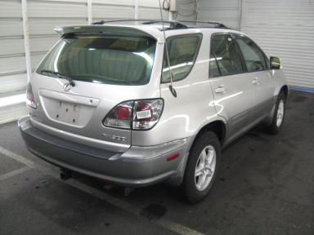
  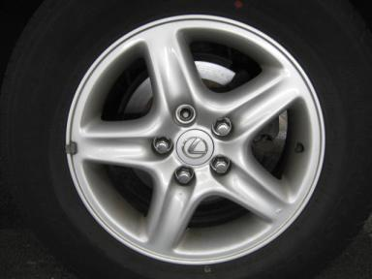 | 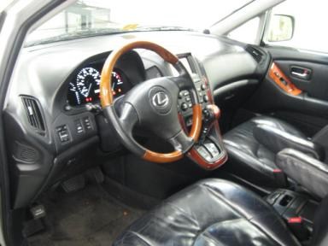
  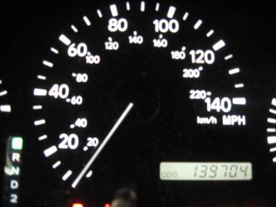 | 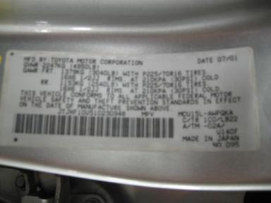
  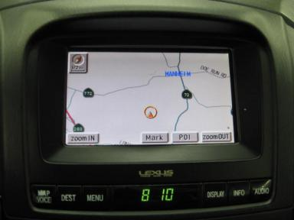

VEHICLE INFORMATION
  MECHANICAL
  6 Cylinder Gas
  Automatic
  AWD
  Pwr Brakes
  3.0 L
  INTERIOR
  Average
  BLK - Leather
  Int Odor: OK
  Regular Dash
  OPTIONS
  Pwr Lock  Pwr Window  Tilt Steering  Cruise Ctl  Cassette Tape  Dual Air Bags  Power Mirrors  ABS Brakes  4 Door  Trip Counter  Rear Wiper  Trip Computer  NO Third Seat  5 Passenger Seating  Spoiler  Security System  Power Antenna  Traction Control  Heated Seats  Memory Seat  Navigation System |  | Pwr Steering  Pwr Seats - Both  A/C  Rear Defrost  Side Air Bags  50 State Emissions  Heated Mirrors  Tinted Windows  Fog Lamps  CD Changer - OEM - 6.00  NO Rear Air Conditioning  Luggage Rack  Keyless Entry  Floor Mats  US EPA Label  Step Bumper  Trailer Hitch  HomeLink  Cargo Cover  Woodgrain Interior Package  Directional Stability Control
FLUID LEVELS
Fuel Level: 1/8

  TIRES AND WHEELS
  Tire | Tread Depth | Brand | Size
  Left Front: | 7/32" | MICHELIN | 225/70R16
  Left Rear: | 5/32" | BRIDGESTONE | 225/70R16
  Right Front: | 11/32" | MICHELIN | 225/70R16
  Right Rear: | 7/32" | GOODYEAR | 225/70R16
  Spare: | 5/32" | MICHELIN
  Tire Condition: Average
  Wheels: Alloy
  KEYS
  Master Key - 1

ANNOUNCED CONDITION: AS IS OVER 100K,AWD,NAV, Navigation CD Present, Shift Knob Present, Buyer Fee includes a $10 TFS/LFS Administrative Fee.
INTERNET REMARKS:
REMARKS/ADDITIONAL DAMAGE:
DISCLOSURES: . NAV DISC INACCESSIBLE
NOTES TO CONSIGNOR:
REMARKS:
COMMENTS FOR CONSIGNOR: P/D 07/01, . NAV DISC INACCESSIBLE

2001 LEXUS RX300 - SLVER
VIN: JTJHF10U510230948 Work Order: 6749634
Manheim Pennsylvania 1190 Lancaster Rd
Manheim, PA 17545-9789
(717) 665-3571

DAMAGES
 | DESCRIPTION | CONDITION | SEVERITY | REPAIR  HOURS | PAINT  HOURS | PART  HOURS | TOTAL  HOURS
 | LF Lug Nut | Missing | Replacement Req | .00 | .00 | .10 | .10
 | LR Lug Nut | Missing | Replacement Req | .00 | .00 | .10 | .10
 | RF Lug Nut | Missing | Replacement Req | .00 | .00 | .10 | .10
 | RR Lug Nut | Missing | Replacement Req | .00 | .00 | .10 | .10
 | Front Bumper Co | Prev Repair | Unacceptable | .00 | .00 | .00 | .00
 | Hood | Dent/No Paint Dmg | PDR/3 | .00 | .00 | .00 | .00
 | Hood | Multiple Chips | < 1/8" | .00 | .00 | .00 | .00
 | Roof | Dent/No Paint Dmg | PDR/1 | .00 | .00 | .00 | .00
 | LF Fender | Dent/No Paint Dmg | PDR/2 | .00 | .00 | .00 | .00
 | LF Door | Dent/No Paint Dmg | PDR/1 | .00 | .00 | .00 | .00
 | LF Door | Mult Scratches | Less 1" | .00 | .00 | .00 | .00
 | LF Door Edge | Bent | 2" to 3" | .00 | .00 | .00 | .00
 | LR Door | Dent/No Paint Dmg | PDR/1 | .00 | .00 | .00 | .00
 | L Qtr Panel | Dent/No Paint Dmg | PDR/1 | .00 | .00 | .00 | .00
 | L Fuel Door | Dent | Less 1" | .00 | .00 | .00 | .00
 | Rear Bumper Cov | Multiple Dents CREASE | 1" to 2" | .00 | .00 | .00 | .00
 | Rear Bumper Cov | Prev Repair | Unacceptable | .00 | .00 | .00 | .00
 | RF Fender | Dent/No Paint Dmg | PDR/2 | .00 | .00 | .00 | .00
 | RR Door | Prev Repair | Unacceptable | .00 | .00 | .00 | .00
 | RR Door | Scratch Light MULTIPLE / WETSA | 7" to 8" | .00 | .00 | .00 | .00
 | R Qtr Panel | Dent | 1" to 2" | .00 | .00 | .00 | .00
 | R Qtr Panel | Prev Repair | Unacceptable | .00 | .00 | .00 | .00
 | RR Wheel | Curb Rash | 7" to 8" | .00 | .00 | .00 | .00
 | LF Seat Cushion | Torn | 2" to 3" | .00 | .00 | .00 | .00
 |  |  | TOTALS | .00 | .00 | .40 | .40



