Manheim Fredericksburg
120 Auction Dr
Fredericksburg, VA 22406
(540) 368-3400

VEHICLE DETAILS - 2004 LEXUS RX330
VIN: | JTJHA31U240014830 | Body Style: | 4CUV | Top Type: | Sun Roof
Ext Color: | BLU-GRY | Int Color: | BLK | Odometer: | 144,735
Work Order: | 1218306 | Seller: | CHASE MANHATTAN AUTOMOTIVE FINANCE GROUP | Received Date: | 11/03/2009
Sale Number: | 47 | Lane Number: | 94 | Run Number: | 6
Inspector: | MGLADING 11/05/2009 | InService Date: | 12/10/2009

VEHICLE IMAGES
 |  |  | GRADING
  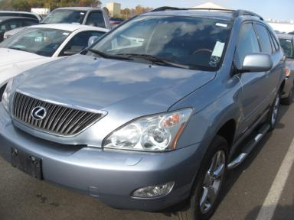 | 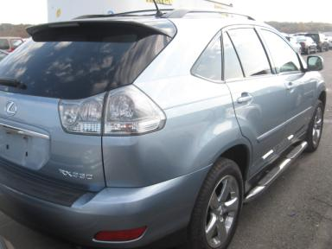
  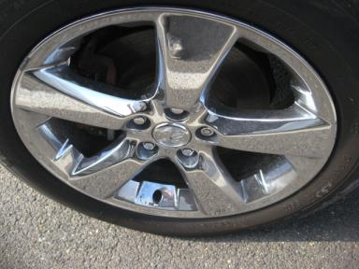 | 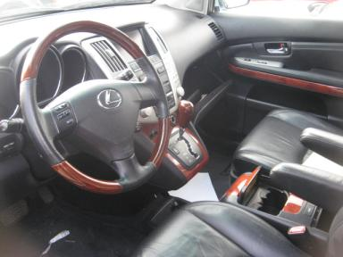
  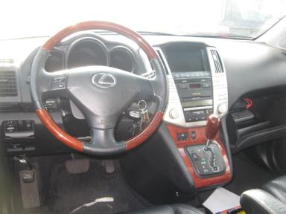 | 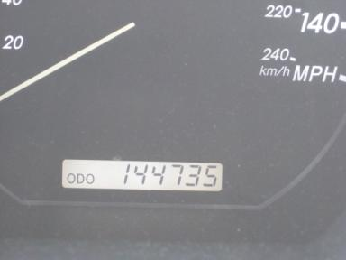
  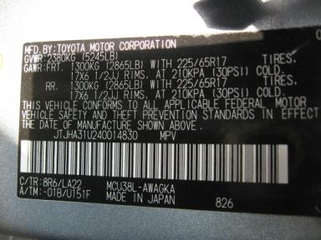
  
  Grade 2.8 Below Average
  More About Auto Grade
  MMR: - ¤ 12 823
  MSRP - Not Available
  Certified - No
  Drivable - Yes

VEHICLE INFORMATION
OPTIONS
Pwr Lock  Tilt Steering  Tape/CD  Owner's Manual  Trip Counter  NO Third Seat  Running Board  Memory Seat  Navigation System |  | Pwr Steering  A/C  Side Air Bags  ABS Brakes  Rear Wiper  5 Passenger Seating  Steering Wheel Audio Control  Television |  | Pwr Window  Cruise Ctl  Dual Air Bags  Tinted Windows  NO Rear Air Conditioning  Floor Mats  HomeLink  Woodgrain Interior Package |  | Pwr Seats - Both  Rear Defrost  Power Mirrors  Fog Lamps  Luggage Rack  Xenon Headlights  Heated Seats  Power Telescopic Steering

MECHANICAL | INTERIOR
  6 Cylinder Gas
  Automatic
  AWD
  Pwr Brakes
  3.3 L
  Odometer - 6 Digits Digital - Operable
  Average
  BLK - Leather
  Int Odor: OK
  Wood Trim Dash
TIRES AND WHEELS
  Tire Condition: | Average | Wheels: | Chrome
  Tire | Tread Depth | Brand | Size
  Left Front: | 3/32" | MICHELIN | 235/55R18
  Left Rear: | 5/32" | MICHELIN | 235/55R18
  Right Front: | 3/32" | MICHELIN | 235/55R18
  Right Rear: | 6/32" | MICHELIN | 235/55R18
  Spare: | 0/32" | (Mini)
  KEYS
  Combo Key - 2
  OTHER
  Title State: MD
  Title Date: 11/17/2009

ADDITIONAL INFORMATION
AWD/TV/NAV SYSTEM/OVER100/ASIS
Common Abbreviations

DAMAGES - SUGGESTED REPAIRS
Suggested repairs are based on Manheim professional inspector's recommendation.
Total labor hours include paint, body or repair estimates.
 | DESCRIPTION | CONDITION | SEVERITY | SUGGESTED  REPAIR | TOTAL  LABOR  HOURS
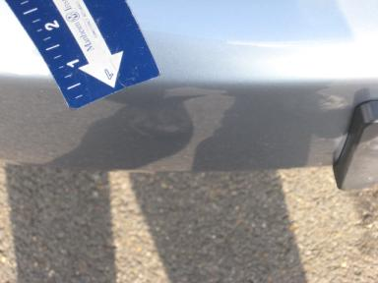 | Front Bumper | Multiple Chips | 10 or More | Refinish | 6.50
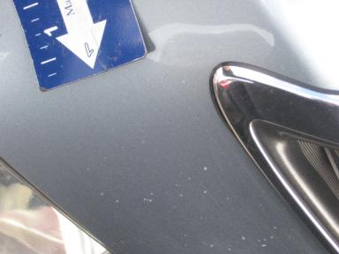 | Hood | Multiple Chips | 10 or More | Refinish | 6.80
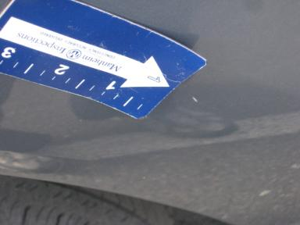 | LF Fender | Dent/Paint Dmg | < 1/8" | Repair | 5.30
 | LF Tire | Worn | Replacement Req | Replace | .00
 | LF Door | Dent/No Paint Dmg | PDR/3 | PDR | .00
 | LF Door Molding | Chipped | 4 | Paint Chip Repair | .00
 | LF Door Edge | Scratched | > 1/8" | Airbrush | .00
 | LR Door Molding | Chipped | 3 | Paint Chip Repair | .00
 | LR Window Regul | Inop | Not Mech Snd | Ck/Advise | 1.00
 | Lift Gate | Chipped | 6 | Paint Chip Repair | .00
 | Lift Gate | Scratched | 1" to 2" | Airbrush | .00
 | Rear Bumper | Scratched | 1/2" to 1" | Airbrush | .00
 | RF Tire | Worn | Replacement Req | Replace | .00
 | RF Door Molding | Chipped | 4 | Paint Chip Repair | .00
 | RF Door Edge | Chipped | 3 | Paint Chip Repair | .00
 | RR Door Molding | Chipped | 4 | Paint Chip Repair | .00
 | RR Door Edge | Chipped | 3 | Paint Chip Repair | .00
 | RR Window Regul | Inop | Not Mech Snd | Ck/Advise | 1.00
 | R Qtr Panel | Chipped | 3 | Paint Chip Repair | .00
 | LF Fender | Prev Repair | Acceptable | No Action Required | .00
 | RF Fender | Prev Repair | Acceptable | No Action Required | .00
 |  |  |  | TOTALS | 20.60

VIN: JTJHA31U240014830, Work Order: 1218306


© 2009 Manheim All Rights

