Manheim Baltimore-Washington
7120 Dorsey Run Rd
Elkridge, MD 21075
(410) 796-8899

VEHICLE DETAILS - 2001 HONDA CR-V SE
VIN: | JHLRD18771S021617 | Body Style: | 4CUV | Top Type: | Hard Top
Ext Color: | SILVER | Int Color: | GRY | Odometer: | 96,140
Work Order: | 1121195 | Seller: | RA ROGERS INC | Received Date: | 08/21/2009
Sale Number: | 48 | Lane Number: | 11 | Run Number: | 116
Inspector: | JBETZ 08/26/2009

VEHICLE IMAGES
 |  |  | GRADING
  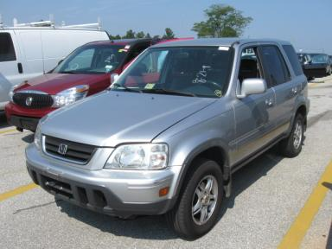 | 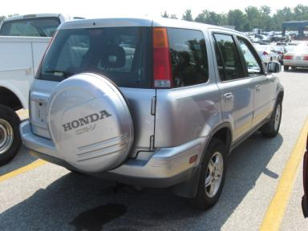
  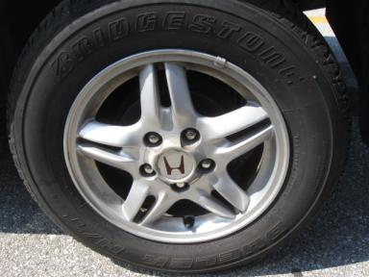 | 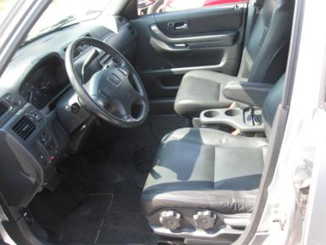
  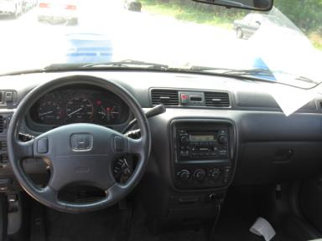 | 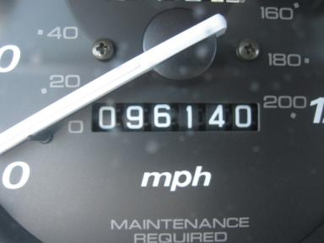
  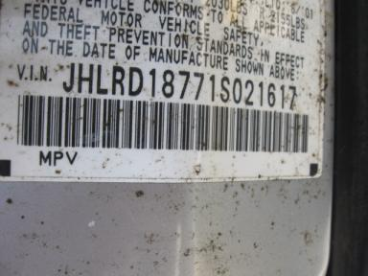
  
  Grade 2.8 Below Average
  More About Auto Grade
  MMR: - ¤ 6 990
  MSRP - Not Available
  Certified - No
  Drivable - Yes

VEHICLE INFORMATION
OPTIONS
Pwr Lock  A/C  Dual Air Bags  4 Door  NO Third Seat  2 Captain Seats 1 Bench |  | Pwr Steering  Cruise Ctl  Power Mirrors  Trip Counter  5 Passenger Seating |  | Pwr Window  Rear Defrost  ABS Brakes  Rear Wiper  US EPA Label |  | Tilt Steering  Tape/CD  Tinted Windows  NO Rear Air Conditioning  Security System

MECHANICAL | INTERIOR
  4 Cylinder Gas
  Automatic
  AWD
  Pwr Brakes
  2.0 L
  Odometer - 6 Digits Analog - Operable
  Average
  GRY - Leather
  Int Odor: OK
  Regular Dash
TIRES AND WHEELS
  Tire Condition: | Average | Wheels: | Alloy
  Tire | Tread Depth | Brand | Size
  Left Front: | 6/32" | GOODYEAR | 205/70R15
  Left Rear: | 6/32" | BRIDGESTONE | 205/70R15
  Right Front: | 6/32" | GOODYEAR | 205/70R15
  Right Rear: | 6/32" | GOODYEAR | 205/70R15
  Spare: | 10/32" | GOODYEAR | 205/70R15
  KEYS
  Master Key - 1
  Remote Key/Fob - 1
  OTHER
  Title State: VA
  Title Date: 11/11/2009

ADDITIONAL INFORMATION
**LOC
Common Abbreviations

DAMAGES - SUGGESTED REPAIRS
Suggested repairs are based on Manheim professional inspector's recommendation.
Total labor hours include paint, body or repair estimates.
 | DESCRIPTION | CONDITION | SEVERITY | SUGGESTED  REPAIR | TOTAL  LABOR  HOURS
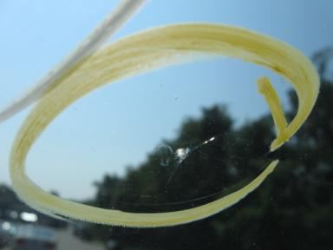 | Windshield | Cracked | Less 1" | Replace | .00
 | Front Bumper | Scratches | 2" to 3" | Refinish | 3.90
 | Hood | Chipped | 10 or More | Refinish | 4.10
 | Hood | Dent/No Paint Dmg | PDR/2 | PDR | .00
 | LF Door | Dent/No Paint Dmg | PDR/3 | PDR | .00
 | LR Door | Dent/No Paint Dmg | PDR/6 | PDR | .00
 | Rear Bumper | Scratches | 2" to 3" | Refinish | 3.90
 | RF Door | Dent/No Paint Dmg | PDR/4 | PDR | .00
 | RR Door | Dent/No Paint Dmg | PDR>10 | PDR | .00
 | R Qtr Panel | Dent/No Paint Dmg | PDR/7 | PDR | .00
 | RR Wheel | Scratches | 2" to 3" | Repair | .00
 | Front Mats | Missing | Replacement Req | Replace | .00
 | Rear/2nd Row Ma | Missing | Replacement Req | Replace | .00
 | Warranty Books | Missing | Replacement Req | Replace | .00
 | Owners manuals | Missing | Replacement Req | Replace | .00
 | Maintenance Boo | Missing | Replacement Req | Replace | .00
 | Oil | Dirty | Unacceptable | Replace | .00
 | Battery | Dead | Replacement Req | Replace | .40
 | Gas | Missing | Replacement Req | Replace | .00
 |  |  |  | TOTALS | 12.30

VIN: JHLRD18771S021617, Work Order: 1121195

