2007 VOLVO XC90 3.2T AWD7 3.2T AWD7 - GREY
VIN: YV4CM982571346235 Work Order: 3005070
Manheim Chicago 20401 Cox Ave
Matteson, IL 60443
(815) 806-4222

VIN:
  YV4CM982571346235
  Body Style: | 4CUV - Sun Roof
  Ext Color/Code: | GREY - 455
  Int Color/Code: | BLK
  Odometer: | 53,620
  ECM Mileage:
  Seller: | VOLVO FINANCE NA
  Title State: | WI
  Certified: | No
  Condition/Grade: | 4.0, Clean
  Sale: | 49
  Lane: | 52
  Run: | 331
  Inspection: | SPETERMAN 11/20/2009
  Drivable: | Yes
  Factory Category: | RCT
  Invoice Price: | $42,415.00
  InService Date: | 10/31/2006
  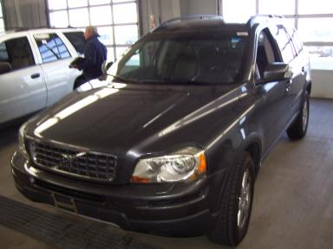 | 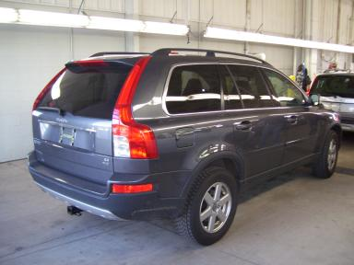

VEHICLE INFORMATION
  MECHANICAL
  6 Cylinder Gas
  Automatic
  AWD
  Pwr Brakes
  3.2 L
  INTERIOR
  Odometer - 6 Digits Digital Operable
  Average
  BLK - Leather
  Int Odor: OK
  Regular Dash
  OPTIONS
  Pwr Lock  Pwr Window  Tilt Steering  Cruise Ctl  CD Player  Dual Air Bags  Heated Mirrors  ABS Brakes  4 Door  Trip Counter  Rear Wiper  Warranty Books  Luggage Rack  5 Passenger Seating  Xenon Headlights  MP3 Compatible Stereo  Auxiliary Input  Dual Air Conditioning  Rear Tail/Lift Gate  Memory Seat  Telescopic Steering Wheel  Rain Sensor Windshield  Headlight Washers |  | Pwr Steering  Pwr Seats - Both  A/C  Rear Defrost  Side Air Bags  Power Mirrors  Owner's Manual  Tinted Windows  Fog Lamps  CD Changer - FACT - 6.00  NO Rear Air Conditioning  Trip Computer  NO Third Seat  Floor Mats  Security System  Steering Wheel Audio Control  Trailer Hitch  HomeLink  Heated Seats  Woodgrain Interior Package  Navigation System  Directional Stability Control
FLUID LEVELS
Fuel Level: 1/8

  TIRES AND WHEELS
  Tire | Tread Depth | Brand | Size
  Left Front: | 12/32" | BRIDGESTONE | 235/65R17
  Left Rear: | 13/32" | BRIDGESTONE | 235/65R17
  Right Front: | 12/32" | BRIDGESTONE | 235/65R17
  Right Rear: | 13/32" | BRIDGESTONE | 235/65R17
  Spare: | 0/32" | (Mini)
  Tire Condition: Good
  Wheels: Alloy
  KEYS
  Valet Key - 1
  Combo Key - 2

ANNOUNCED CONDITION: CLD PKG BLK LTR AWD 5 PASS
INTERNET REMARKS:
REMARKS/ADDITIONAL DAMAGE:
DISCLOSURES: NAV.SYST.NO DISC,MAPS PRELOADED IPOD DOCKING STATION
NOTES TO CONSIGNOR: *NAV SYS/NO DISC
REMARKS: *NAV SYS/NO DISC
COMMENTS FOR CONSIGNOR: ASR,AWD,5PASS,BLK LTHR,CLD PKG, NAV.SYST.NO DISC,MAPS PRELOADED IPOD DOCKING STATION

2007 VOLVO XC90 3.2T AWD7 3.2T AWD7 - GREY
VIN: YV4CM982571346235 Work Order: 3005070
Manheim Chicago 20401 Cox Ave
Matteson, IL 60443
(815) 806-4222

DAMAGES
 | DESCRIPTION | CONDITION | SEVERITY | REPAIR  HOURS | PAINT  HOURS | PART  HOURS | TOTAL  HOURS
 | Hood | Multiple Chips | Less 1" | .00 | .00 | .00 | .00
 | Gas | Low Fluid | None | .00 | .00 | .00 | .00
 |  |  | TOTALS | .00 | .00 | .00 | .00



