Manheim Fredericksburg
120 Auction Dr
Fredericksburg, VA 22406
(540) 368-3400

VEHICLE DETAILS - 2004 SUBARU FORESTER AWD XS
VIN: | JF1SG65604H732677 | Body Style: | 4CUV | Top Type: | Sun Roof
Ext Color: | RED | Int Color: | TAN | Odometer: | 180,442
Work Order: | 7069004 | Seller: | MARLOW MOTOR COMPANY INC | Received Date: | 11/18/2009
Sale Number: | 49 | Lane Number: | 92 | Run Number: | 14
Inspector: | RWRIGHT 11/18/2009

VEHICLE IMAGES
 |  |  | GRADING
  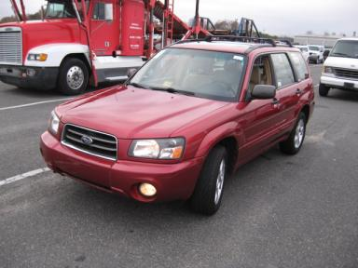 | 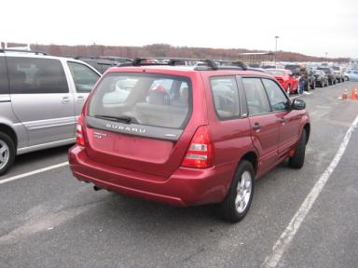
  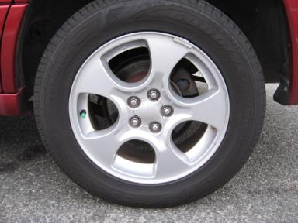 | 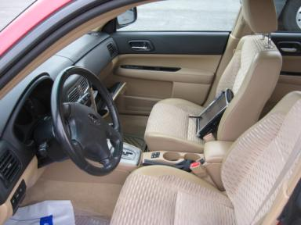
  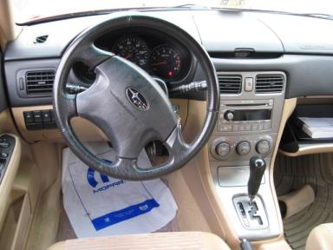 | 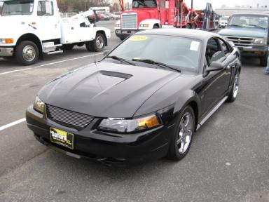
  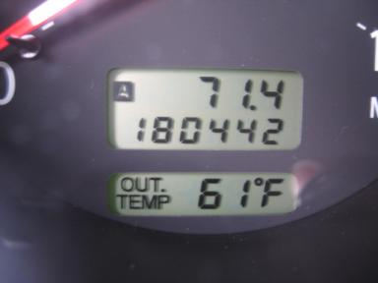
  
  Grade 2.9 Below Average
  More About Auto Grade
  MMR: - ¤ 3 820
  MSRP - Not Available
  Certified - No
  Drivable - Yes

VEHICLE INFORMATION
OPTIONS
Pwr Lock  A/C  Side Air Bags  ABS Brakes  Rear Wiper  Floor Mats |  | Pwr Steering  Cruise Ctl  Dual Air Bags  Tinted Windows  NO Rear Air Conditioning |  | Pwr Window  Rear Defrost  Power Mirrors  Fog Lamps  Power Trunk/Liftgate |  | Tilt Steering  CD Player  Owner's Manual  Trip Counter  NO Third Seat

MECHANICAL | INTERIOR
  4 Cylinder Gas
  Automatic
  AWD
  Pwr Brakes
  2.5 L
  Odometer - 6 Digits Digital - Operable
  Average
  TAN - Cloth
  Int Odor: OK
  Regular Dash
TIRES AND WHEELS
  Tire Condition: | Good | Wheels: | Alloy
  Tire | Tread Depth | Brand | Size
  Left Front: | 8/32" | GOODYEAR | 215/60R16
  Left Rear: | 8/32" | GOODYEAR | 215/60R16
  Right Front: | 8/32" | GOODYEAR | 215/60R16
  Right Rear: | 8/32" | GOODYEAR | 215/60R16
  Spare: | 10/32" | GOODYEAR | 215/60R16
  KEYS
  Master Key - 2
  OTHER
  Title State:
  Title Date: N/A

ADDITIONAL INFORMATION
AWD 100K+ T/A
Common Abbreviations

DAMAGES - SUGGESTED REPAIRS
Suggested repairs are based on Manheim professional inspector's recommendation.
Total labor hours include paint, body or repair estimates.
 | DESCRIPTION | CONDITION | SEVERITY | SUGGESTED  REPAIR | TOTAL  LABOR  HOURS
 | Front Bumper Co | Scratched | 1" to 2" | Airbrush | .00
 | Hood | Chipped | 2 | Paint Chip Repair | .00
 | LF Fender | Dent | > 1/8" | Repair | 3.80
 | LF Door | Dent/No Paint Dmg | PDR/2 | PDR | .00
 | LR Door | Dent/No Paint Dmg | PDR/3 | PDR | .00
 | L Qtr Panel | Dent | 1/2" to 1" | Repair | 4.10
 | Rear Bumper Cov | Chipped | 2 | Paint Chip Repair | .00
 | Rear Bumper Cov | Scratch Light | 3" to 4" | Wet Sand | .00
 | RF Fender | Chipped | 1 | Paint Chip Repair | .00
 | RF Door | Dent/No Paint Dmg | PDR/2 | PDR | .00
 | RF Door Molding | Chipped | 3 | Paint Chip Repair | .00
 | RR Door | Dent | 1" to 2" | Repair | 3.80
 | R Qtr Panel | Dent/Paint Dmg | 1/2" to 1" | Repair | 4.10
 | RF Fender | Prev Repair | Acceptable | No Action Required | .00
 | RF Door | Prev Repair | Acceptable | No Action Required | .00
 | RR Door | Prev Repair | Acceptable | No Action Required | .00
 |  |  |  | TOTALS | 15.80

VIN: JF1SG65604H732677, Work Order: 7069004

