Manheim Omaha
9201 South 144th St
Omaha, NE 68138
(402) 896-8000

VEHICLE DETAILS - 2000 LEXUS RX300
VIN: | JT6HF10U5Y0145788 | Body Style: | 4CUV | Top Type: | Moon Roof
Ext Color: | SILVER | Int Color: | GRY | Odometer: | 194,564
Work Order: | 8053173 | Seller: | ACURA OF JOHNSTON | Received Date: | 12/07/2009
Sale Number: | 49 | Lane Number: | 1 | Run Number: | 41
Inspector: | LCUNNINGH2 12/07/2009

VEHICLE IMAGES
 |  |  | GRADING
  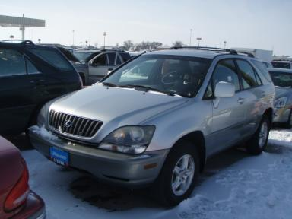 | 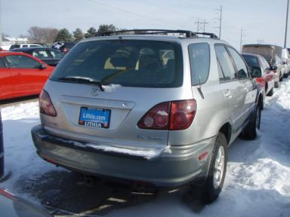
  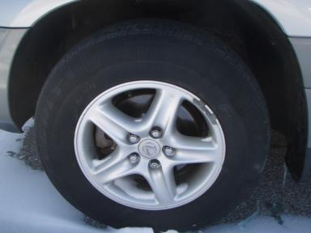 | 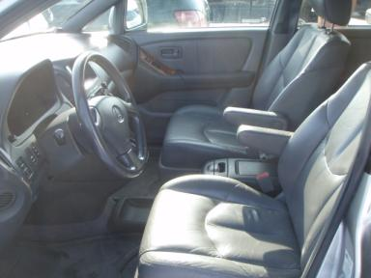
  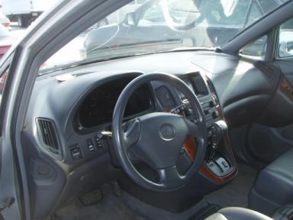 | 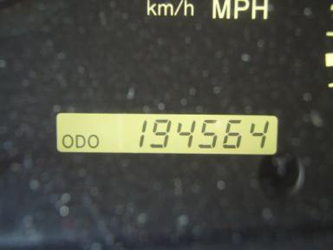
  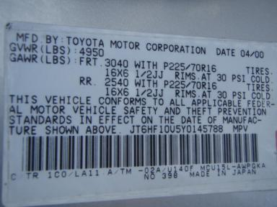
  
  Grade 2.6 Below Average
  More About Auto Grade
  MMR: - ¤ 5 407
  MSRP - Not Available
  Certified - No
  Drivable - Yes

VEHICLE INFORMATION
OPTIONS
Pwr Lock  Tilt Steering  Tape/CD  Trip Counter  Heated Seats |  | Pwr Steering  A/C  Dual Air Bags  NO Rear Air Conditioning |  | Pwr Window  Cruise Ctl  Power Mirrors  NO Third Seat |  | Pwr Seats - Both  Rear Defrost  Owner's Manual  US EPA Label

MECHANICAL | INTERIOR
  6 Cylinder Gas
  Automatic
  AWD
  Pwr Brakes
  3.0 L
  Odometer - 6 Digits Analog - Operable
  Average
  GRY - Leather
  Int Odor: OK
TIRES AND WHEELS
  Tire Condition: |  | Wheels:
  Tire | Tread Depth | Brand | Size
  Left Front: | 5/32" | GOODYEAR | 225/70R16
  Left Rear: | 4/32" | GOODYEAR | 225/70R16
  Right Front: | 5/32" | GOODYEAR | 225/70R16
  Right Rear: | 4/32" | GOODYEAR | 225/70R16
  Spare: | 0/32" | (Mini)
  KEYS
  Master Key - 2
  OTHER
  Title State:
  Title Date: N/A

ADDITIONAL INFORMATION
AS IS
Common Abbreviations

DAMAGES - SUGGESTED REPAIRS
Suggested repairs are based on Manheim professional inspector's recommendation.
Total labor hours include paint, body or repair estimates.
 | DESCRIPTION | CONDITION | SEVERITY | SUGGESTED  REPAIR | TOTAL  LABOR  HOURS
 | Front Bumper | Chipped | 4 | Paint Chip Repair | .00
 | Hood | Chipped | 10 or More | Refinish | 3.80
 | Roof | Dent/No Paint Dmg | PDR/2 | PDR | .00
 | LF Fender | Chipped | 8 | Paint Chip Repair | .00
 | LF Door | Dent/No Paint Dmg | PDR/3 | PDR | .00
 | LR Door | Dent/No Paint Dmg | PDR/2 | PDR | .00
 | L Qtr Panel | Dent/Paint Dmg | 1" to 2" | Repair | 3.80
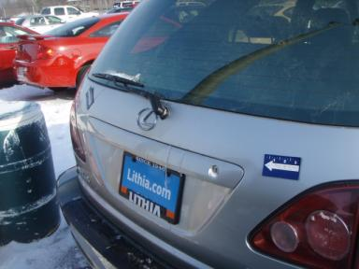 | Lift Gate | Dent | 1" to 2" | Repair | 5.10
 | Rear Bumper | Scratched | 1/2" to 1" | Airbrush | .00
 | RF Fender | Chipped | 7 | Paint Chip Repair | .00
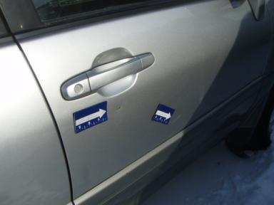 | RF Door | Dent/Paint Dmg | 1" to 2" | Repair | 4.80
 | RR Door | Mult Scratches | 1/2" to 1" | Airbrush | .00
 | R Qtr Panel | Dent | 1" to 2" | Repair | 4.30
 | Rear View Mirro | Missing | Replacement Req | Replace | .20
 | LF Seat | Worn | 8" to 9" | Replace | .20
 | Light Brighteni | Value Added | None | Install New | .00
 | Windshield | Chipped | < 1/8" | No Action Required | .00
 | R Qtr Panel | Prev Repair | Acceptable | No Action Required | .00
 |  |  |  | TOTALS | 22.20

VIN: JT6HF10U5Y0145788, Work Order: 8053173


© 2009 Manheim All Rights Reserved

