Manheim Pennsylvania
1190 Lancaster Rd
Manheim, PA 17545-9789
(717) 665-3571

VEHICLE DETAILS - 2004 LEXUS RX330
VIN: | JTJHA31U340030731 | Body Style: | 4SUV | Top Type: | Pwr Glass Sun Roof
Ext Color: | BLUE- 8R6 | Int Color: | BLK | Odometer: | 91,355
Work Order: | 2463059 | Seller: | AUTOLENDERS LIQUIDATION CENTER | Received Date: | 12/05/2009
Sale Number: | 74 | Lane Number: | 19 | Run Number: | 560
Inspector: | BGRAHAM 12/07/2009

VEHICLE IMAGES
 |  |  | GRADING
  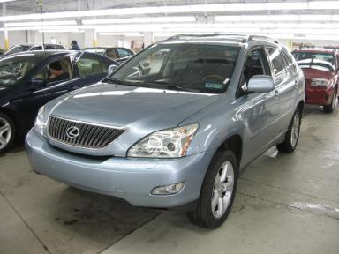 | 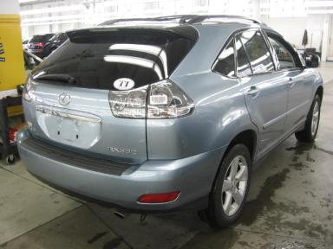
  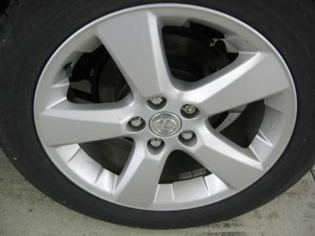 | 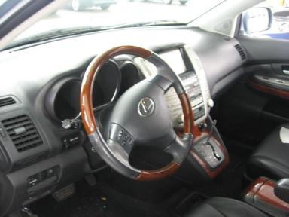
  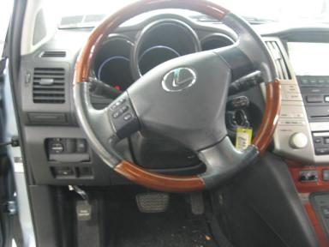 | 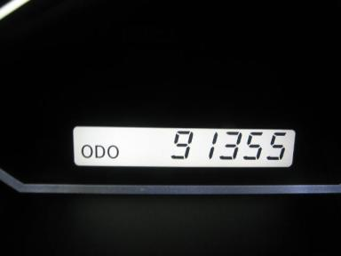
  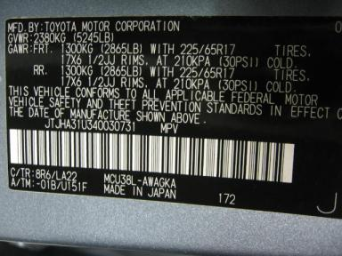
  
  Grade 4.3 Clean
  More About Auto Grade
  MMR: - ¤ 14 861
  MSRP - Not Available
  Certified - No
  Drivable - Yes

VEHICLE INFORMATION
OPTIONS
Pwr Lock  A/C  Side Air Bags  Heated Mirrors  Fog Lamps  Rear Wiper  Luggage Rack  Security System |  | Pwr Steering  Cruise Ctl  Dual Air Bags  Owner's Manual  Maintenance Records  Power Trunk/Liftgate  Floor Mats  Steering Wheel Audio Control |  | Pwr Window  Rear Defrost  50 State Emissions  ABS Brakes  Trip Counter  Warranty Books  Xenon Headlights  Rear View Camera |  | Pwr Seats - Both  Tape/CD  Power Mirrors  Tinted Windows  CD Changer - OEM - 6.00  Trip Computer  US EPA Label

MECHANICAL | INTERIOR
  6 Cylinder Gas
  Automatic
  AWD
  Pwr Brakes
  3.3 L
  Average
  BLK - Leather
  Int Odor: OK
  Regular Dash
TIRES AND WHEELS
  Tire Condition: | Poor | Wheels: | Alloy
  Tire | Tread Depth | Brand | Size
  Left Front: | 8/32" | BRIDGESTONE | 235/55R18
  Left Rear: | 3/32" | MICHELIN | 235/55R18
  Right Front: | 8/32" | BRIDGESTONE | 235/55R18
  Right Rear: | 3/32" | MICHELIN | 235/55R18
  Spare: | 9/32" | BRIDGESTONE | 235/55R18
  OTHER
  Title State: PA
  Title Date: 12/11/2009

ADDITIONAL INFORMATION
AWD;KEY;KNOB
KEY SHIFT KNOB BAGGED
Common Abbreviations

DAMAGES - SUGGESTED REPAIRS
Suggested repairs are based on Manheim professional inspector's recommendation.
Total labor hours include paint, body or repair estimates.
 | DESCRIPTION | CONDITION | SEVERITY | SUGGESTED  REPAIR | TOTAL  LABOR  HOURS
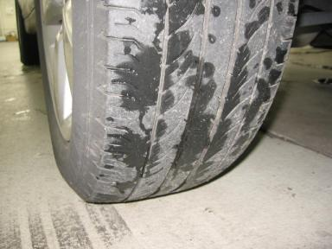 | LR Tire | Worn | Replacement Req | Replace | .00
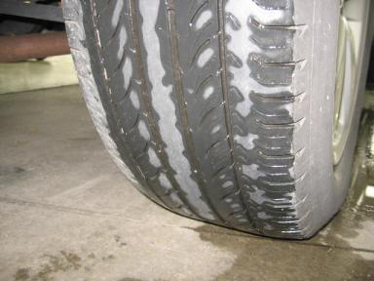 | RR Tire | Worn | Replacement Req | Replace | .00
 | RF Door | Prev Repair | Acceptable | No Action Required | .00
 | RR Door | Prev Repair | Acceptable | No Action Required | .00
 | R Qtr Panel | Prev Repair | Acceptable | No Action Required | .00
 |  |  |  | TOTALS | .00

VIN: JTJHA31U340030731, Work Order: 2463059


© 2009 Manheim All Rights Reserved

