Manheim Baltimore-Washington
7120 Dorsey Run Rd
Elkridge, MD 21075
(410) 796-8899

VEHICLE DETAILS - 2001 TOYOTA RAV-4 AWD L
VIN: | JTEHH20VX10080729 | Body Style: | 4CUV | Top Type: | Sun Roof
Ext Color: | SILVER | Int Color: | GRY | Odometer: | 96,199
Work Order: | 8086552 | Seller: | SHEEHY FORD | Received Date: | 12/08/2009
Sale Number: | 50 | Lane Number: | 2 | Run Number: | 22
Inspector: | DENGEL1 12/09/2009

VEHICLE IMAGES
 |  |  | GRADING
  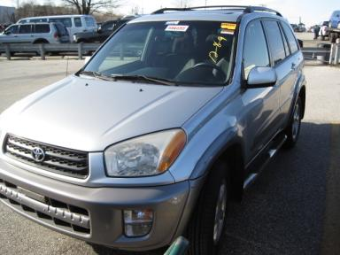 | 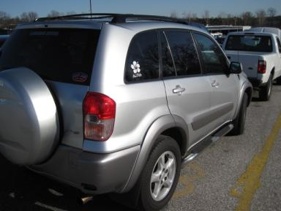
  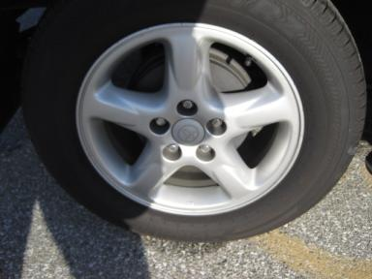 | 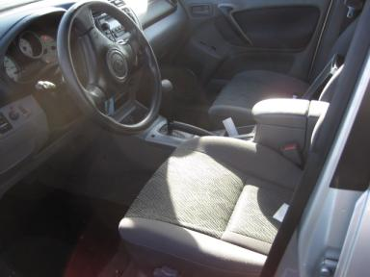
  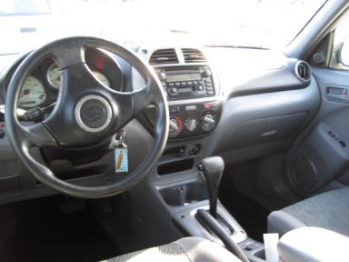 | 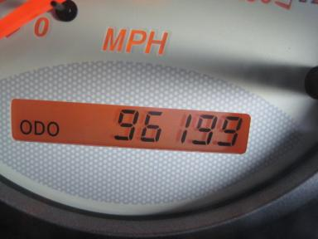
  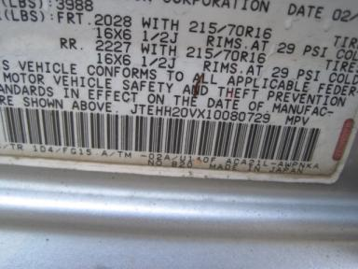
  
  Grade 4.5 Clean
  More About Auto Grade
  MMR: - ¤ 8 087
  MSRP - Not Available
  Certified - No
  Drivable - Yes

VEHICLE INFORMATION
OPTIONS
Pwr Lock  A/C  Dual Air Bags  4 Door  NO Rear Air Conditioning  Floor Mats  Cargo Net |  | Pwr Steering  Cruise Ctl  49 State Emissions  Fog Lamps  Luggage Rack  US EPA Label |  | Pwr Window  Rear Defrost  Power Mirrors  Trip Counter  NO Third Seat  Running Board |  | Tilt Steering  Tape/CD  Tinted Windows  Rear Wiper  5 Passenger Seating  2 Captain Seats 1 Bench

MECHANICAL | INTERIOR
  4 Cylinder Gas
  Automatic
  AWD
  Pwr Brakes
  2.0 L
  Odometer - 6 Digits Digital - Operable
  Average
  GRY - Cloth
  Int Odor: OK
  Regular Dash
TIRES AND WHEELS
  Tire Condition: | Good | Wheels: | Alloy
  Tire | Tread Depth | Brand | Size
  Left Front: | 11/32" | YOKOHAMA | 235/60R16
  Left Rear: | 8/32" | YOKOHAMA | 235/60R16
  Right Front: | 11/32" | YOKOHAMA | 235/60R16
  Right Rear: | 9/32" | YOKOHAMA | 235/60R16
  Spare: | 7/32" | YOKOHAMA | 235/60R16
  KEYS
  Master Key - 1
  Remote Key/Fob - 1
  OTHER
  Title State: MD
  Title Date: 12/14/2009

ADDITIONAL INFORMATION
Common Abbreviations

DAMAGES - SUGGESTED REPAIRS
Suggested repairs are based on Manheim professional inspector's recommendation.
Total labor hours include paint, body or repair estimates.
 | DESCRIPTION | CONDITION | SEVERITY | SUGGESTED  REPAIR | TOTAL  LABOR  HOURS
 | LF Fender | Dent | 1" to 2" | Repair | 4.30
 | LF Fender | Scratched | 2" to 3" | Included | .00
 | L Fender Flare | Gouged | 1" to 2" | Repair | 1.00
 | R Fender Flare | Scratched | 1" to 2" | Airbrush | .00
 | RR Door | Dent/No Paint Dmg | PDR/1 | PDR | .00
 | Warranty Books | Missing | Replacement Req | Replace | .00
 | Owners manuals | Missing | Replacement Req | Replace | .00
 | Gas | Low Fluid | Replacement Req | Replace | .00
 | Light Brighteni | Value Added | None | Install New | .00
 |  |  |  | TOTALS | 5.30

VIN: JTEHH20VX10080729, Work Order: 8086552

