Manheim Chicago
20401 Cox Ave
Matteson, IL 60443
(815) 806-4222

VEHICLE DETAILS - 2004 LEXUS GX470
VIN: | JTJBT20X340053822 | Body Style: | 4SUV | Top Type: | Pwr Glass Sun Roof
Ext Color: | BLACK | Int Color: | GRY | Odometer: | 149,549
Work Order: | 9039604 | Seller: | WELLS FARGO FINANCIAL ACCEPTANCE | Received Date: | 12/10/2009
Sale Number: | 53 | Lane Number: | 29 | Run Number: | 66
Inspector: | JSTROZ 12/11/2009

VEHICLE IMAGES
 |  |  | GRADING
  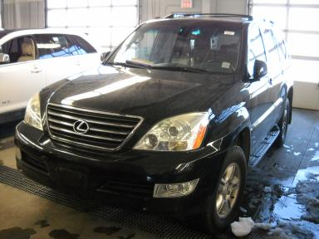 | 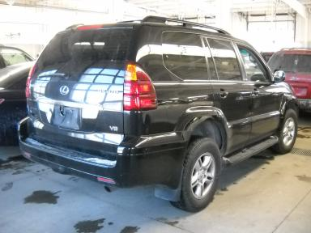
  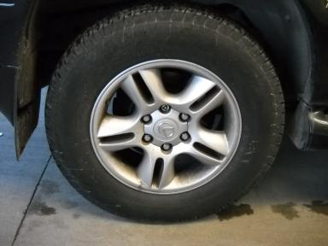 | 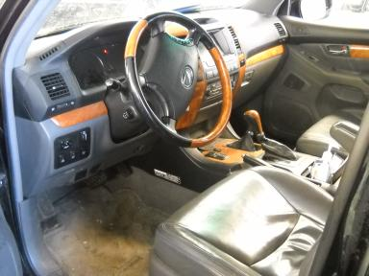
  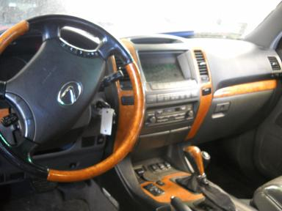 | 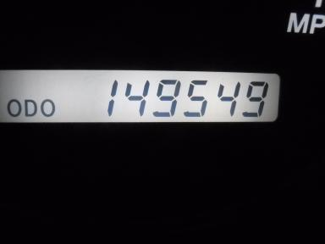
  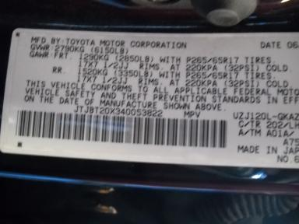
  Grade 3.0 Average
  MSRP - Not Available
  Certified - No
  Drivable - Yes

VEHICLE INFORMATION
OPTIONS
Pwr Lock  Tilt Steering  Tape/CD  Owner's Manual  Fog Lamps  Rear Wiper  Luggage Rack  Running Board  Trailer Plug  Memory Seat  Navigation System |  | Pwr Steering  A/C  Dual Air Bags  ABS Brakes  Trip Counter  Power Trunk/Liftgate  7 Passenger Seating  Steering Wheel Audio Control  Dual Air Conditioning  Woodgrain Interior Package  Rear Radio Controls |  | Pwr Window  Cruise Ctl  Power Mirrors  Tinted Windows  Rear Air Conditioning  Warranty Books  US EPA Label  Trailer Hitch  HomeLink  Power Telescopic Steering |  | Pwr Seats - Both  Rear Defrost  Heated Mirrors  4 Door  CD Changer - OEM - 6.00  Third Seat  Step Bumper  Traction Control  Heated Seats  Power Tilt Steering

MECHANICAL | INTERIOR
  8 Cylinder Gas
  Automatic
  4X4
  Pwr Brakes
  4.7 L
  Odometer - 6 Digits Digital - Operable
  Average
  GRY - Leather
  Int Odor: OK
TIRES AND WHEELS
  Tire Condition: | Average | Wheels: | Alloy
  Tire | Tread Depth | Brand | Size
  Left Front: | 7/32" | MICHELIN | 265/65R17
  Left Rear: | 7/32" | MICHELIN | 265/65R17
  Right Front: | 7/32" | MICHELIN | 265/65R17
  Right Rear: | 7/32" | MICHELIN | 265/65R17
  Spare: | 0/32" | (Mini)
  KEYS
  Combo Key - 2
  OTHER
  Title State: IL
  Title Date: 12/18/2009

ADDITIONAL INFORMATION
4X4 AS-IS MILES OVER, BOOKS IN F/L
*ENGINE LITE ON
Common Abbreviations

DAMAGES - SUGGESTED REPAIRS
Suggested repairs are based on Manheim professional inspector's recommendation.
Total labor hours include paint, body or repair estimates.
 | DESCRIPTION | CONDITION | SEVERITY | SUGGESTED  REPAIR | TOTAL  LABOR  HOURS
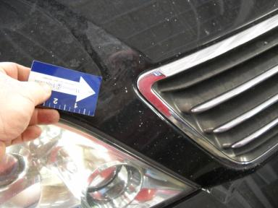 | Hood | Chipped | 10 or More | Refinish | 3.80
 | Roof | Dent | 1" to 2" | Included | .00
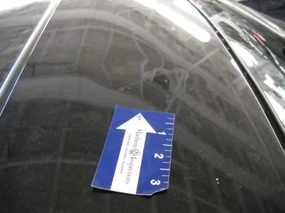 | Roof | Dent/Paint Dmg | 2" to 3" | Repair | 8.30
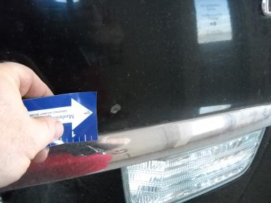 | Rear Door | Dent/Paint Dmg | > 1/8" | Repair | 4.60
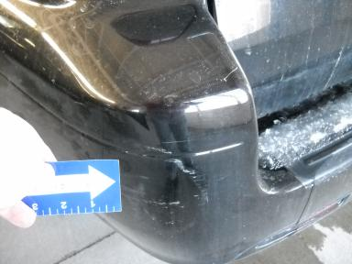 | Rear Bumper Cov | Scratch Light | 2" to 3" | Wet Sand | .00
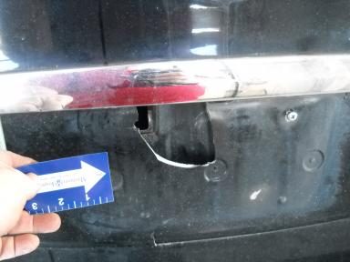 | Rear License Br | Broken GARNISH | Replacement Req | Replace | .50
 | Warning - Engin | On | Unacceptable | Ck/Advise | 1.00
 | Warning - Tire | On | Unacceptable | Ck/Advise | 1.00
 | Warning - Maint | On | Unacceptable | Ck/Advise | 1.00
 | Oil | Dirty | Unacceptable | Replace | .00
 | Gas | Low Fluid | Replacement Req | Replace | .00
 |  |  |  | TOTALS | 20.20

VIN: JTJBT20X340053822, Work Order: 9039604


© 2009 Manheim All Rights Reserved

