Manheim Chicago
20401 Cox Ave
Matteson, IL 60443
(815) 806-4222

VEHICLE DETAILS - 2001 LEXUS RX300
VIN: | JTJHF10U110207473 | Body Style: | 4CUV | Top Type: | Pwr Glass Sun Roof
Ext Color: | BLUE- 8P6/LB00 | Int Color: | BEI | Odometer: | 150,687
Work Order: | 4311632 | Seller: | MCGRATH LEXUS OF CHICAGO | Received Date: | 12/16/2009
Sale Number: | 2 | Lane Number: | 7 | Run Number: | 117
Inspector: | SVOSS 12/16/2009

VEHICLE IMAGES
 |  |  | GRADING
  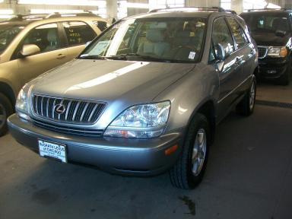 | 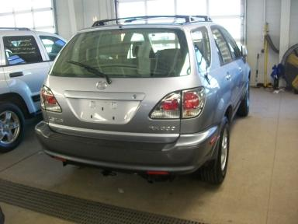
  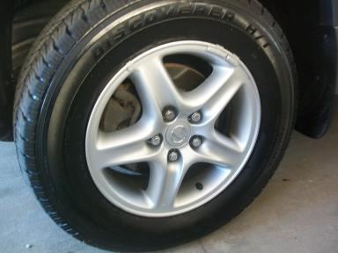 | 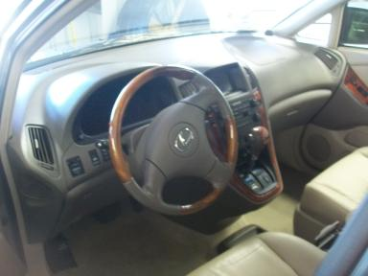
  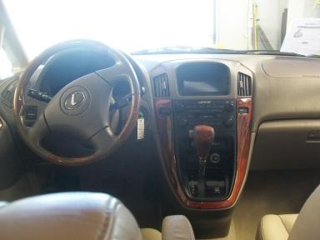 | 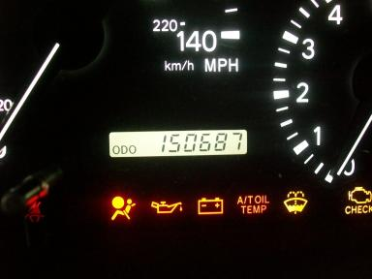
  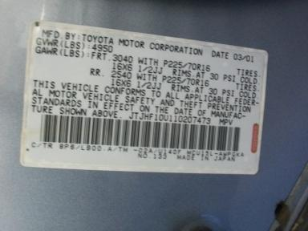
  
  Grade 3.5 Average
  More About Auto Grade
  MSRP - Not Available
  Certified - No
  Drivable - Yes

VEHICLE INFORMATION
OPTIONS
Pwr Lock  Tilt Steering  Cassette Tape  ABS Brakes  CD Changer - 6.00  Luggage Rack  US EPA Label  Trailer Hitch  Heated Seats |  | Pwr Steering  A/C  Dual Air Bags  Tinted Windows  Rear Wiper  NO Third Seat  Security System  Traction Control  Memory Seat |  | Pwr Window  Cruise Ctl  Power Mirrors  4 Door  NO Rear Air Conditioning  5 Passenger Seating  Step Bumper  Trailer Plug  Woodgrain Interior Package |  | Pwr Seats - Both  Rear Defrost  Owner's Manual  Trip Counter  Warranty Books  Floor Mats  Power Antenna  HomeLink

MECHANICAL | INTERIOR
  6 Cylinder Gas
  Automatic
  AWD
  Pwr Brakes
  3.0 L
  Odometer - 6 Digits Digital - Operable
  Clean
  BEI - Leather
  Int Odor: OK
  Wood Trim Dash
TIRES AND WHEELS
  Tire Condition: | Good | Wheels: | Alloy
  Tire | Tread Depth | Brand | Size
  Left Front: | 8/32" | COOPER | 225/70R16
  Left Rear: | 7/32" | COOPER | 225/70R16
  Right Front: | 7/32" | COOPER | 225/70R16
  Right Rear: | 8/32" | COOPER | 225/70R16
  Spare: | 0/32" | (Mini)
  KEYS
  Combo Key - 1
  OTHER
  Title State:
  Title Date: 12/17/2009

ADDITIONAL INFORMATION
AG RT FRONT WINDOW INOP MO
Common Abbreviations

DAMAGES - SUGGESTED REPAIRS
Suggested repairs are based on Manheim professional inspector's recommendation.
Total labor hours include paint, body or repair estimates.
 | DESCRIPTION | CONDITION | SEVERITY | SUGGESTED  REPAIR | TOTAL  LABOR  HOURS
 | Front Bumper Co | Chipped | 10 or More | Refinish | 3.50
 | Front Bumper Co | Mult Scratches | 1" to 2" | Included | .00
 | Hood | Chipped | 10 or More | Included | .00
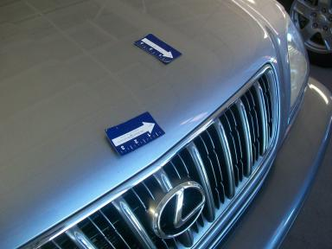 | Hood | Dent | 1" to 2" | Repair | 5.80
 | Hood | Multiple Dents | 1" to 2" | Included | .00
 | Roof | Dent/No Paint Dmg | PDR/1 | PDR | .00
 | LF Fender | Dent/No Paint Dmg | PDR/2 | PDR | .00
 | LF Door | Dent/No Paint Dmg | PDR/1 | PDR | .00
 | LR Door | Dent/No Paint Dmg | PDR/1 | PDR | .00
 | L Qtr Panel | Chipped | 1 | Paint Chip Repair | .00
 | L Qtr Panel | Dent/No Paint Dmg EDGE | PDR/2 | PDR | .00
 | L Fuel Door | Dent | PDR/1 | PDR | .00
 | Lift Gate | Dent/No Paint Dmg | PDR/1 | PDR | .00
 | Rear Bumper Cov | Chipped | 6 | Included | .00
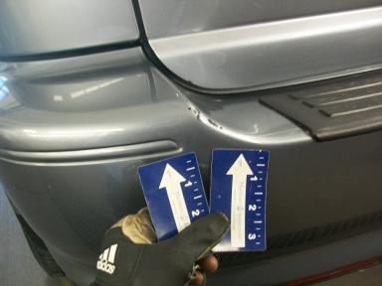 | Rear Bumper Cov | Prev Repair | Substd Repair | Repair | 5.10
 | RF Fender | Chipped | 7 | Paint Chip Repair | .00
 | RF Door | Dent/No Paint Dmg | PDR/1 | PDR | .00
 | RR Door | Dent/No Paint Dmg | PDR/2 | PDR | .00
 | R Qtr Panel | Dent/No Paint Dmg | PDR/3 | PDR | .00
 | Windshield | Chipped | < 1/8" | No Action Required | .00
 |  |  |  | TOTALS | 14.40

VIN: JTJHF10U110207473, Work Order: 4311632

