Manheim Riverside
6446 Fremont St
Riverside, CA 92504-1437
(951) 689-6000

VEHICLE DETAILS - 2000 BMW X5 4.4L
VIN: | WBAFB3359YLH04267 | Body Style: | 4CUV | Top Type: | Sun Roof
Ext Color: | BLACK | Int Color: | GRY | Odometer: | 123,269
Work Order: | 5475874 | Seller: | CENTERONE/MASSACHUSETTS CREDIT UNION LEAGUE | Received Date: | 12/02/2009
Sale Number: | 2 | Lane Number: | 90 | Run Number: | 87
Inspector: | CBRIDDLE 12/03/2009

VEHICLE IMAGES
 |  |  | GRADING
  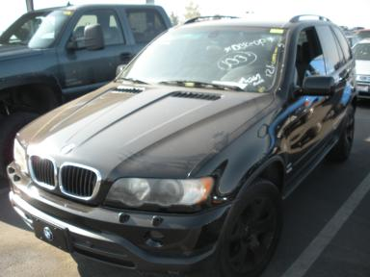 | 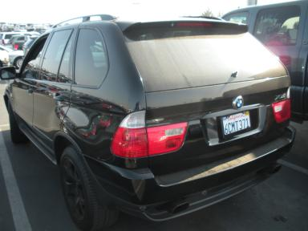
  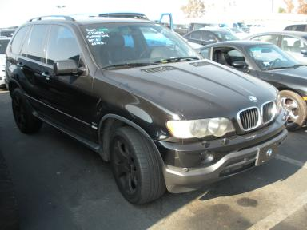 | 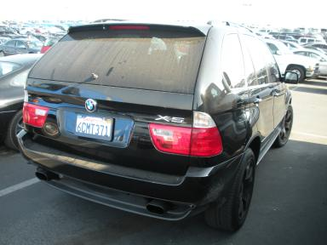
  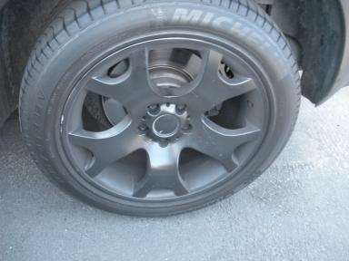 | 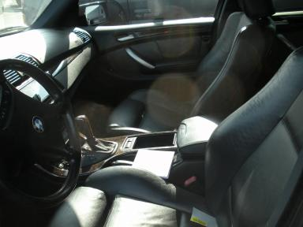
  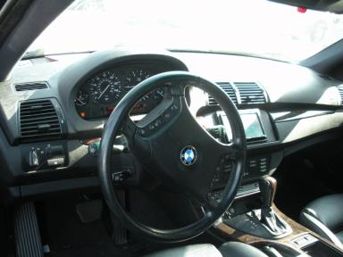 | 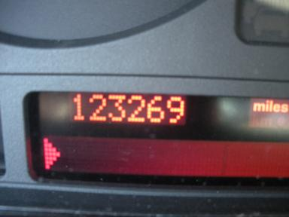
  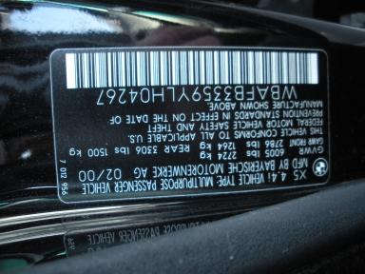 | 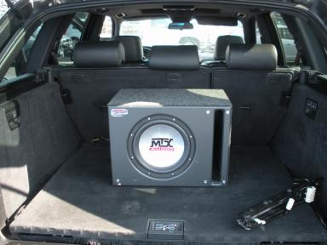
  
  Grade 3.8 Average
  More About Auto Grade
  MSRP - Not Available
  Certified - No
  Drivable - Yes

VEHICLE INFORMATION
OPTIONS
Pwr Lock  A/C  Side Air Bags  ABS Brakes  Rear Wiper  Security System  Dual Air Conditioning  Power Tilt Steering |  | Pwr Steering  Cruise Ctl  Dual Air Bags  Premium Stereo - KENWOOD  Trip Computer  NO US EPA Label  Heated Seats |  | Pwr Window  Rear Defrost  49 State Emissions  Tinted Windows  Keyless Entry  Steering Wheel Audio Control  Woodgrain Interior Package |  | Tilt Steering  CD Player  Power Mirrors  Fog Lamps  Floor Mats  Traction Control  Power Telescopic Steering

MECHANICAL | INTERIOR
  8 Cylinder Gas
  Automatic
  AWD
  Pwr Brakes
  0.1 L
  Odometer - 6 Digits Digital - Operable
  Average
  GRY - Leather
  Int Odor: OK
  Wood Trim Dash
TIRES AND WHEELS
  Tire Condition: | Average | Wheels: | Alloy
  Tire | Tread Depth | Brand | Size
  Left Front: | 6/32" | CONTINENTAL | 275/45R19
  Left Rear: | 8/32" | MICHELIN | 275/45R19
  Right Front: | 6/32" | CONTINENTAL | 275/45R19
  Right Rear: | 6/32" | MICHELIN | 275/45R19
  Spare: | 0/32"
  KEYS
  Combo Key - 1
  OTHER
  Title State: CA
  Title Date: 01/08/2010

ADDITIONAL INFORMATION
DMV $15 AS IS OVER 100
Common Abbreviations

DAMAGES - SUGGESTED REPAIRS
Suggested repairs are based on Manheim professional inspector's recommendation.
Total labor hours include paint, body or repair estimates.
 | DESCRIPTION | CONDITION | SEVERITY | SUGGESTED  REPAIR | TOTAL  LABOR  HOURS
 | Front Bumper | Mult Scratches | 1" to 2" | Airbrush | .00
 | Header Panel | Misaligned | 5" to 6" | Align/Adjust | 1.00
 | LF Door | Dent/No Paint Dmg | PDR/4 | PDR | .00
 | LR Door | Dent/No Paint Dmg | PDR/2 | PDR | .00
 | L Qtr Panel | Dent/No Paint Dmg | PDR/2 | PDR | .00
 | Rear Wiper | Missing | Replacement Req | Replace | .20
 | RF Fender | Dent/No Paint Dmg | PDR/2 | PDR | .00
 | RF Door | Dent/No Paint Dmg | PDR/2 | PDR | .00
 | RR Door | Dent/No Paint Dmg | PDR/3 | PDR | .00
 | Hood | Replaced | Acceptable | No Action Required | .00
 | LF Door | Scratch Light | 1/2" to 1" | Wet Sand | .00
 | RF Door | Scratch Light | 1" to 2" | Wet Sand | .00
 | RR Door | Scratch Light | 2" to 3" | Wet Sand | .00
 |  |  |  | TOTALS | 1.20

VIN: WBAFB3359YLH04267, Work Order: 5475874

