  Year: | 2000
  Make: | AUDI
  Model: | A6
  Mileage: | 99,075
  Ext. Color: | Tan
  Color Desc: | Tan
  Int. Color: | UNAVAIL
  Air Bag Type: | Dual Airbags
  Body Style: | Sedan
  Door Type: | Four Door
  Drive Train: | All wheel drive
  Engine Type: | 6 Cylinder Gasoline
  Frame Damage: | NOT PROVIDED
  Fuel Used: | Gasoline
  Prior Paint: | NOT PROVIDED
  Radio: | Unavailable
  VEHICLE LOCATION:
  Vehicle Type:
  Transmission: | Automatic Transmission
  Interior Type: | Leather Interior
  Vin#: | WAUEH24B1YN070897
  Comments: | AWD 2.8 eng. runs and drives fantastic.WARRANTY AND FINANCING AVAIL.TRADES WELCOME.
  Installed Options: | Alloy Wheels
   | Child Seat
   | Power Mirrors
   | Rear Defroster
   | Air Conditioning
   | Tilt Wheel
   | Power Windows
   | Power Steering
   | Power Seats
   | Power Locks
   | Cruise Control
   | Brakes
  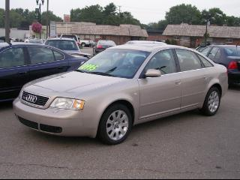
  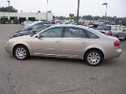 | 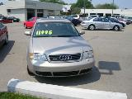

Copyright © 1996-2008 Manheim Auctions.
For product inquiry or support, e-mail us at info@manheim.com or call Manheim Online at 1-800-377-4343

