Manheim Fredericksburg
120 Auction Dr
Fredericksburg, VA 22406
(540) 368-3400

VEHICLE DETAILS - 2001 TOYOTA RAV-4 AWD BASE
VIN: | JTEHH20V410027668 | Body Style: | 4CUV
Ext Color: | SILVER | Int Color: | GRY | Odometer: | 111,129
Work Order: | 7071892 | Seller: | BROWN TOYOTA | Received Date: | 01/25/2010
Sale Number: | 4 | Lane Number: | 9 | Run Number: | 99
Inspector: | MPOTTER 01/26/2010 | InService Date: | N/A

VEHICLE IMAGES
 |  |  | GRADING
  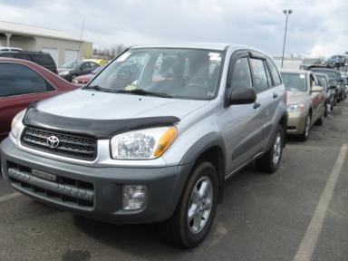 | 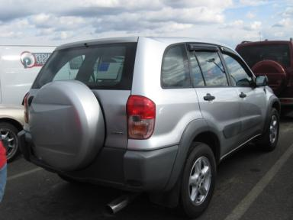
  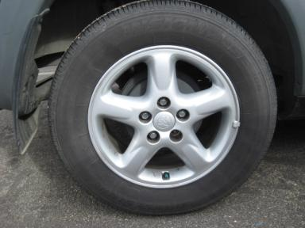 | 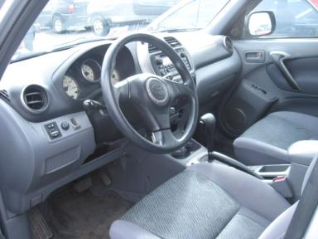
  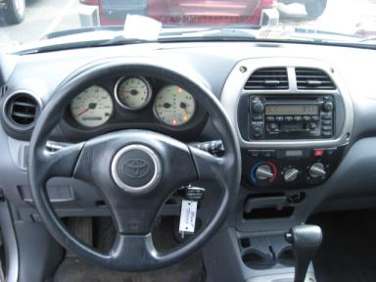 | 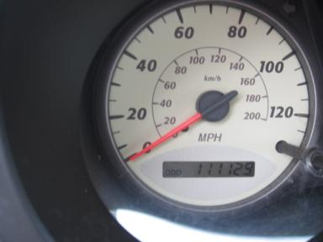
  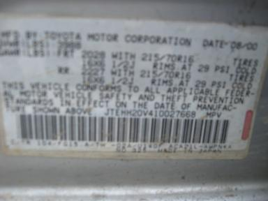
  
  Grade 3.4 Average
  More About Auto Grade
  MSRP - Not Available
  Certified - No
  Drivable - Yes

VEHICLE INFORMATION
OPTIONS
Pwr Locks  A/C  Dual Air Bags  4 Door  Floor Mats |  | Pwr Steering  Cruise Ctl  Power Mirrors  Fog Lamps  US EPA Label |  | Pwr Windows  Rear Defrost  Owner's Manual  Trip Counter  Rain Shields |  | Tilt Steering  CD Player  ABS Brakes  Rear Wiper  Bug Deflector

MECHANICAL | INTERIOR
  4 Cylinder Gas
  Automatic
  AWD
  Pwr Brakes
  2.0 L
  Odometer - 6 Digits Analog - Operable
  Cloth - GRY
  Regular Dash
  Int Odor: OK
  Interior Condition - Clean
TIRES AND WHEELS
  Tire Condition: | Good | Wheels: | Alloy
  Tire | Tread Depth | Brand | Size
  Left Front: | 8/32" | BRIDGESTONE | 235/60R16
  Left Rear: | 9/32" | BRIDGESTONE | 235/60R16
  Right Front: | 8/32" | BRIDGESTONE | 235/60R16
  Right Rear: | 9/32" | BRIDGESTONE | 235/60R16
  Spare: | 11/32" | BRIDGESTONE | 235/60R16
  KEYS
  Master Key - 3
  Remote Key/Fob - 2
  OTHER
  Title State: VA
  Title Received Date: 01/28/2010

ADDITIONAL INFORMATION
AWD 100K+,
** ENGINE LIGHT ON
Common Abbreviations

DAMAGES - SUGGESTED REPAIRS
Suggested repairs are based on Manheim professional inspector's recommendation.
Total labor hours include paint, body or repair estimates.
 | DESCRIPTION | CONDITION | SEVERITY | SUGGESTED  REPAIR | TOTAL  LABOR  HOURS
 | Hood | Multiple Chips | 9 | Paint Chip Repair | .00
 | LF Fender | Multiple Chips | 2 | Paint Chip Repair | .00
 | LF Door Edge | Multiple Chips | 4 | Paint Chip Repair | .00
 | LR Door Edge | Multiple Chips | 5 | Paint Chip Repair | .00
 | Rear Bumper | Scratched | 1" to 2" | Airbrush | .00
 | RF Fender | Dent/No Paint Dmg | PDR/1 | PDR | .00
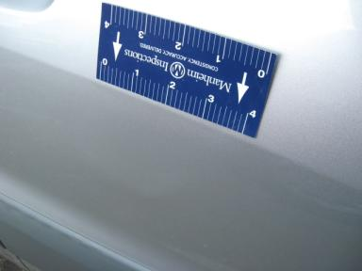 | RF Door | Mult Dents/No Paint Dmg MULTI DENTS | 2" to 3" | Repair | 6.80
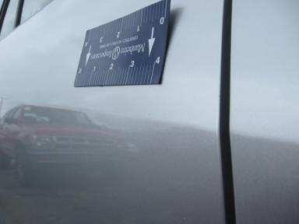 | RR Door | Mult Dents/No Paint Dmg | 1/8" to 1/2" | Repair | 5.80
 | Warning - Engine | On | Unacceptable | Ck/Advise | 1.00
 | Windshield | Chipped | < 1/8" | No Action Required | .00
 | LR Door | Prev Repair | Acceptable | No Action Required | .00
 |  |  |  | TOTALS | 13.60

VIN: JTEHH20V410027668, Work Order: 7071892

