Manheim Pennsylvania
1190 Lancaster Rd
Manheim, PA 17545-9789
(717) 665-3571

VEHICLE DETAILS - 2004 LEXUS RX330
VIN: | JTJHA31U940027879 | Body Style: | 4SUV | Top Type: | Pwr Glass Sun Roof
Ext Color: | BLUE | Int Color: | GRY | Odometer: | 88,712
Work Order: | 8647415 | Seller: | WESTFALL AUTO SALES | Received Date: | 01/11/2010
Sale Number: | 6 | Lane Number: | 19 | Run Number: | 621
Inspector: | STEVENC 01/14/2010 | InService Date: | N/A

VEHICLE IMAGES
 |  |  | GRADING
  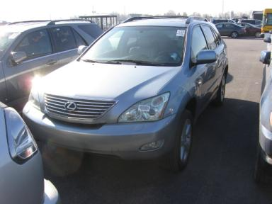 | 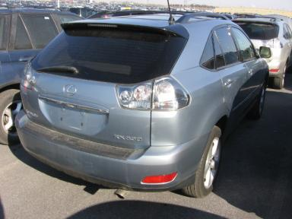
  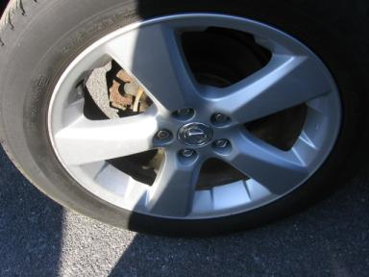 | 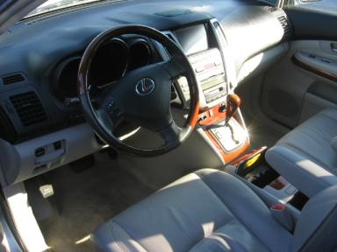
  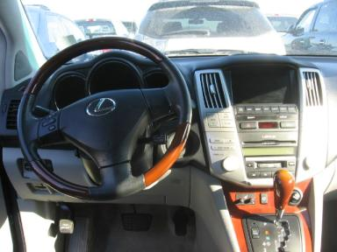 | 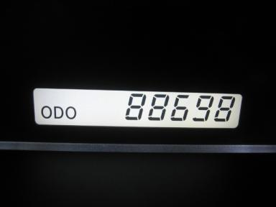
  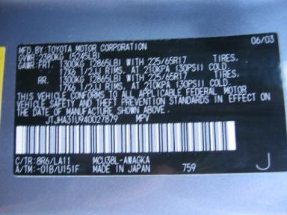
  
  Grade 4.0 Clean
  More About Auto Grade
  MSRP - Not Available
  Certified - No
  Drivable - Yes

VEHICLE INFORMATION
OPTIONS
Pwr Locks  Tilt Steering  Tape/CD  50 State Emissions  Tinted Windows  Rear Wiper  Trip Computer  Floor Mats  Step Bumper  HomeLink  Rear View Camera  Navigation System |  | Pwr Steering  A/C  Side Air Bags  Power Mirrors  4 Door  NO Rear Air Conditioning  Luggage Rack  Xenon Headlights  Steering Wheel Audio Control  Front Center Console  Woodgrain Interior Package  Parking Distance Control |  | Pwr Windows  Cruise Ctl  Dual Air Bags  Owner's Manual  Fog Lamps  Power Trunk/Liftgate  NO Third Seat  US EPA Label  Traction Control  Heated Seats  Power Telescopic Steering  Tire Pressure Monitor System |  | Pwr Seats - Both  Rear Defrost  CD Changer - OEM - 6  ABS Brakes  Trip Counter  Warranty Books  5 Passenger Seating  Security System  Dual Air Conditioning  Memory Seat  Power Tilt Steering

MECHANICAL | INTERIOR
  6 Cylinder Gas
  Automatic
  AWD
  Pwr Brakes
  3.3 L
  Odometer - Digits Analog - Operable
  Leather - GRY
  Int Odor: OK
  Wood Trim Dash
  Interior Condition - Average
TIRES AND WHEELS
  Tire Condition: |  | Wheels: | Alloy
  Tire | Tread Depth | Brand | Size
  Left Front: | 5/32" | MICHELIN | 235/55R18
  Left Rear: | 5/32" | MICHELIN | 235/55R18
  Right Front: | 5/32" | MICHELIN | 235/55R18
  Right Rear: | 5/32" | MICHELIN | 235/55R18
  Spare: | 0/32" | (Mini)
  KEYS
  Combo Key - 1
  OTHER
  Title State: MI
  Title Received Date: 01/29/2010

ADDITIONAL INFORMATION
Common Abbreviations

DAMAGES - SUGGESTED REPAIRS
Suggested repairs are based on Manheim professional inspector's recommendation.
Total labor hours include paint, body or repair estimates.
 | DESCRIPTION | CONDITION | SEVERITY | SUGGESTED  REPAIR | TOTAL  LABOR  HOURS
 | Front Bumper | Scratched | 3" to 4" | Refinish | 3.50
 | Rear Bumper | Mult Scratches/Heavy | 6" to 7" | Refinish | 3.60
 | RF Wheel | Curb Rash | 7" to 8" | Repair | .00
 | RF Door | Dent/No Paint Dmg | PDR/1 | PDR | .00
 | RR Wheel | Curb Rash | 3" to 4" | Repair | .00
 |  |  |  | TOTALS | 7.10

VIN: JTJHA31U940027879, Work Order: 8647415

