Manheim Imperial Florida
3300 County Line Rd
Lakeland, FL 33811
(863) 607-6000

VEHICLE DETAILS - 2000 TOYOTA LAND CRUISER
VIN: | JT3HT05JXY0092049 | Body Style: | 4SUV | Top Type: | Sun Roof
Ext Color: | BLACK | Int Color: | TAN | Odometer: | 186,417
Work Order: | 190104 | Seller: | FLORIDA AUTO & TRUCK EXCHANGE INC | Received Date: | 02/01/2010
Sale Number: | 6 | Lane Number: | 92 | Run Number: | 5
Inspector: | SSHERLOCK 02/03/2010 | InService Date: | N/A

VEHICLE IMAGES
 |  |  | GRADING
  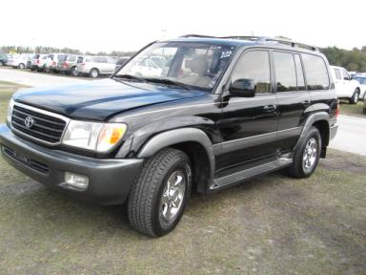 | 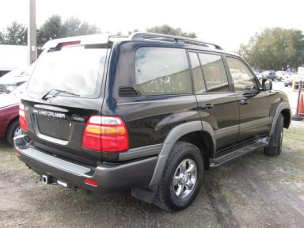
  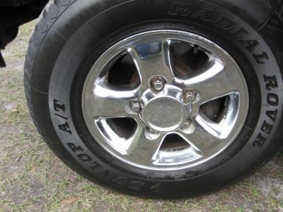 | 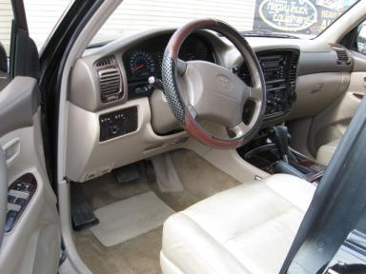
  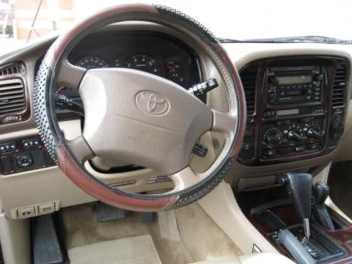 | 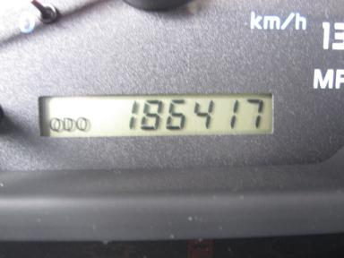
  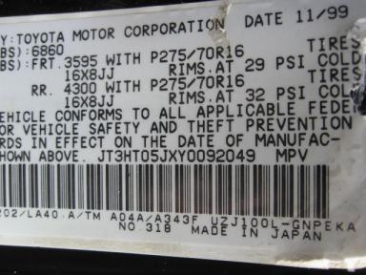
  
  Grade 4.5 Clean
  More About Auto Grade
  MSRP - Not Available
  Certified - No
  Drivable - Yes

VEHICLE INFORMATION
OPTIONS
Pwr Locks  Tilt Steering  CD Player  Owner's Manual  Rear Wiper  Luggage Rack  Running Board |  | Pwr Steering  A/C  Dual Air Bags  ABS Brakes  Rear Heat  No 4th Row Seat  Trailer Hitch - Bolt On |  | Pwr Windows  Cruise Ctl  50 State Emissions  Fog Lamps  Warranty Books  US EPA Label  Heated Seats |  | Pwr Seats - Both  Rear Defrost  Power Mirrors  Trip Counter  Third Seat  Step Bumper

MECHANICAL | INTERIOR
  8 Cylinder Gas
  Automatic
  4X4
  Pwr Brakes
  4.7 L
  Odometer - 6 Digits Analog - Operable
  Leather - TAN
  Int Odor: OK
  Wood Trim Dash
  Interior Condition - Average
TIRES AND WHEELS
  Tire Condition: | Good | Wheels: | Alloy
  Tire | Tread Depth | Brand | Size
  Left Front: | 5/32" | DUNLOP | 275/70R16
  Left Rear: | 5/32" | DUNLOP | 275/70R16
  Right Front: | 5/32" | DUNLOP | 275/70R16
  Right Rear: | 5/32" | DUNLOP | 275/70R16
  Spare: | 5/32" | DUNLOP | 275/70R16
  KEYS
  Master Key - 1
  OTHER
  Title State:
  Title Received Date: N/A

ADDITIONAL INFORMATION
SELLER GUARANTEE,
Common Abbreviations

DAMAGES - SUGGESTED REPAIRS
Suggested repairs are based on Manheim professional inspector's recommendation.
Total labor hours include paint, body or repair estimates.
 | DESCRIPTION | CONDITION | SEVERITY | SUGGESTED  REPAIR | TOTAL  LABOR  HOURS
 | Front Bumper Cover | Mult Scratches | 2" to 3" | Refinish | 3.10
 | Roof | Dent/No Paint Dmg | PDR/9 | PDR | .00
 | LR Door | Chipped | 6 | Paint Chip Repair | .00
 | Rear Bumper Cover | Scratch Light | 4" to 5" | Wet Sand | .00
 |  |  |  | TOTALS | 3.10

VIN: JT3HT05JXY0092049, Work Order: 190104

