Manheim Fredericksburg
120 Auction Dr
Fredericksburg, VA 22406
(540) 368-3400

VEHICLE DETAILS - 2000 MITSUBISHI MON SP XLS-4
VIN: | JA4MT31H2YP015966 | Body Style: | 4SUV | Top Type: | Hard Top
Ext Color: | SILVER | Int Color: | GRY | Odometer: | 135,708
Work Order: | 7070126 | Seller: | ENTERPRISE CAR SALES | Received Date: | 12/11/2009
Inspector: | ADRAYTON 12/18/2009 | InService Date: | N/A

VEHICLE IMAGES
 |  |  | GRADING
  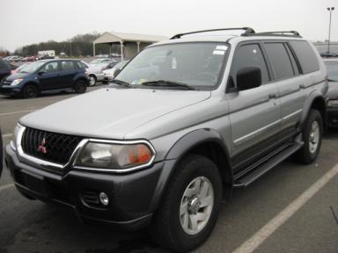 | 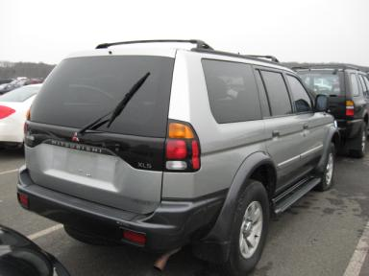
  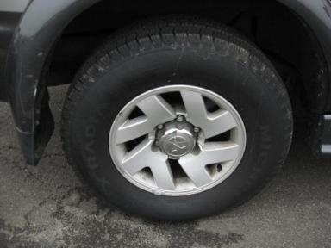 | 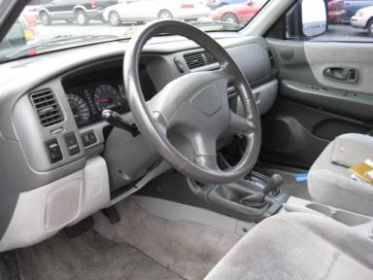
  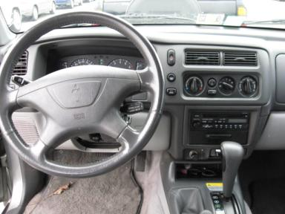 | 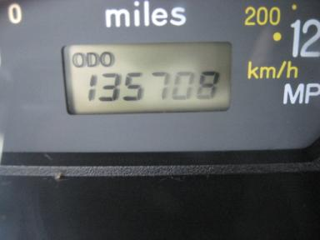
  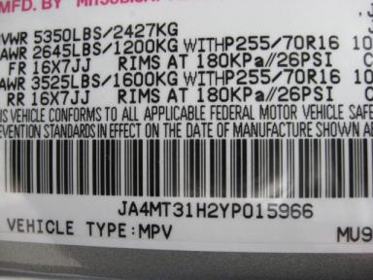
  
  Grade 3.3 Average
  More About Auto Grade
  MSRP - Not Available
  Certified - No
  Drivable - Yes

VEHICLE INFORMATION
OPTIONS
Pwr Locks  A/C  Dual Air Bags  4 Door  NO Rear Air Conditioning  Floor Mats |  | Pwr Steering  Cruise Ctl  Power Mirrors  Fog Lamps  Luggage Rack  Step Bumper |  | Pwr Windows  Rear Defrost  Owner's Manual  Trip Counter  NO Third Seat  Running Board |  | Tilt Steering  CD Player  Tinted Windows  Rear Wiper  5 Passenger Seating  Power Antenna

MECHANICAL | INTERIOR
  6 Cylinder Gas
  Automatic
  4X4
  Pwr Brakes
  3.0 L
  Odometer - 6 Digits Analog - Operable
  Cloth - GRY
  Regular Dash
  Int Odor: OK
  Interior Condition - Dirty
TIRES AND WHEELS
  Tire Condition: | Average | Wheels: | Alloy
  Tire | Tread Depth | Brand | Size
  Left Front: | 9/32" | GOODYEAR | 255/70R16
  Left Rear: | 9/32" | MICHELIN | 255/70R16
  Right Front: | 7/32" | MICHELIN | 255/70R16
  Right Rear: | 9/32" | MICHELIN | 255/70R16
  Spare: | 9/32" | YOKOHAMA | 255/70R16
  KEYS
  Master Key - 1
  OTHER
  Title State: VA
  Title Received Date: 02/02/2010

ADDITIONAL INFORMATION
4X4/OVER 100/AS IS,
Common Abbreviations

DAMAGES - SUGGESTED REPAIRS
Suggested repairs are based on Manheim professional inspector's recommendation.
Total labor hours include paint, body or repair estimates.
 | DESCRIPTION | CONDITION | SEVERITY | SUGGESTED  REPAIR | TOTAL  LABOR  HOURS
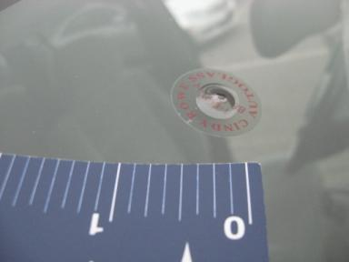 | Windshield | Star in Glass | 1" to 2" | Replace | .00
 | Front Bumper | Multiple Chips | 10 or More | Refinish | 1.50
 | Hood | Chipped | 4 | Paint Chip Repair | .00
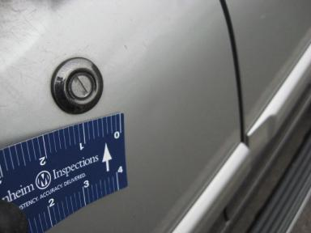 | LF Door | Dent/Paint Dmg | 1" to 2" | Repair | 5.50
 | LR Door | Chipped | 4 | Paint Chip Repair | .00
 | LR Door | Dent/No Paint Dmg | PDR/3 | PDR | .00
 | L Qtr Panel | Chipped | 3 | Paint Chip Repair | .00
 | Rear Bumper | Multiple Chips CENTER | 10 or More | Partial Repair | .00
 | RF Tire | Flat | Replacement Required | Replace | .00
 | RR Door | Chipped | 3 | Paint Chip Repair | .00
 | RR Door | Dent/No Paint Dmg | PDR/2 | PDR | .00
 | Warning - Maintenance | On | Unacceptable | Ck/Advise | 1.00
 |  |  |  | TOTALS | 8.00

VIN: JA4MT31H2YP015966, Work Order: 7070126


© 2010 Manheim All Rights Reserved

