2004 LEXUS GX470 - SILVER
VIN: JTJBT20X640047142 Work Order: 6755189
Manheim Pennsylvania 1190 Lancaster Rd
Manheim, PA 17545-9789
(717) 665-3571

VIN:
  JTJBT20X640047142
  Body Style: | 4SUV - Pwr Glass Sun Roof
  Ext Color/Code: | SILVER - 1FO
  Int Color/Code: | GRY - LH10
  Odometer: | 117,253
  ECM Mileage:
  Seller: | LEXUS FINANCIAL SERVICES/EASTERN
  Title State: | VA
  Certified: | No
  Condition/Grade: | 3.0, Average
  Sale: | 10
  Lane: | 43
  Run: | 78
  Inspection: | DWALLACE4 02/04/2010
  Drivable: | Yes
  MSRP: | $0
  Factory Category: | L
  InService Date: | N/A
  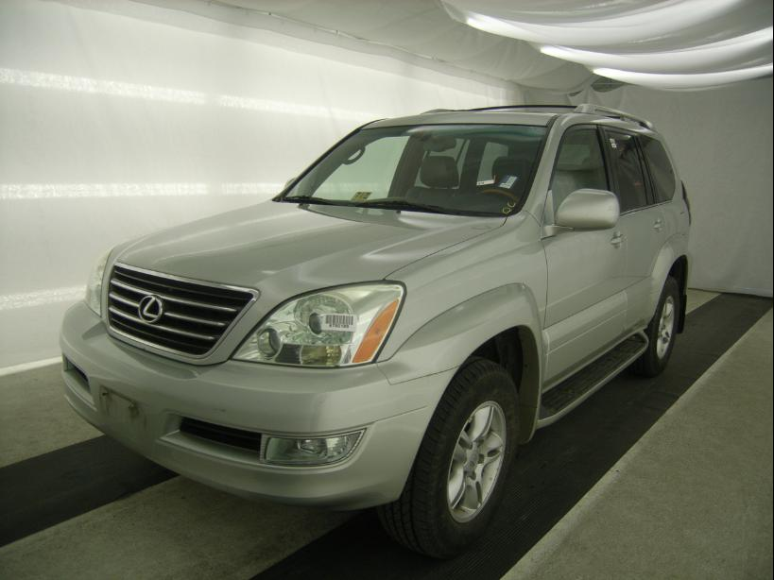 | 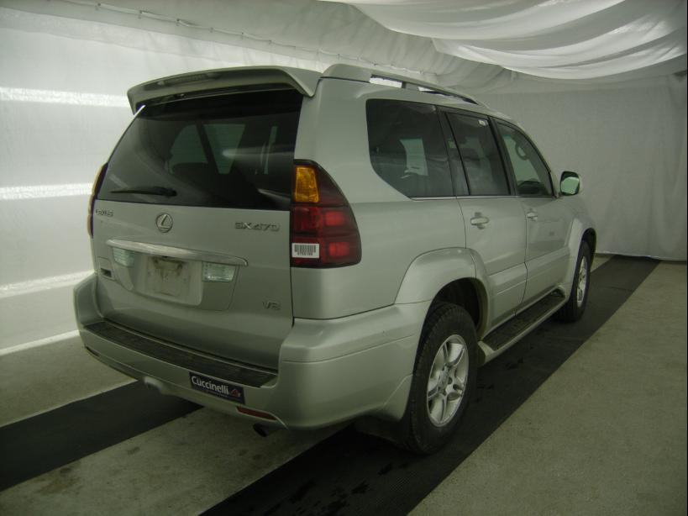
  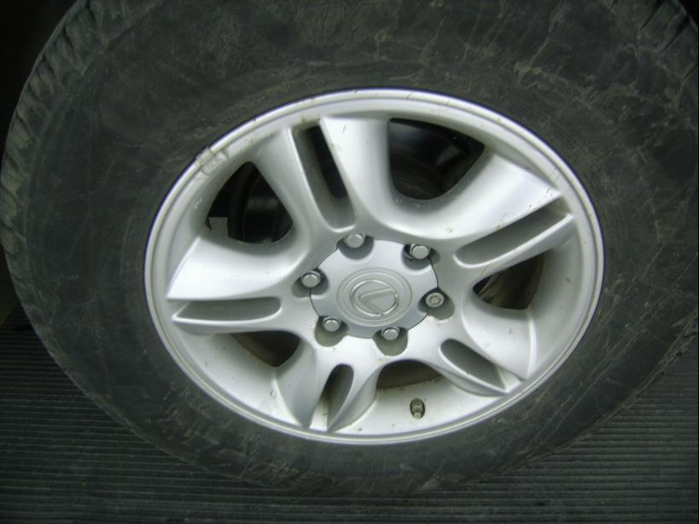 | 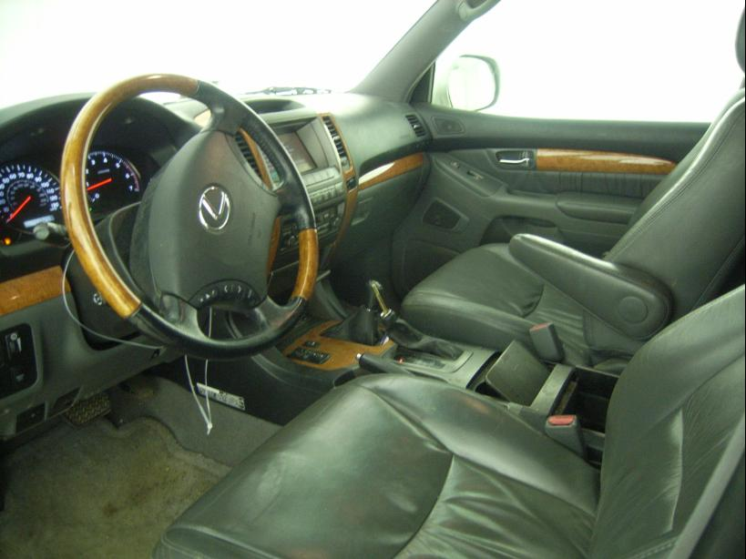
  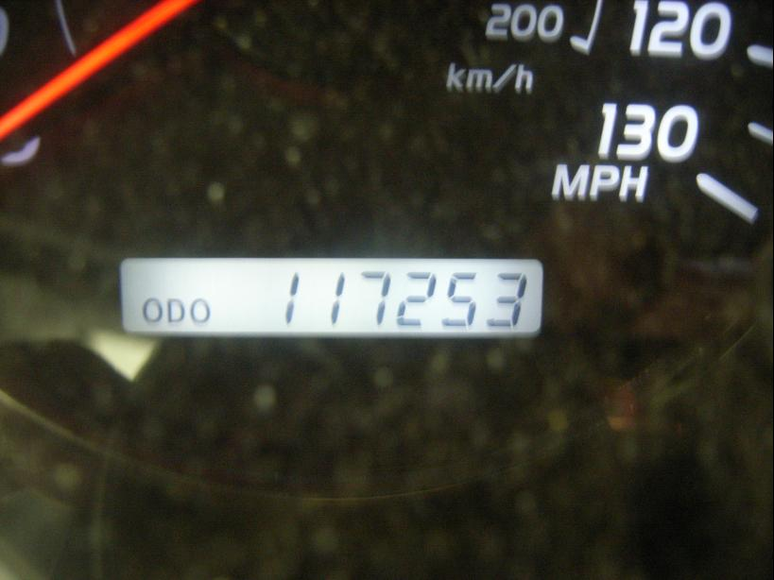 | 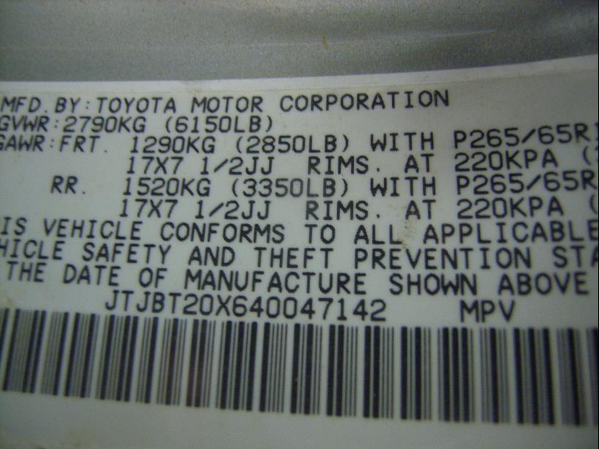
  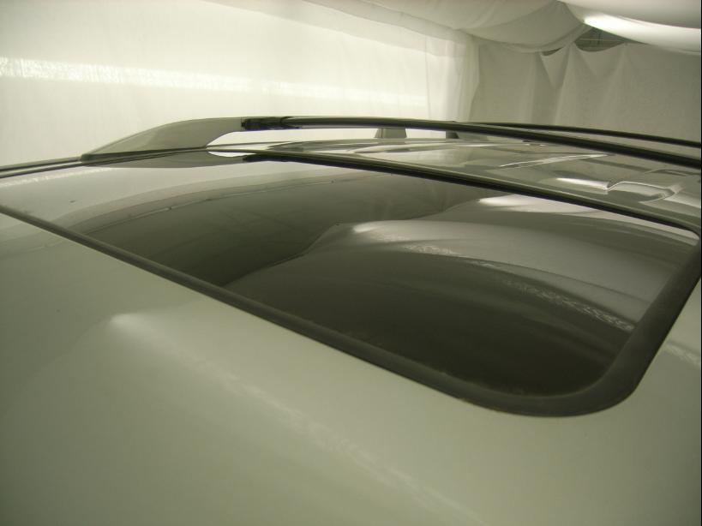 | 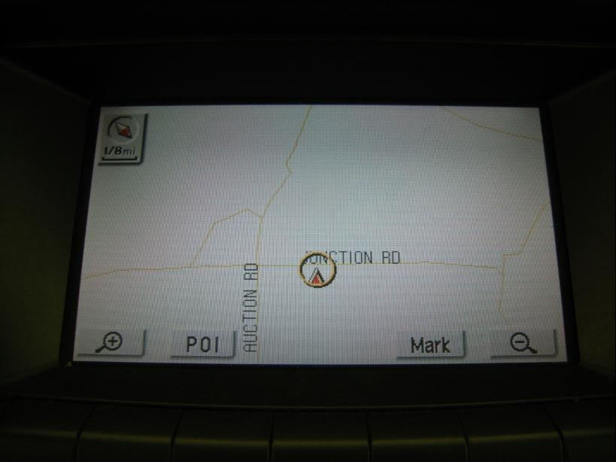
  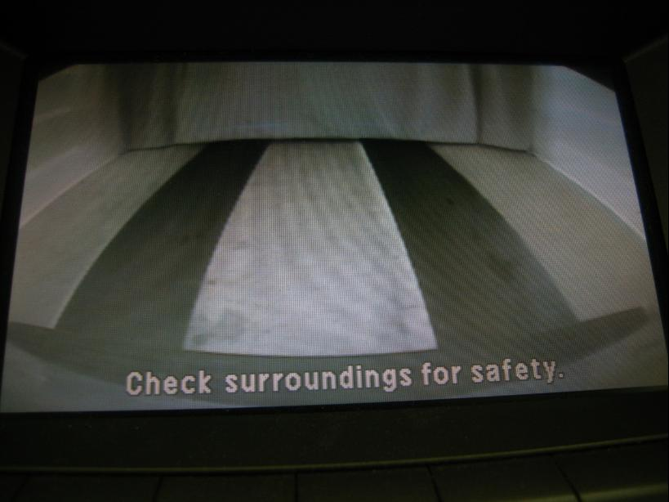

VEHICLE INFORMATION
  MECHANICAL
  8 Cylinder Gas
  Automatic
  4X4
  Pwr Brakes
  4.7 L
  INTERIOR
  Odometer - Digits Digital Operable
  Leather - GRY
  Int Odor: OK
  Wood Trim Dash
  Interior Condition - Dirty
  OPTIONS
  Pwr Locks  Pwr Windows  A/C  Rear Defrost  Side Air Bags  Premium Stereo - M L  50 State Emissions  Heated Mirrors  Tinted Windows  Fog Lamps  Rear Air Conditioning  Trip Computer  Luggage Rack  On-Board Computer  7 Passenger Seating  Security System  Running Board  Traction Control  HomeLink  Heated Seats  Memory Seat  Woodgrain Interior Package  Power Tilt Steering  Directional Stability Control  Tire Pressure Monitor System  Rollover Protection |  | Pwr Steering  Pwr Seats - Both  Cruise Ctl  Cassette Tape  Dual Air Bags  CD Changer - OEM - 6  Power Mirrors  ABS Brakes  4 Door  Trip Counter  Rear Wiper  Third Seat  Keyless Entry  Floor Mats  US EPA Label  Step Bumper  Steering Wheel Audio Control  Dual Air Conditioning  Front Center Console  Wheel Locks  Rear View Camera  Power Telescopic Steering  Rain Sensor Windshield  Ride Control  Rear Radio Controls
FLUID LEVELS
Fuel Level: Empty

  TIRES AND WHEELS
  Tire | Tread Depth | Brand | Size
  Left Front: | 9/32" | MICHELIN | 265/65R17
  Left Rear: | 9/32" | MICHELIN | 265/65R17
  Right Front: | 8/32" | MICHELIN | 265/65R17
  Right Rear: | 8/32" | MICHELIN | 265/65R17
  Spare: | 0/32" | MICHELIN
  Wheels: Alloy
  KEYS
  Master Key - 1
  OTHER

ANNOUNCED CONDITION: AS IS OVER 100K,4X4;KNOB, Navigation CD Present Shift Knob Present Buyer Fee includes a $10 TFS/LFS Administrative Fee.
INTERNET REMARKS:
REMARKS/ADDITIONAL DAMAGE:
DISCLOSURES: KNOB, BAGGED NAV DISC PRESENT NO WARNING LAMPS REAR CENTER HEAD REST PRESENT
NOTES TO CONSIGNOR: *HOLD GATEPASS FOR PAYMENT
REMARKS: *HOLD GATEPASS FOR PAYMENT
COMMENTS FOR CONSIGNOR: PD 03/04, KNOB, BAGGED NAV DISC PRESENT NO WARNING LAMPS REAR CENTER HEAD REST PRESENT

2004 LEXUS GX470 - SILVER
VIN: JTJBT20X640047142 Work Order: 6755189
Manheim Pennsylvania 1190 Lancaster Rd
Manheim, PA 17545-9789
(717) 665-3571

DAMAGES
 | DESCRIPTION | CONDITION | SEVERITY | REPAIR  HOURS | PAINT  HOURS | PART  HOURS | TOTAL  HOURS
 | Windshield | Multiple Chips | < 1/8" | .00 | .00 | .00 | .00
 | Front Bumper | Mult Scratches | 1" to 2" | .00 | .00 | .00 | .00
 | Hood | Multiple Chips | < 1/8" | .00 | .00 | .00 | .00
 | Sun Roof | Factory | Acceptable | .00 | .00 | .00 | .00
 | LF Door | Chipped | 1/8" to 1/2" | .00 | .00 | .00 | .00
 | LF Door | Scratch Light | GR 12" | .00 | .00 | .00 | .00
 | LF Mirror Housing | Mult Scratches | 1" to 2" | .00 | .00 | .00 | .00
 | L Qtr Panel | Dent/No Paint Dmg | 1/2" to 1" | .00 | .00 | .00 | .00
 | Rear Bumper | Mult Scratches | 2" to 3" | .00 | .00 | .00 | .00
 | Rear Camera | Factory | Acceptable | .00 | .00 | .00 | .00
 | R Qtr Panel | Dent/No Paint Dmg | PDR/3 | .00 | .00 | .00 | .00
 | Navigation System | Factory | Acceptable | .00 | .00 | .00 | .00
 |  |  | TOTALS | .00 | .00 | .00 | .00



